**Faculty Senate Executive Committee Minutes**

October 11, 2016

LI 516, 3:00-5:00 pm

***Present***: Jon Anderson, Anne Arendt, Mark Bracken, Kat Brown, Logan Cottle (UVUSA), Karen Cushing, Doug Gardner, Lindsay Gerber, Ryan Leick, Tanner McAllister (UVUSA), Anthony Morris (Library), Jeff Olson, Sean Tolman

Visitors: Dennis Potter

***Excused or Absent:*** David Connelly, Jim Pettersson

* Call to order – 3:04 PM
* Approval of Minutes from September 27, 2016. Minutes approved.

UVUSA

* McAllister will follow up with Ashley Larson for website links. Consider putting article in UVU Review about the value of a diploma.
* Each school/college has a student rep. UVUSA now has department reps in most departments. Would like to share this information with Faculty Senate so they are aware they exist and ask how these reps can be most effective. ExCo would like a list of all department and school/college reps. Will provide a list of reps and responsibilities at the next ExCo meeting.
* McAllister will also follow-up on the student rep honorarium due to the new Procurement system.

POLICY

* Just finished Policy 601 – *Classroom Instruction and Management* addressing religious accommodations and minors in the classroom. Moving forward to President’s Council.
* Finished Post Tenure and Annual Review last Friday. Pilar Hays finishing language and preparing for President’s Council.
* Textbook Policy is next on the agenda.
* Policy 605 – *Curriculum and Program Changes Approval Process* has been through Faculty Senate. It is ready to move forward. Would like to wait for Policy 604 – *Course Outlines Records* and Policy 610 – *Credit Hour* to move forward. As side note, any item going before President’s Council needs to be submitted on a new form.

PRONOUNS & BATHROOMS

* In LGBQT community, the T stands for Transgender, but many are not aware. People who are “non-binary” feel the language is too binary. In practice, individuals decide what pronouns to use to identify themselves.
* Recommend asking students first day of class their preferred name and what pronouns they would like to go by. Students can go to Student Support Services and ask that their information be shared with faculty.
* UVU has done a good job with gender neutral restrooms.
* Karen Deysher will present to Faculty Senate on October 18, 2016. Contact her if you have any questions or attend a Safe Zone Training.

SVPAA

* Roots of Knowledge unveiling is scheduled for November 18, 2016.
* PBA Conversations will begin on November 7, 2016. Schedule of conversations can be found at <http://www.uvu.edu/pba/docs/2016_pba_schedule.pdf>. Budget will be given to the President to decide. Every comment made at the presentations is reviewed during discussions. Encourage your faculty to attend.

DEBATE CALENDAR

* Bracken would like to reorder the Faculty Senate agenda and handle the Policy items right after the Administrative Updates. ExCo agreed.
* Gardner will ask Linda Makin to present on Accreditation.
* RTP Advisory Committee was tabled at the last Senate meeting. Connelly noted that the item will need to be brought off the table. Bracken can ask that it be deferred for the business of the Senate.

RTP ADVISORY COMMITTEE

* Arendt reviewed a Tenure Flow Chart she prepared.
* Connelly noted that in Policy 101 – *Policy Governing Policies*, the President has the right to interpret policy with President’s Council. If there is a disagreement about interpretation of policy, it should be taken to President’s Council. Discussion regarding how the agenda item should be brought forward in Faculty Senate and guidelines for discussion. Recommendation was to make a motion to limit the time to 15 minutes. Decision was to entertain a motion to reorder the agenda.
* Recommend beginning the discussion with the purpose of the discussion. Brown noted that the original purpose in bringing the item to the Senate was transparency and political will. A Senate Resolution should be submitted in opposition only to the formation of the RTP Advisory Committee.
* Several schools/colleges have either sent out notices or held elections.

BYLAWS

* Goal is to have Bylaws out of ExCo by November 1. Have four issues for discussion:
  + Service & Elections Duties – Item 7 – Discussion over “maintain presence of Faculty Senate members in Senate meetings.” Minutes are the official record of attendance.
  + Election of Senate President or Vice President – Referenced Policy 103.3.2 definition of Faculty.
  + Length of term for Parliamentarian – Extends over the period of time of the President to maintain institutional knowledge and continuity. Decision is four years elected on the off-year of the President.
  + Election of President and Vice President – Elections need to happen no later than the end of February. Recommendation was to hold an instant “run-off” election by preference ballots and completed by March 1. New Senate Executive Committee nominations due by April 1 and elections will occur at the second to last spring full senate meeting.

VOTING

* Two voting options: 1) Qualtrics and 2) Current System on Faculty Senate Website.
* Anderson shared his thoughts on programming and recommended using current system since single sign-on is not possible. The system can provide a unique link after an upload of individuals with email addresses which can then be emailed to the individuals. Authentication is your email login, but the email can be forwarded. Gardner recommends Qualtrics. Cushing will work with Tim Stanley and share ideas for elections and note that the filter has to be turned off.

ADJUNCT PAY FOR ATTENDING FACULTY ORIENTATION

* An adjunct attended the new orientation which lasted four hours, but was only paid for two hours. Will send out notice reminding faculty what functions adjuncts can attend and proper procedures to follow when requesting their attendance.

CAGAS

* UW/U/I/E – still under discussion
* Bylaws discussed with Olson, but will seek a website based on discussions with Jan Klingman.

LIBRARY

* Web of Science, a citation index, will be up and running on the website in the next few weeks.

Meeting adjourned 4:55 p.m.

**Gender Pronouns**

Some people don’t feel like traditional gender pronouns (she/her, he/him) fit their gender identities. Transgender, genderqueer, and other gender-variant people may choose different pronouns for themselves. The following is a starting point for using pronouns respectfully. It can be tough to remember pronouns at first. The best solution is to practice! Correct pronoun use is an easy step toward showing respect for people of every gender.

**How do I know which pronouns to use?**

Please do not assume an individual’s gender identity by their appearance. Appearance and gender expression are different from gender identity. If the person you’re referring to is a stranger or brief acquaintance (like a server, cashier, fellow bus patron, etc), you may not need to know. If the person is a classmate, student, or coworker, for example, it is best to ask. Try:

* “What pronouns do you use?”
* “How would you like me to refer to you?”
* “How would you like to be addressed?”
* “My name is Bob and my pronouns are *he* and *him*. What about you?”

**How do I use and/or pronounce particular pronouns?**

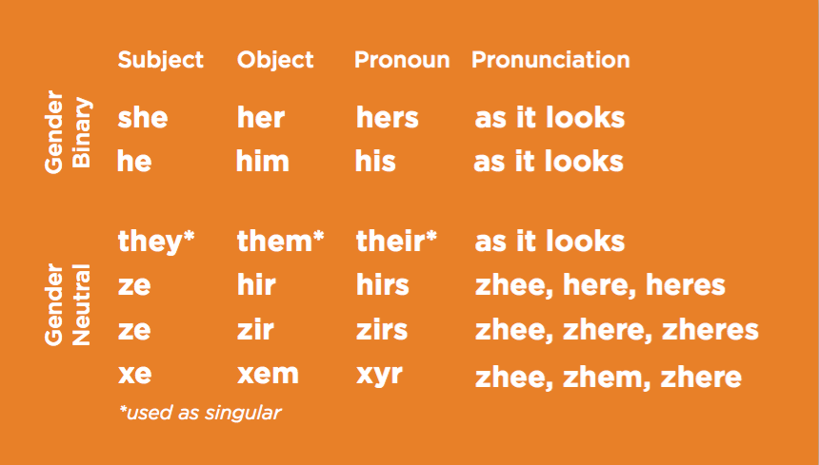

**How often do pronouns change?**

Remember that people may change their pronouns without changing their name, appearance, or gender identity. Try making pronouns an optional part of introductions or check-ins at meetings or in class.

**What if I make a mistake?**

Most people appreciate a quick apology and correction at the time of the mistake. Try:

* “*Her* books are—I’m sorry, *hir* books are over there.”

By correcting yourself, you’re modeling respectful pronoun use for others in the conversation. If you only realize the mistake later, a brief apology can help. Try:

* “I’m sorry I used the wrong pronoun earlier. I’ll be more careful next time.”

**When should I correct others?**

Some people may not want a lot of public attention to their pronouns, while others will appreciate you standing up for them. If someone uses the wrong pronoun for a person who isn’t present, try a brief correction:

* “I think Sam uses *she* and *her* pronouns. And yes, I’m going to *her* house later too!”



**Safe Zone training** is about fostering an environment of inclusion for lesbian, gay bisexual, transgender, queer, questioning, intersex, allies, and asexual/nonsexual (LGBTQIA*) individuals on our campus and in the surrounding community. The training raises visibility and promotes ally building through:

* Educating individuals on LGBTQIA* issues relating to gender and sexuality and how one can intervene when they witness discrimination.
* Creating visibility of people who can provide resources to LGBTQIA* community members.
* Creating a safe environment on campus free from restrictive transphobia, homophobia, heterosexism and cisgender bias.
* Look for this sign in offices around campus to identify those who have completed Safe Zone training and who are committed to providing an inclusive environment for members of the LGBTQIA* community at UVU.

Upcoming Safe Zone training sessions:

* Wednesday, October 26th at 10:30-12:30 PM in LA 116
* Friday, November 11th at 1-3 PM in LA 116

If you are interested in attending, please contact Karen Deysher at [karen.deysher@uvu.edu](mailto:karen.deysher@uvu.edu)