General Education Review
Preliminary Proposal
1.5.23

The GE Task Force Charge is provided below for background information and to give context for the proposal.

Context: Most of UVU’s general education curriculum is set by state policy (R470). These include 30 credit hours of course and distribution requirements applicable to all USHE institutions. Individual universities may require additional hours (up to 9) of general education coursework. The task force will review the current general education requirements, above those required by the state, and make recommendations to the faculty and administration in response to key questions outlined below. The task force will also assess general education’s alignment with institutional priorities and the new ELOs.

Goal: To ensure that UVU’s general education curriculum meets the needs of UVU students and is consistent with UVU’s mission as an open enrollment institution. The general education curriculum should prepare all students for success at UVU and provide opportunities to develop foundational skills to allow UVU graduates to achieve success in their lives and chosen career paths.

Administrative Commitment: Policy 605 outlines curriculum development at UVU and the roles of different stakeholders on campus regarding curriculum. Per policy 605, UVU faculty have “a central role in the design, approval, delivery, revision, periodic review, and deletion of curriculum” (section 4.1). This is consistent with NWCCU Standard 1.C.5, “The institution recognizes the central role of faculty to establish curricula.” The Office of the President and Provost acknowledge this and remain committed to and support the rights and responsibilities of faculty in this regard. While faculty have a central role in curriculum, there are other groups who play important roles and whose voice and input matters (policy 605 section 5.1.1). Our students, staff (advisors), and administrators have an important role in helping to shape the general education curriculum goals. We are committed to working together and recognize that faculty must take the lead in reviewing and making curricular changes, as necessary, to promote the best interest of our students. We also recognize that the Academic Affairs Council (AAC) is responsible for “evaluating the financial impact and program viability of curriculum proposals and existing curriculum” and ensuring that curriculum reflects “institutional strategic plans and missions” (policy 605 section 5.6.1).

Key Goals of the General Education Curriculum
- It should provide baseline skills to enhance student success in any course of study.
- It should be intentional and comprehensible: Students, Faculty and Staff should understand the purpose of the general education curriculum. The general education curriculum must not be seen simply as an arbitrary set of degree requirements that one must “get out of the way” to graduate.
- It should prepare students to achieve success after graduation, whether that involves graduate and professional education, immediate entry into the workforce, or any other life/career path our students may choose.
- The curriculum should prepare students with essential skills that employers repeatedly demand. At a minimum, these skills include written and oral communication, critical thinking, and quantitative literacy. It should also help to ensure that our students are prepared for the unique demands of 21st century careers, including such areas as digital and economic and financial literacy.
- The curriculum should serve to broaden students’ intellectual knowledge base.
- At the foundation of a liberal democracy is an educated populace, the general education curriculum should help prepare students for effective engagement with the range of social, political, and ethical issues (from local to global) that they will encounter in their careers and as citizens.

Charge: To review the current general education curriculum considering the key components outlined above and to bring recommendations for review and approval.
Questions for the task force to consider:
- Does the current general education curriculum meet our student’s educational needs?
- Does the curriculum help prepare student to address a wide range of social, political, and ethical issues that they may encounter in their personal and professional lives?
- Is the general education curriculum effectively aligned with UVU’s Essential Learning Outcomes?
- Does the curriculum provide opportunities for students to develop crucial leadership skills?
- Does the general education curriculum help prepare our students for the demands of the 21st century workforce?
- What modifications, if any, does the task force believe would enhance the general education experience for our students?

To address the charge, the General Education Task Force has 1) met weekly, 2) reviewed internal and external data related to general education and student success, and 3) gathered feedback provided by a range of UVU stakeholders. With all of this in mind, the General Education Task Force has developed the following preliminary proposal for UVU’s General Education Program and seeks feedback from the campus community. The General Education Task Force will use this feedback to finalize this proposal for a Faculty Senate vote in March 2023.

Proposal:

- Number of Credits: The task force recommends the GE requirement remain at 35 credits hours with an expansion of the Ethics and Values, Wellness, and Third Science categories.

- Remove Prescriptive GE Requirements: The task force recommends the elimination of prescriptive GE requirements in academic degree programs. For purposes of this proposal a prescriptive GE requirement is any place where a program requires a student to take a specific course to fulfill a GE distribution requirement. The screen shot below shows examples of prescriptive GE compared to choose from a list.

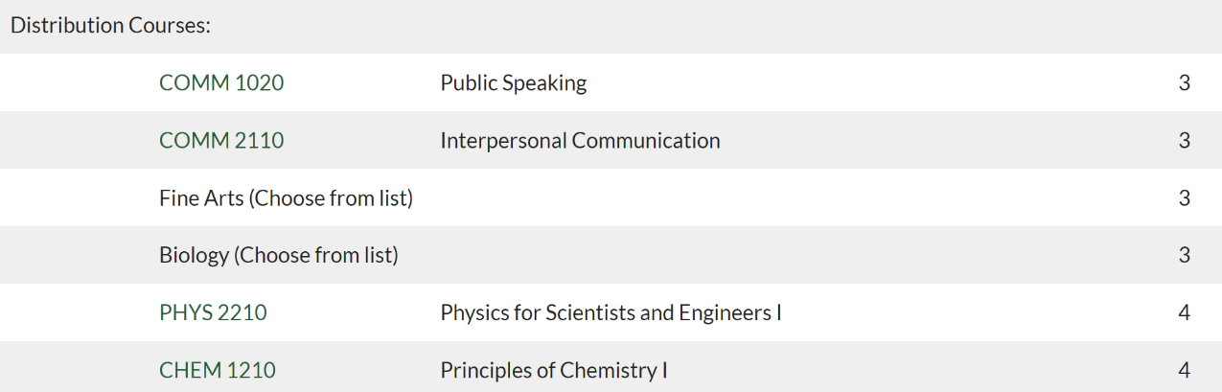
For reference:
COMM 1020 (Humanities distribution: 1/46 options)
COMM 2110 (Social/Behavioral Science: 1/45 options)
PHYS 2210 (Physical Science: 1/28 options)
CHEM 1210 (3rd science: 1/47 options)

The task force acknowledges there may be some programs with accreditation requirements. These concerns can be addressed on a case-by-case basis by the appropriate University committees. The task force recommendations are not intended to cause programs to lose any special accreditation they have.

- Modified Core Requirements: The task force recommends the following modifications to the existing Wellness, Ethics and Values, and Third Science categories.
- Wellness: This category will remain a 2-credit hour GE requirement. The task force recommends changing the name of this category to Personal and Professional Growth. This modification will require the creation of modified GE Program Learning Outcomes (PLOs) for this category, which will allow for a variety of class options. Examples of class options may include the existing wellness courses, financial wellness, or First Year Seminar courses.
- Ethics and Values: This category will remain a 3-credit hour GE requirement, but more discussion is needed to determine how this is expanded. There are two main themes emerging within discussions regarding this category:
    - The requirement be expanded to include additional ethics courses in addition to the existing Ethics and Values course.
    - This category could be expanded to include additional areas of focus.
    - Either change may include a modification of the Ethics & Values PLOs.

- Third Science: This category will remain a 3-credit hour GE requirement. The task force recommends changing this category to Science, Technology, Engineering, and Math (STEM). This modification will require the creation of GE PLOs which will allow for a variety of class options. Topics could include programming, data analytics and visualization, technology applications, technical communication, computer aided design, and emerging technology.

Justification: After much discussion and deliberation about possible options, along with associated consequences, the task force determined the above proposal helps students gain a baseline of skills, while allowing options for students to choose courses that address a wide range of social, political, and ethical issues. The proposed modifications above provide additional options to students to help prepare them to meet the unique demands of the 21st century.

Additional Considerations: The task force has identified several other items that should be addressed to support this proposal.
- GE informational campaign: During the information gathering phase the task force acknowledged there is a lack of knowledge in the University community with regards to the goals of General Education and how it helps support the institutions ELOs and creating life-long learners.
- Faculty & Staff Professional Development:
  - High Impact Practices (HIPs): Data overwhelmingly demonstrates the benefit to student success and retention when HIPs are incorporated into the classroom. It is the recommendation of the task force that further faculty development and resources be provided to faculty, especially those teaching GE courses to aid them in incorporating HIPs into GE courses. The task force would like to see departments consider how they can incorporate HIPs on the course level rather than leaving it to individual sections and instructors. This increases the chances that all students are allowed the opportunity to have the same experience across the various sections of a GE course.
  - GE pedagogy and best practices: The task force recommends developing opportunities for workshops focused on GE pedagogy. These opportunities should also be made available to adjunct faculty teaching GE courses.
- UVU needs to evaluate transfer of GE from other institutions on a holistic basis. This is especially true when students are transferring with completed GE or completed associates degrees.
- USHE GE Task Force could potentially influence this process.

Feedback: You can provide feedback to any member of the GE Task Force (links to contact members are on the GE Task Force Website), the GE Task Force Chair, Faculty Senate Vice President, or Faculty Senate President.

