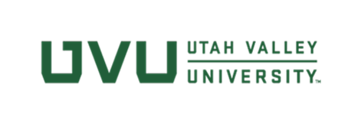

Questions to Ask When Talking to Vendors

- Can you provide the name and contact information for the person/team in your company responsible for handling accessibility issues?
- Is your product compliant with WCAG 2.0, Level AA?
- Is there a plan to make inaccessible features accessible, and if so, what is the timeframe? Could you provide a copy of an accessibility roadmap?
- What is the process we should follow for reporting accessibility issues and how do you respond to those issues?
- Can you provide the most current Voluntary Product Accessibility Template (VPAT) you have for the product?
- How have the VPAT claims been verified?
- Can you share any accessibility reviews, done either internally or externally?
- Are you aware of the UVU EIT Accessibility policy and the EIT Accessibility contract language included with all contracts? [link to EIT Accessibility Compliance Terms and Agreements]

