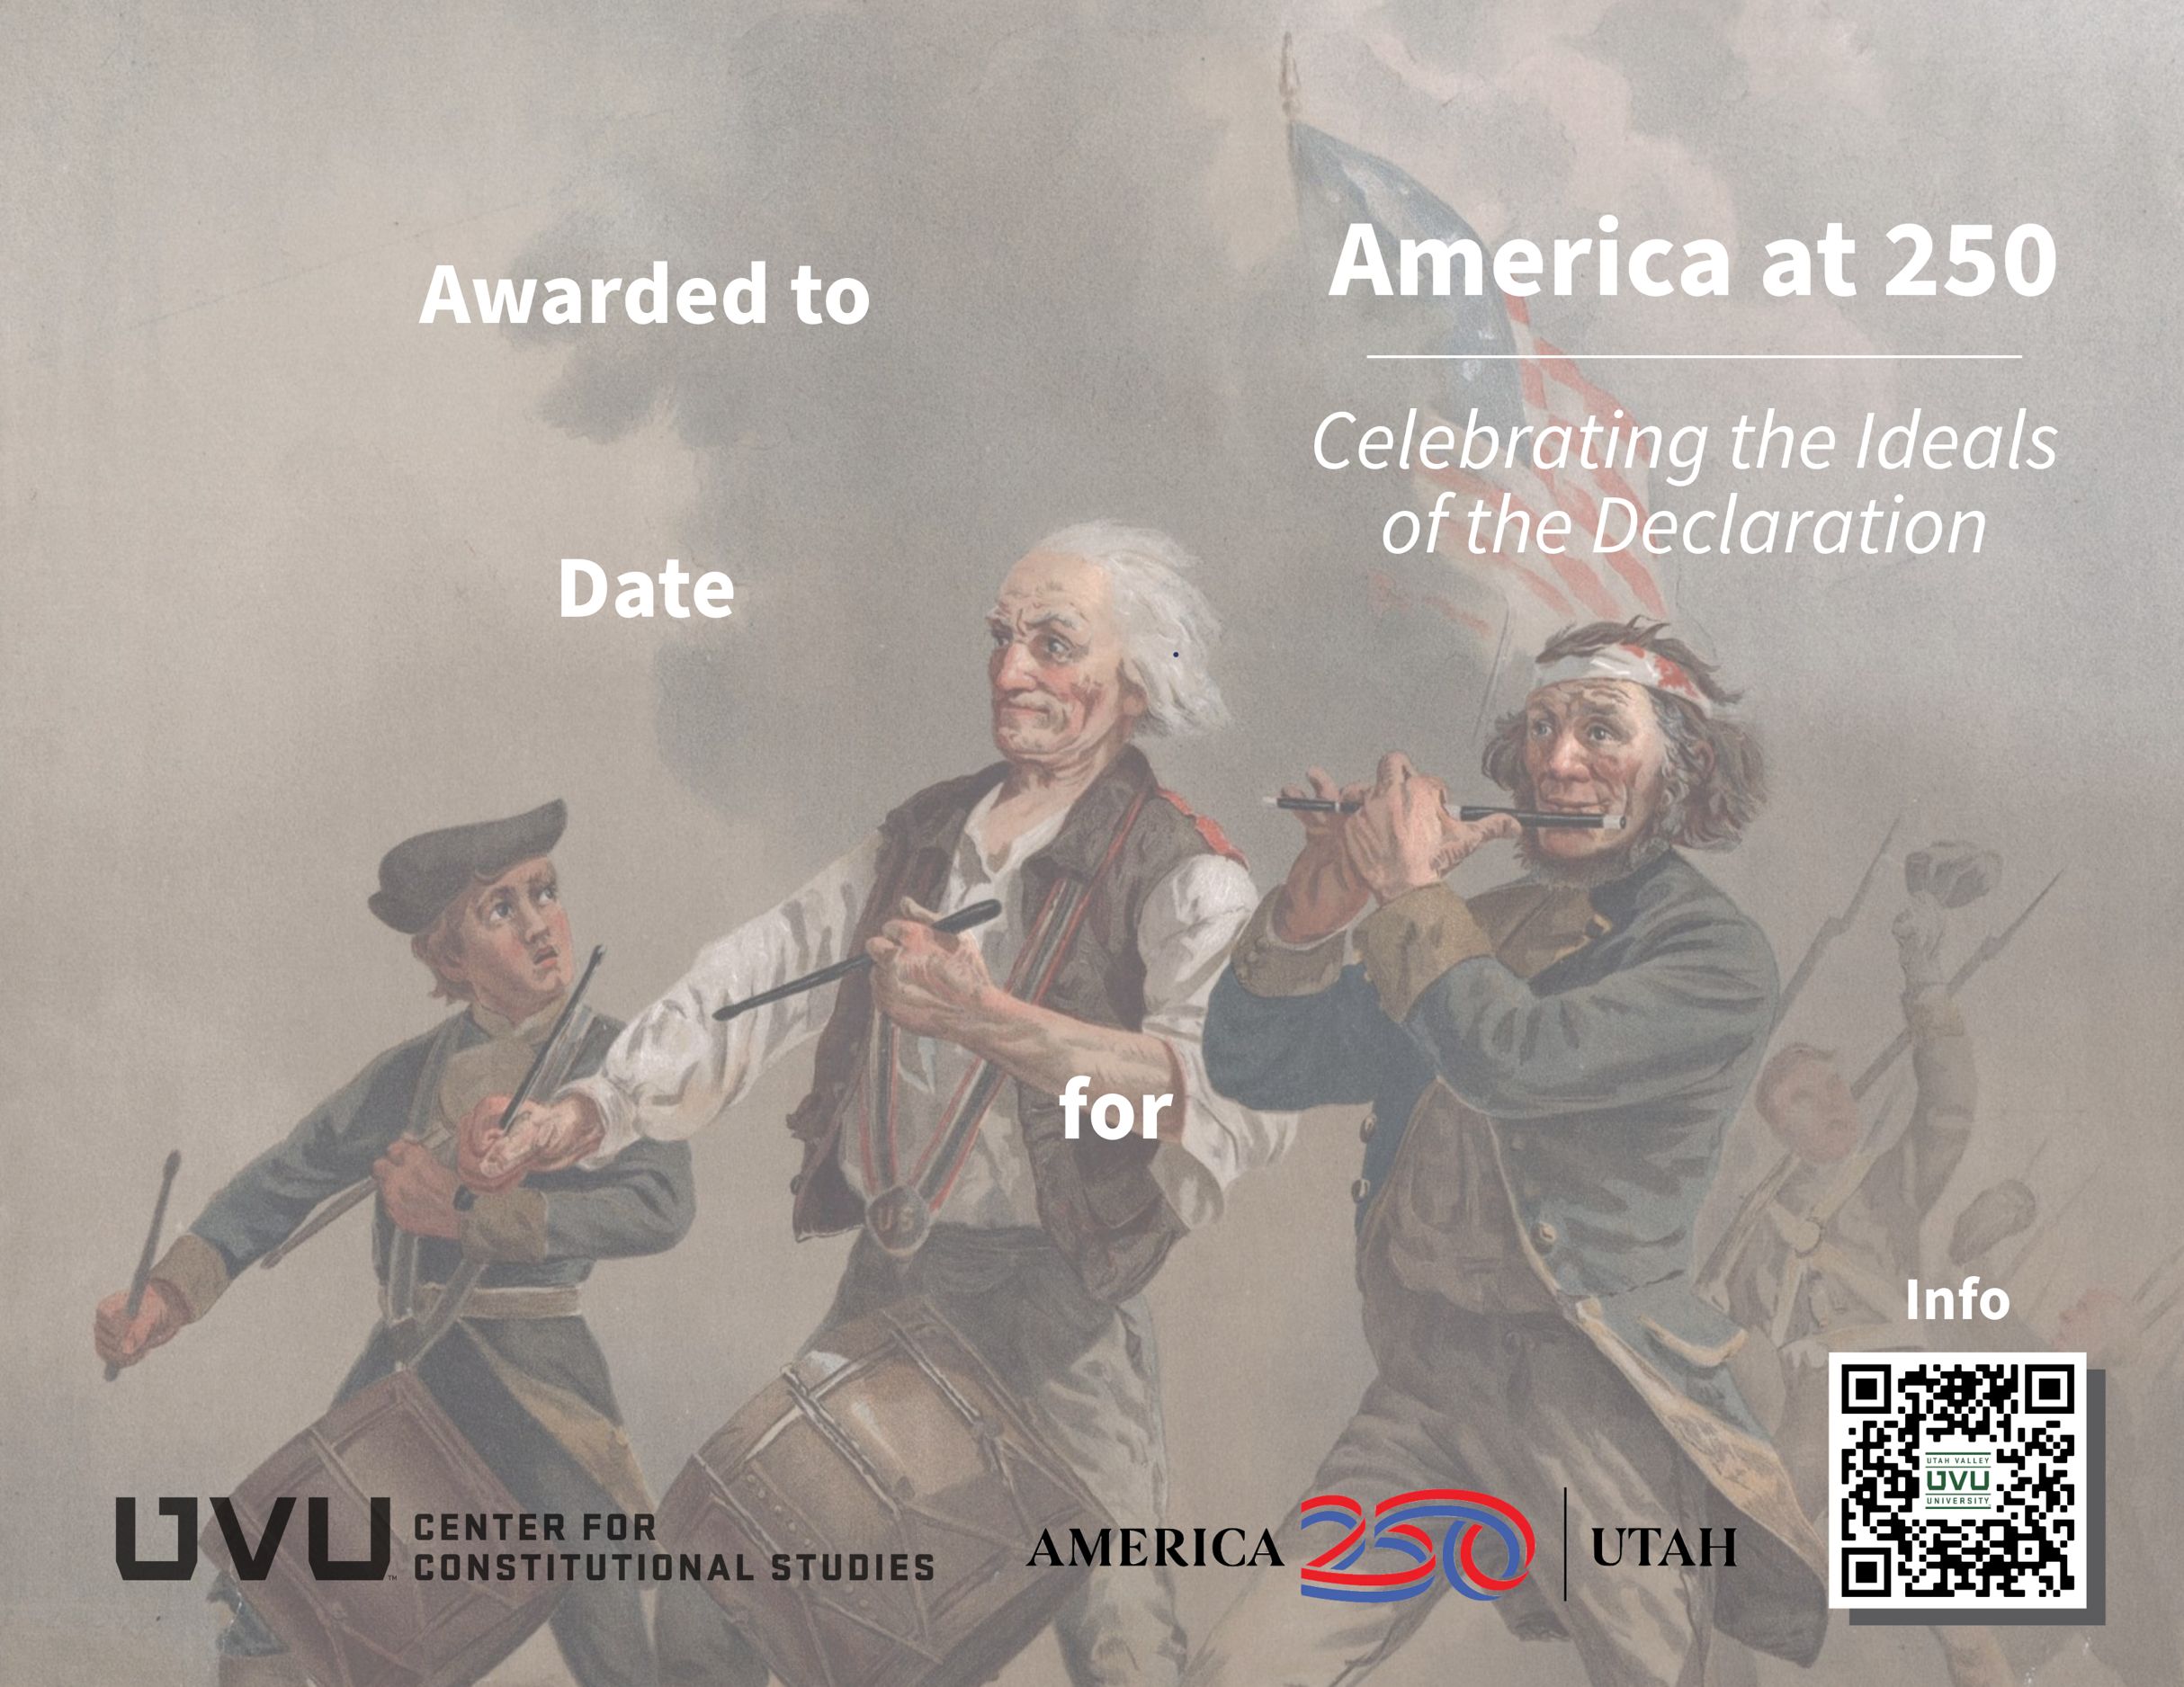
Reading McCullough’s 1776
July 4, 2026
Jane Smithson

