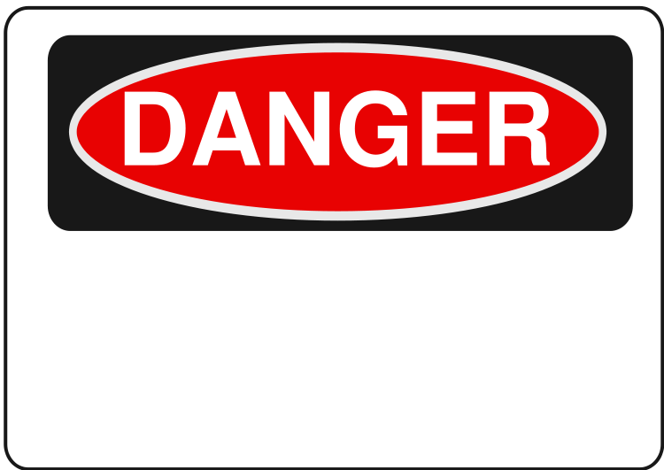**AUTHORIZED PERSONNEL ONLY**

The following Chemical(s) are being used inside this Laboratory:

________________________________________________________________________________Which has/have been designated as a (circle appropriate):

Carcinogen

Reproductive Hazard

High Acute Toxicity

Do not enter unless you are familiar with the appropriate PPE, handling, storage, transportation, decontamination, and disposal procedures.