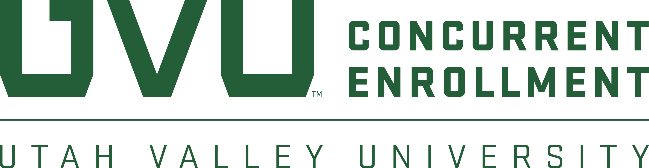
2020 CONCURRENT ENROLLMENT
STUDENT ART SHOW

CALL FOR ENTRIES
IMPORTANT DATES:  Entries Due: April 13  Artists Notified: April 20  Drop Off Artwork: April 29-30  Exhibit Begins: May 8  Opening Reception: May 8  Exhibit Ends: May 18  Pick Up Artwork: May 19-21 | FOR MORE INFORMATION:  Visit: www.uvu.edu/concurrent  Contact: High School Art Teachers  Phone: (801) 863-8376  Email: concurrent@uvu.edu | PRIZES:  BEST OF SHOW - One-year, half  tuition scholarship to UVU*  2nd Place - $100 Gift Card  3rd Place - $50 Gift Card  People’s Choice - $200 Gift Card  Scholarship Award - $1,000 private scholarship to UVU

ELIGIBLE ARTWORK
All two-dimensional media (Photography, Drawing, Painting, Graphic Design) 4’ x 4’, or smaller, no more than 40 lbs. Artists must currently be high school students and have enrolled in a UVU Concurrent Enrollment course within the last three (3) years.

ENTRY REQUIREMENTS:
Up to three (3) entries allowed per student. One (1) entry per medium allowed per student. Entries should be emailed to concurrent@uvu.edu. Images should be in JPEG format with the image resolution set to 300 dpi and with approximately a 4 x 6-inch image size. Image files should use the following naming convention:
ArtistName_TitleOfArtwork_Medium.jpeg

Include the following information in the body of the email:
Student Name
High School
Telephone Number
Email Address
Year concurrent enrollment course was taken

For each entry, please list the Artist, Title, Medium (watercolor, photograph, etc.) and Dimensions in inches. For example: Leonardo DaVinci, Mona Lisa, Oil, 12” x 14”

SELECTION PROCESS:
Submissions will be reviewed by a vetting committee of local artists representing a variety of mediums and will determine the final pieces. You will be notified by April 20, 2020, via email, if your artwork has been selected as a finalist. Awards will be determined by the Head Judge and announced at the opening reception on May 8th.

LOCATION:
If your artwork is selected to participate in the juried show, it will be displayed at the UVU Fulton Library, Third Floor Gallery, May 8-18, 2020.
*Best of Show award requires full-time attendance at UVU upon graduation from high school. Other restrictions apply.

