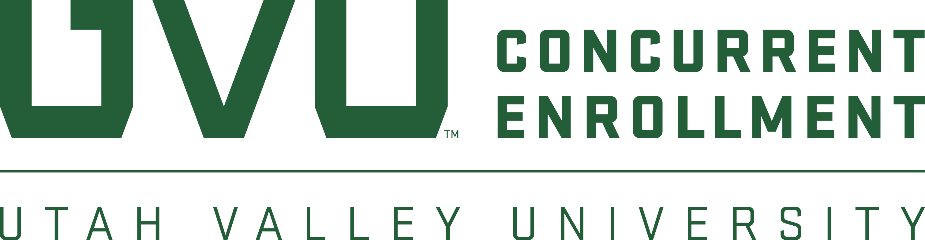
2022 CONCURRENT ENROLLMENT
STUDENT ART SHOW

CALL FOR ENTRIES
IMPORTANT DATES:  Entries Due: April 25  Artists Notified: April 29  Exhibit Begins: May 13  Opening Reception: May 13  Exhibit Ends: June 3 | FOR MORE INFORMATION:  Visit: www.uvu.edu/concurrent  Contact: High School Art Teachers  Phone: (801) 863-8376  Email: concurrent@uvu.edu | PRIZES:  BEST OF SHOW - One-year, half  tuition scholarship to UVU*  2nd Place - $100 Gift Card  3rd Place - $50 Gift Card  People’s Choice - $200 Gift Card  Scholarship Award - $1,000 private scholarship to UVU

ELIGIBLE ARTWORK
All two-dimensional media (Photography, Drawing, Painting, Graphic Design) 4’ x 4’, or smaller. Artists must currently be high school students and have enrolled in a UVU Concurrent Enrollment course within the last three (3) years.

ENTRY REQUIREMENTS:
Up to three (3) entries allowed per student. One (1) entry per medium allowed per student. Entries should be emailed to concurrent@uvu.edu. Images should be in JPEG format with the image resolution set to 300 dpi and with approximately a 4 x 6-inch image size. Image files should use the following naming convention:
ArtistName_TitleOfArtwork_Medium.jpeg

Include the following information in the body of the email:
Student Name
High School
Telephone Number
Email Address
Year concurrent enrollment course was taken

For each entry, please list the Artist, Title, Medium (watercolor, photograph, etc.) and Dimensions in inches. For example: Leonardo DaVinci, Mona Lisa, Oil, 12” x 14”. Please provide artist statement for each entry if available.

SELECTION PROCESS:
Submissions will be reviewed by a vetting committee of artists representing a variety of mediums and will determine the final pieces. You will be notified by April 29th, via email, if your artwork has been selected as a finalist. Awards will be announced at the opening reception on May 13th.

LOCATION:
If your artwork is selected to participate in the juried show, it will be displayed at the UVU Gunther Trades 6th Floor Gallery, May 13-June 3, 2022.
*Best of Show award requires full-time attendance at UVU upon graduation from high school. Other restrictions apply.

