Please take the course evaluation. Evaluation Details: Availability through January 30, 2026
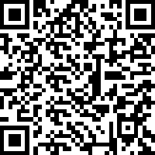

Please take the course evaluation. Evaluation Details: Availability through January 30, 2026

Please take the course evaluation. Evaluation Details: Availability through January 30, 2026

