SPANISH CONCURRENT ENROLLMENT PROGRAM

SPANISH 1020 Course Description and Syllabus school year 2022/2023

Instructor: Office:
Phone: Email address
Office Hours:
Changes to the syllabus must be approved by either Professor Mari De Dios-UVU Concurrent Enrollment Coordinator or Professor Jorge Nisguritzer-UVU Spanish Program Coordinator.
Utah Valley University Spanish Program:
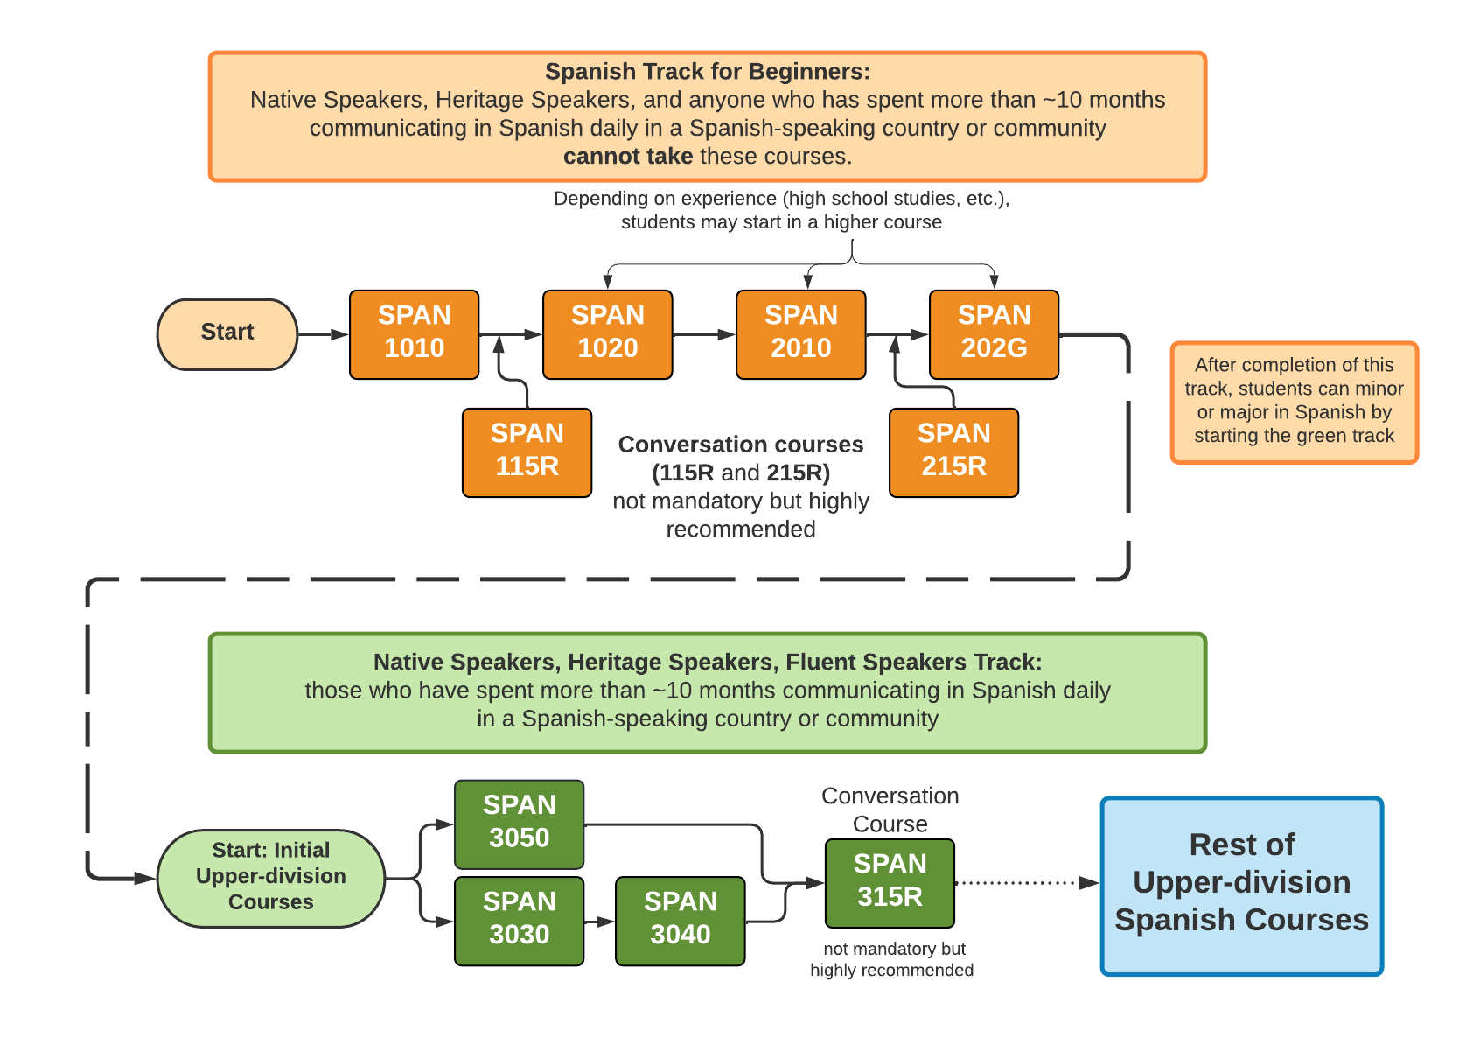
Course materials: 1. Vistas, sixth edition (Blanco, Dellinger, Donley, and García). 2 Workbook, answer key and CDs. 3. Spanish-English Dictionary
Course Description: Includes the continuation of study of grammar and language concepts, literature, and cultural readings. Uses an eclectic method of instruction, emphasizing conversational exchanges. Conversational lab required. Computer and multimedia lab encouraged.
Course Objectives: Upon successful completion, students should be able to: (ACTFL LEVELS)
1 | Participate in simple conversations in Spanish at a Novice High Proficiency level.
2 | Express feelings or opinions on a given topic at a Novice High Proficiency level.
3 | Present information orally and in writing at a Novice High Proficiency level.
4 | Identify the main idea and some basic details in conversations and texts at a Novice High Proficiency level.
5 | Recognize some of the complexities present in Spanish-speaking society at a Novice High Proficiency level.
6 | Recognize aspects of the Spanish-speaking cultures at a Novice High Proficiency level.

Evaluation:

1. Participation (includes in-class oral participation, attendance) 15%
2. Homework 15%
4. Unit exams (5), and Assessment 30%
5. Oral Interviews 15%
6. Composition 10%
7. Presentation 10%
8. Conversation Groups 5%
Participation and attendance: You are required to attend class every day. Your instructor will keep roll and at the end of the day assess your attendance and participation in class and assign a daily grade. The participation grade will be based on student attitude, effort, and the quality of involvement in class. Speaking IN SPANISH throughout the class is essential to good participation. You can improve your daily class work grade by 1) coming to class prepared and ready to participate on a regular basis; and 2) consistently interacting in Spanish with your instructor and classmates.
Homework: Written assignments will generally come from the workbook. Each time you take an exam, you will be required to complete and hand in the corresponding workbook chapter. The total number of exercises assigned will determine the total number of points possible at the end of the semester.
Unit exams: These exams will each cover the material of the chapter being studied. Exams may include vocabulary, composition, grammar, listening and reading comprehension sections.
Oral interviews: You will have three oral interviews (brief conversation with the instructor) in which the instructor will evaluate your ability to understand and communicate as well as the correct use of grammar, vocabulary and pronunciation.
Composition: You will write a composition which will require a first and final draft. The final draft must be turned in with the first draft. Organization and grammar are very important. The feedback you received on the first draft will concern principally the content and organization of the composition. The final draft will be evaluated with more attention to the smaller details as well as to the content and organization. The format is type-written, 12 pt. Font, double spaced, one full page.
Presentation: Each student will present a topic related to any cultural aspect of a Spanish country such as: music, food, people, geography, tourism, customs etc. The presentation will last between 5-8 minutes. The instructor will consider: the appropriate use of language and grammar, visual aids (posters, pictures, videos) and additional material presented by the students such as food, clothing etc, related to the topic being presented. The purpose of the presentation is to learn about other cultures as well as to improve the ability to speak in front of people.
Conversation Groups: Speaking is an important skill, but sometimes can be intimidating for nonnative speakers. For that reason, we will have group work in the classroom every other class for about 25 minutes. The class will be divided in small groups where the students will have to speak about the topic of ‘contextos’ of each chapter, or about a topic assigned by the instructor. Students will receive points for their participation in these activities.
Grading scale.
A = 100-94 B = 86-83 C = 76-73 D = 66-63
A- = 93-90 B- = 82-80 C-= 72-70 D- = 62-60
B+ = 89-87 C+ = 79-77 D+= 69-67 F = 59 and below
LEARNING TECHNIQUES: Successful foreign language learning requires daily class attendance and participation and consistent study (as opposed to occasional cramming). Here are some recommendations that will help you succeed in this course:
* Memorize and review vocabulary, conjugations, and grammatical structures. Just completing assigned homework is not sufficient to learn course material.
* Keep a list of new vocabulary. This list should include all new vocabulary from the text, the workbook and from class. Practice this vocabulary daily in the following progressive order: recall meaning of word in English, recall word orally in Spanish, practice writing the word in Spanish.* Speak exclusively in Spanish during class.
* Use resources available to you: instructor’s office hours, dictionaries and other aids.

SPANISH 1020 SCHEDULE OF ACTIVITIES
UNIDAD # 6
SEMANA 1
Páginas 190, 191, 192, 193.
SEMANA 2
Páginas 194, 195-Fotonovela-Grupo de Conversación
SEMANA 3
Páginas 200, 201, 202, 203, 204-Repaso y práctica.
SEMANA 4
Páginas 206, 207, 208-Grupo de Conversación
SEMANA 5
Páginas 210, 211, 212, 222, 223-Flash cultura-Repaso Unidad # 6
SEMANA 6
Examen Unidad # 6-Entregar la tarea
UNIDAD # 7
SEMANA 1
Páginas 226-227-228-Grupo de Conversación
SEMANA 2
Páginas 230, 231-Fotonovela-236, 237, 238-Repaso y práctica.
SEMANA 3
Páginas 239, 240, 241, 242-Grupo de Conversación.
SEMANA 4
Páginas 244, 245, 246, 247, 248-Flash Cultura-Repaso y práctica.
SEMANA 5
Páginas 258, 259-Repaso Unidad # 7
SEMANA 6
Examen Unidad # 7-Entregar la tarea.
UNIDAD # 8
SEMANA 1
Páginas 262, 263, 264-Grupo de Conversación
SEMANA 2
Páginas 268, 269-Fotonovela-273, 274, 275-Repaso y práctica
SEMANA 3
Páginas 277, 278, 279-Flash Cultura-Grupo de Conversación
SEMANA 4
Páginas 281, 282, 283, 284, 286, 287
SEMANA 5
Páginas 296, 297-Repaso Examen Unidad # 8-Grupo de Conversación
SEMANA 6
Examen Unidad # 8-Entregar la tarea.
UNIDAD # 9
SEMANA 1
Páginas 300, 301, 302, 304, 305-Fotonovela
SEMANA 2
Entrevista Oral # 1
SEMANA 3
Páginas 310, 311, 312, 313, 314, 315-Grupo de Conversación
SEMANA 4
Páginas 316, 317, 318, 319-Presentación Grupo # 1: Cuba y discusión sobre la presentación
SEMANA 5
Páginas 328, 329-Flash Cultura-Repaso Examen Unidad # 9
SEMANA 6
Examen Unidad # 9-Entregar la tarea
UNIDAD 10
SEMANA 1
Páginas 332, 333, 334-Grupo de Conversación
SEMANA 2
Entrevista Oral # 2
SEMANA 3
Escribir en clase el primer borrador de la composición: ‘La rutina diaria de mi fin de semana’
SEMANA 4
Presentación Grupo # 2: Bolivia y discusión sobre la presentación.
SEMANA 5
Páginas 336, 337-Fotonovela-342, 343, 344
SEMANA 6
Escribir en clase la versión final de la composición-Repaso y práctica
SEMANA 7
Presentación Grupo # 3: El Salvador y discusión en clase sobre la presentación.
SEMANA 8
Páginas 346, 347, 348-Grupo de Conversación
SEMANA 9
Páginas 350, 351, 352-Flash Cultura
SEMANA 10

Páginas 354, 355, 364, 365-Repaso Examen Unidad # 10
SEMANA 11

Entrevista Oral # 3
SEMANA 12

Examen Unidad 10-Entregar la tarea.

