SPANISH CONCURRENT ENROLLMENT PROGRAM

SPANISH 2010 Course Description and Syllabus school year 2022/2023

Instructor: Office:
Phone: Email address
Office Hours:
Changes to the syllabus must be approved by either Professor Mari De Dios-UVU Concurrent Enrollment Coordinator or Professor Jorge Nisguritzer-UVU Spanish Program Coordinator.
Utah Valley University Spanish Program:
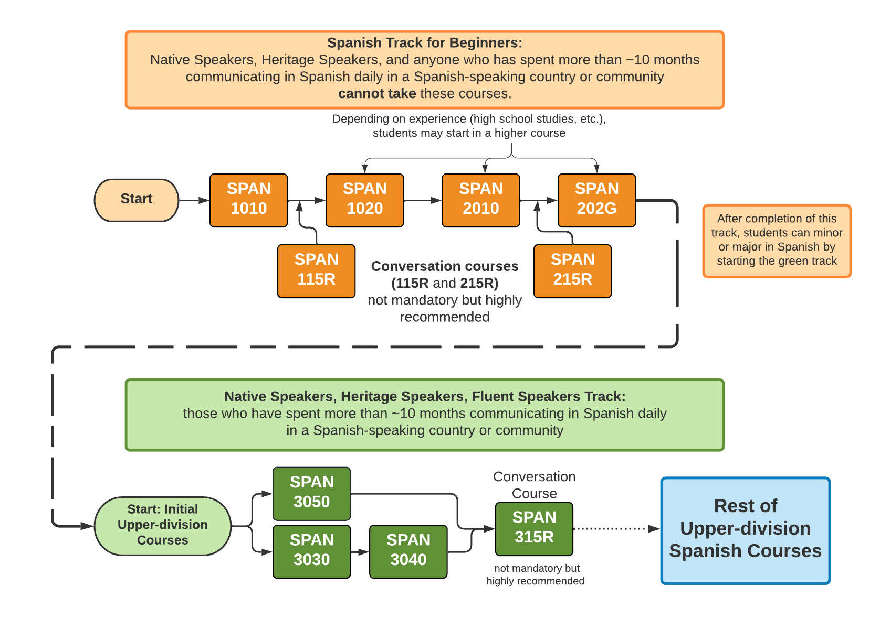
Course materials: 1. Vistas, sixth edition (Blanco, Dellinger, Donley, and García).2 Workbook, answer key and CDs. 3. Spanish-English Dictionary
Course Description: Reviews and builds upon the grammar, reading, writing, and conversation skills learned in the first year courses. Introduces readings and discussions on the history, culture, and literature of the Spanish speaking world, maintaining a focus on oral proficiency. Lab access fee of $10 applies.
Course Objectives: Upon successful completion, students should be able to: (ACTFL LEVELS)
1 | Communicate in spoken and written conversations at the Intermediate Mid proficiency level.
2 | Express feelings or opinions on a given topic at intermediate Mid proficiency level.
3 | Present information orally and in writing at intermediate Mid proficiency level.
4 | Summarize the main idea in informational and fictional texts that are spoken and written at intermediate Mid proficiency level.
5 | Produce aspects of Spanish grammar at intermediate Mid proficiency level.
6 | Recognize aspects of the Spanish cultural heritage, society and everyday life.

Evaluation:
1. Participation (includes in-class oral participation, attendance) 15%
2. Homework 15%
3. Unit exams (5), Final, and Assessment 30%
4. Oral Interviews 15%
6. Composition 10%
7. Group Presentation 10%
8. Conversation Groups 5%
Participation and attendance: You are required to attend class every day. Your instructor will keep roll and at the end of the day, assess your participation in class and assign a daily grade. The participation grade will be based on student attitude, effort, and the quality of involvement in class. Speaking IN SPANISH throughout the class is essential to good participation. You can improve your daily class work grade by 1) coming to class prepared and ready to participate on a regular basis; and 2) consistently interacting in Spanish with your instructor and classmates.
Homework: Written assignments will generally come from the textbook and workbook. Each time you take an exam, you will be required to complete and hand in the corresponding workbook chapter.
Composition: You will write a composition which will require ‘several drafts’ and a final version. All the drafts and final version will be written in class. The final version must be turned in with the other drafts. Organization and grammar are very important. The feedback you received on the drafts will concern principally the content and organization of the composition. The final draft will be evaluated with more attention to the smaller details as well as to the content and organization.
Unit exams: These exams will each cover the material from the chapter studied. Exams may include vocabulary, composition, grammar, listening and reading comprehension sections.
Oral interview: You will have three oral interviews (brief conversation with the instructor) in which the instructor will evaluate your ability to understand and communicate as well as the correct use of grammar, vocabulary and pronunciation.
Group Presentation: Each group will give one in class presentation about a country assigned by the instructor in which the students will cover cultural aspects of the country such as: music, food, people, geography, tourism, customs etc. The presentation will last between 15-20 minutes. The instructor will consider the appropriate use of language and grammar, visual aids (posters, pictures, videos) and additional material presented by the students such as food, clothing etc. (related to the country being presented).
Conversation Groups: Speaking is an important skill, but sometimes can be intimidating for nonnative speakers. For that reason, we will have group work in the classroom every other Thursday for about 25 minutes. The class will be divided in small groups where the students will have to speak about the topic of ‘contextos’ of each chapter, or about a topic assigned by the instructor. Students will receive points for their participation in these activities.
Grading scale.
A = 100-94 B = 86-83 C = 74-70 D=62-60
A- = 93-90 B- = 82-80 C- = 69-67 F=59 and below
B+ = 89-87 C+ = 79-75 D+=66-63
LEARNING TECHNIQUES: Successful foreign language learning requires daily class attendance and participation and consistent study (as opposed to occasional cramming). Here are some recommendations that will help you succeed in this course:
* Memorize and review vocabulary, conjugations, and grammatical structures. Just completing assigned homework is not sufficient to learn course material.
* Keep a list of new vocabulary in a spiral bound notebook of new words in Spanish and in English. This list should include all new vocabulary from the text, the workbook and from class. Practice this vocabulary daily in the following progressive order: recall meaning of word in English, recall word orally in Spanish, practice writing the word in Spanish.
* Speak exclusively in Spanish during class.
* Use resources available to you: instructor’s office hours, tutors in the Language Lab GC 104, dictionaries and other aids

SPANISH 2010 SCHEDULE OF ACTIVITIES
UNIDAD # 11
SEMANA 1
Páginas 368, 369, 370
SEMANA 2
Páginas 372, 373-Fotonovela-Conversar sobre el episodio.
SEMANA 3
Páginas 378, 379, 380-Grupo de conversación.
SEMANA 4
Páginas 382, 383, 384-Repaso de gramática y vocabulario
SEMANA 5
Páginas 400, 401-Flash Cultura-Repaso Examen Unidad # 11-Grupo de conversación
SEMANA 6
Examen Unidad # 11-Entregar la tarea
UNIDAD # 12
SEMANA 1
Páginas 404, 405, 406.
SEMANA 2
Páginas 408, 409, 414, 415, 416-Fotonovela-Grupo de conversación.
SEMANA 3
Páginas 418, 419, 420-Flash Cultura.
SEMANA 4
Páginas 422, 423, 424, 425-Repaso de gramática-Grupo de conversación
SEMANA 5
Páginas 426, 427, 428, 438, 439
SEMANA 6
Repaso Examen Unidad # 12-Grupo de conversación
SEMANA 7
Examen Unidad # 12-Entregar la tarea.
UNIDAD # 13
SEMANA 1
Páginas 442, 443, 444-Repaso de gramática-Grupo de conversación
SEMANA 2
Páginas 446, 447-Fotonovela
SEMANA 3
Páginas 452, 453, 454-Flash Cultura
SEMANA 4
Páginas 456, 457, 458, 472, 473-Grupo de conversación
SEMANA 5
Páginas -460, 461, 462, 463-Repaso Examen Unidad # 13
SEMANA 6
Examen Unidad # 13-Entregar la tarea.
UNIDAD # 14
SEMANA 1
Páginas 476, 477, 478, 479-Grupo de conversación
SEMANA 2
Páginas 480, 481-Fotonovela-486, 487, 488
SEMANA 3
Páginas 490, 491, 492-Flash Cultura-Grupo de conversación
SEMANA 4
Páginas 493, 494, 495-Repaso de gramática
SEMANA 5
Entrevista Oral # 1
SEMANA 6
504, 505-Repaso examen Unidad # 14
SEMANA 7
Examen Unidad # 14-Entregar la tarea
ACTIVIDADES DE ESCRITURA-CONVERSACIÓN-AUDITIVAS
SEMANA 1
Presentación Grupo # 1: Costa Rica-Hablar de la presentación
SEMANA 2
Repaso Entrevista oral # 1- Grupo de conversación
SEMANA 3
Entrevista Oral # 2
SEMANA 4
Primer borrador de la composición (en clase):Vas a visitar a tu amigo que vive en… (elige tú el lugar). Dile que actividades quieres hacer y que lugares visitar (usa el tiempo presente). Luego debes recomendarle o sugerirle otras actividades y lugares para visitar, puedes agregar con quién, dónde, cuándo etc. (usa el presente del subjuntivo) Escribe una página
SEMANA 5
Repaso de gramática-Grupo de conversación.
SEMANA 6
Versión Final de la composición
SEMANA 7
Presentación Grupo # 2: Honduras-Hablar de la presentación
SEMANA 8
Repaso de gramática y vocabulario de unidades 11 a 14 como preparación para el Assessment-Grupo de conversación
SEMANA 9
Presentación Grupo # 3: Chile-Hablar de la presentación
SEMANA 10

Repaso de las secciones Panorama Cultural de Unidades 11 a 14 como preparación para el Assessment
SEMANA 11
Presentación Grupo # 4: Cuba-Hablar de la presentación-Repaso de gramática como preparación para el Assessment
SEMANA 12
Entrevista Oral # 3

