- Completions
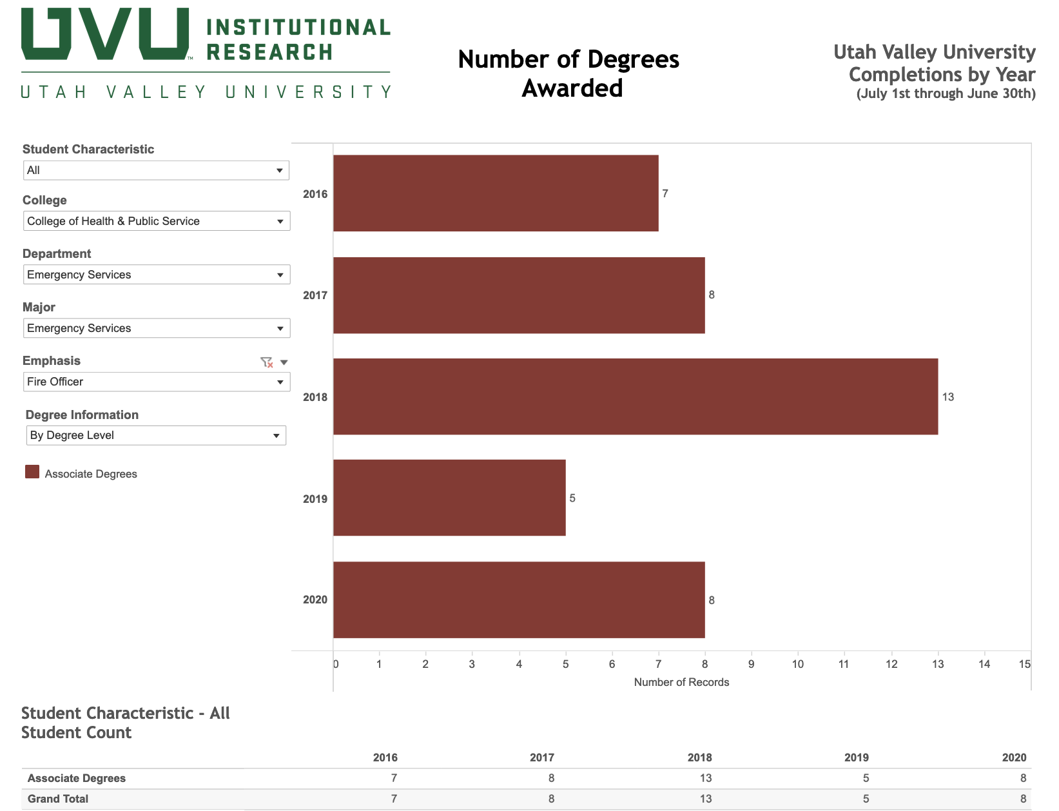
2. Enrollment in Fire Officer Courses
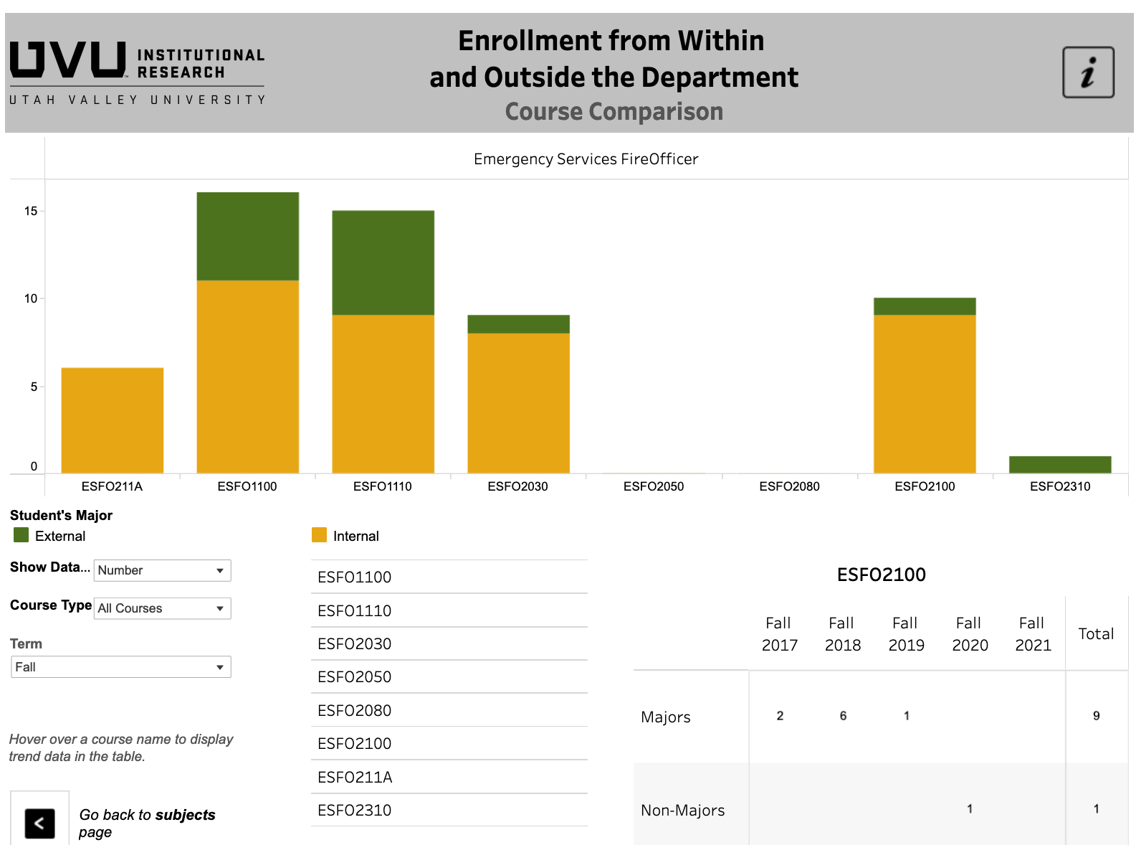
3.Employment – Alumni Survey (2020)
Full time Employment – 100%

