**Faculty Senate Minutes**

March 24, 2015

LC 243, 3:00-5:00 pm

***Present***: Scott Abbott, Christa Albrecht-Crane, Jon Anderson, Anne Arendt, Deborah Baird, Nicholas Ball, Howard Bezzant, Debanjan Bhattacharjee, Kathy Black, Dean Bohl, Mark Borchelt, Mark Bracken, Clayton Brown, Kat Brown, Monica Campbell, Leo Chan, Marty Clayton, David Connelly, Karen Cushing, Courtney Davis, David Dean, Matthew Draper, Debora Escalante, Wioleta Fedeczko, Doug Gardner, Tracy Golden, Barry Hallsted, Laurie Harrop-Purser, Vance Hillman, Matthew Holland, John Hunt, Yang Huo, Ellis Jensen, Dianne Knight, Dianne McAdams-Jones, Gary Measom, Gary Mercado, David Morin, Tyler Nelson, CheolHwan Oh, Jeff Olson, Dennis Potter, Sheri Rysdam, Makenzie Selland, Leslie Simon, Cyrill Slezak, Allison Swenson, Craig Thulin, Violeta Vasilevska, Mallory Wallin (UVUSA), Alex Yuan

***Excused or Absent***: Kim Abunuwara, Steve Allred, Joel Bradford, Carolyn Howard, Ryan Leick

***Guests:***

Call to order – 3:05 p.m.

Approval of Minutes from March 10, 2015. Minutes approved.

President

* Legislative session has just finished. The Legislature allowed us to begin the planning and design phase for the Arts Building.
* They also approved a 2% compensation adjustment for higher education. The language received is confusing between pay for performance and COLA. UVU’s plans are to issue a 2% compensation adjustment for all employees across the university. Due to 1st tier tuition adjustment and benefits, there are some additional monies we can use for targeted equity and retention issues, but only for faculty rank and promotion. There is no money this year for merit pay, but will continue the conversation next year so we can be ready for it.

UVUSA

* New Executive Council was elected a few weeks ago and are in the process of selecting their new council.
* TEDx is April 1. Full day conference with four sessions designed to attend all or individual sessions. Will be offering free overflow for students in the new classroom building auditorium. Will not be streamed live on the website, but will be available after the event.

Miscellaneous

* Students have expressed unhappiness about spring break being so late. President indicated nothing can be done this year, but can be opened up for conversation in the future. Anderson would like to open the discussion about the Thanksgiving break and reduce it again to just three days. Holland noted that the

academic calendar has always been an extensive discussion. Wallin noted that UVUSA has received many comments regarding the break and that students do not want it late. Discussion regarding K-12 spring break has been a part of the overall discussions, but not driving the final decision. Wallin expressed the pros of student government’s decision. Connelly proposed moving spring break so that it falls in the month of March. All in Favor? 6 Opposed. 2 Abstentions. Motion passed.

* Need more changing tables for infants in all restrooms.
* Need more unisex restrooms on campus.
* Extreme frustration over the recent moves to the new classroom building and the lack of communication overall. Holland did recognize that there was a breakdown between AA and Facilities. Borchelt said there was a lack of communication among students as well.
* Restrooms are reversed in the new classroom building at each end of the building. Be careful.

USHE Faculty Senate Presidents Meeting Update

* Last fall there was an incident at Utah State regarding a gun issue and not having a speaker. They would like to survey the USHE system. The University of Utah has said they will not participate in the survey and opposes it completely. The survey is coming out of Utah State and it is essentially to find out if faculty is aware of gun policies in the state as they relate to campuses. What they want to couch it as is would there be any appetite for changing legislative actions with regards to guns on campus. Utah State met with CAOs earlier in the year and result was they are not opposed if faculty wants to participate, but not from the CAOs. Since the U decided they were not going to participate, Utah State then pulled out and left everyone else hanging. Discussion occurred, but no decision was made.
* Shared Governance
  + Shared Governance at the University of Utah – Conducted a survey a few years ago and the general findings were that 75% of all work of shared governance was being done by 75 faculty members.
  + Dixie – The best solution for shared governance is committee ownership in terms of membership of the standing committees. In other words, who is populating the committees?
  + University of Utah – The have a policy liaison (current faculty member) that handles drafting of policy that deals with faculty issues. This individual is an agreed upon person between the faculty and administration. They also have special appointments for special projects.
* Approaches to Policy Changes – no discussion occurred.
* Evaluation of Administrators (Deans, AVPs, VPs, and President by the Faculty)
  + SUU does have a policy, but not done well and results have rarely been published publicly as stated.
  + USU concluded negotiation with the new Provost and has agreed, not in policy, but feels it appropriate to start the process of evaluation. Evaluations will be made public. Great way to head off votes of no confidence.
  + Snow is talking and feels they will have something within the year.
  + University of Utah – All authority resides at the level of the dean and no evaluation is done or anticipated in the future.
* Post-Tenure Review
  + The U is the only one that really wants any teeth. They use a very rigorous five-year review which is the submission of a full portfolio based on department criteria. The question for them still is what happens when you fail. Still determining whether it is termination or probation.
  + USU has a trigger mechanism. The trigger is that one bad annual review triggers a portfolio review.
  + Snow is using similar trigger mechanism at USU.
* Termination of Tenured Faculty
  + Dixie– Case currently dealing with a faculty member being terminated for pedagogical issues.
* Faculty Role in Merit Pay Decisions
  + Will address in merit discussion.

Constitution

* Has been through all campus entities and submitted comments. UVUSA and PACE provided basic comments. Faculty Senate will recognize departments as those recognized officially by the state. AAC had questions over the term limits. The Executive Committee felt it was better to not limit the term limits as it can be accomplished by vote or limited to their term of service on the senate.
* Ratification Language – In Section 5.8.2, Connelly feels this language is problematic. He believes what Faculty Senate is talking about in terms of amendments to the Constitution has to go through the policy process. The Faculty Senate cannot just change the Constitution. Proposed including limitation on the front end for faculty senate discussion on how the policy can be opened for revision. Connelly will draft language.
* Proportional Representation – Current proposal is every department gets one senator and when the department reaches 20 faculty members they will pick up an additional senator. Discussed pros and cons of changing the number of department faculty from 20 to 25 before adding an additional senator. See attachment. Discussion regarding size of the Faculty Senate. Potter noted need to think about what principles we are using. Black noted that senate is an advisory board and not sure we really need more than one person to express the department’s view. Potter noted that when voting on senate matters, three votes are better than one. Abbott noted that senators/faculty members do work and serve on ad hoc committees. Connelly shared that he would rather have more standing committees doing work rather than ad hoc committees.

**MOTION** – Bracken motioned that we leave the faculty number at 20 to receive an additional faculty representative on the senate. Abbott seconded. Albrecht-Crane expressed it is advantageous for the senate to have more voting participation when voting on a recommendation. Bohl expressed his feelings about representation because smaller departments might be lost in the shuffle. All in favor? 2 Opposed. 9 Abstentions. Motion passed.

* Presidential Election Process – New proposed Constitution calls for an internal election by the sitting faculty senate. Do we want to modify it back to some form of the previous election process? Gardner noted his department wants to have a voice by all faculty. Bracken noted that his department wanted to be able to elect the president as they felt that senators electing the President take away from their choice. They want a general vote of the faculty. Bezzant noted his department will stay status quo. Potter indicated that whatever direction we go to not have the petition requirement. Draper noted that his department trusts the senate to make the decision. Education noted it is split. Developmental Math said it is split.

**MOTION** – Measom motioned to amend the proposed constitution to nominate the president by the faculty senate and hold a general election from faculty. Connelly will add language to include “with the stipulation of previous senate service or current service OR as long as they are qualified.” Bezzant seconded. Gardner indicated that if the senate has the opportunity to vet the candidates his department would probably support. Connelly clarified the current election process as it is in the proposed revision of the constitution. Clayton Brown expressed concern that their department may not want to elect them as a senator which means they could not run under the current version. Amendment – change to read “Nominations for senate president will be made by currently sitting members of the senate and then hold a general election from faculty.” Measom agreed to Potter’s amendment. All in favor? 3 Opposed. 5 Abstentions. Motion passed.

* Bracken motioned that the senate president must be elected by the voting majority. Recommendation was to move this election procedure to the bylaws. It was proposed to move the final nominations to the end of fall semester with the vote to occur in January.
* Faculty Committee Work – Question is who puts faculty on university committees. Two types: 1) standing committees of the senate, and 2) all other standing committees of UVU. Question becomes when a faculty member needs to be selected for a committee, who is doing this task. Selection for faculty to populate those committees should be done from the senate and not from someone just selecting. When a faculty member is asked to serve, it is done by a faculty mechanism to serve, not because they’ve been asked by someone else to serve. Connelly provided an example of GE which is a standing committee of the university, but faculty are not selected by the senate. If we are to take service seriously, then faculty should have the ability to serve on the committees they desire. Connelly will include language about ad hoc committees following the same process of obtaining faculty. Olson noted that one of the biggest problems at UVU is the question of legitimacy. This proposed process will address this issue. Need to determine who the legitimate faculty representative(s) is(are) serving on the committee.

**MOTION** – Anderson motioned to extend senate time by five minutes. Abbott seconded. All in favor? Motion passed.

* Council on Admission, Graduation, and Academic Standards (CAGAS) – Committee that oversees academic standards. AA has had no oversight regarding student academic issues as they have been handled by Student Affairs. Faculty Senate is not trying to take over the process, but would be a body that has a role in academic decisions. Proposal is to create a body to address this issue. Anderson noted that the committee has only dealt with admissions issues. He feels the committee needs to be involved in decision-making.
* Connelly will present the Constitution to President’s Council and request approval to move into Stage 3.
* Bezzant motioned to adjourn at 5:08 p.m.

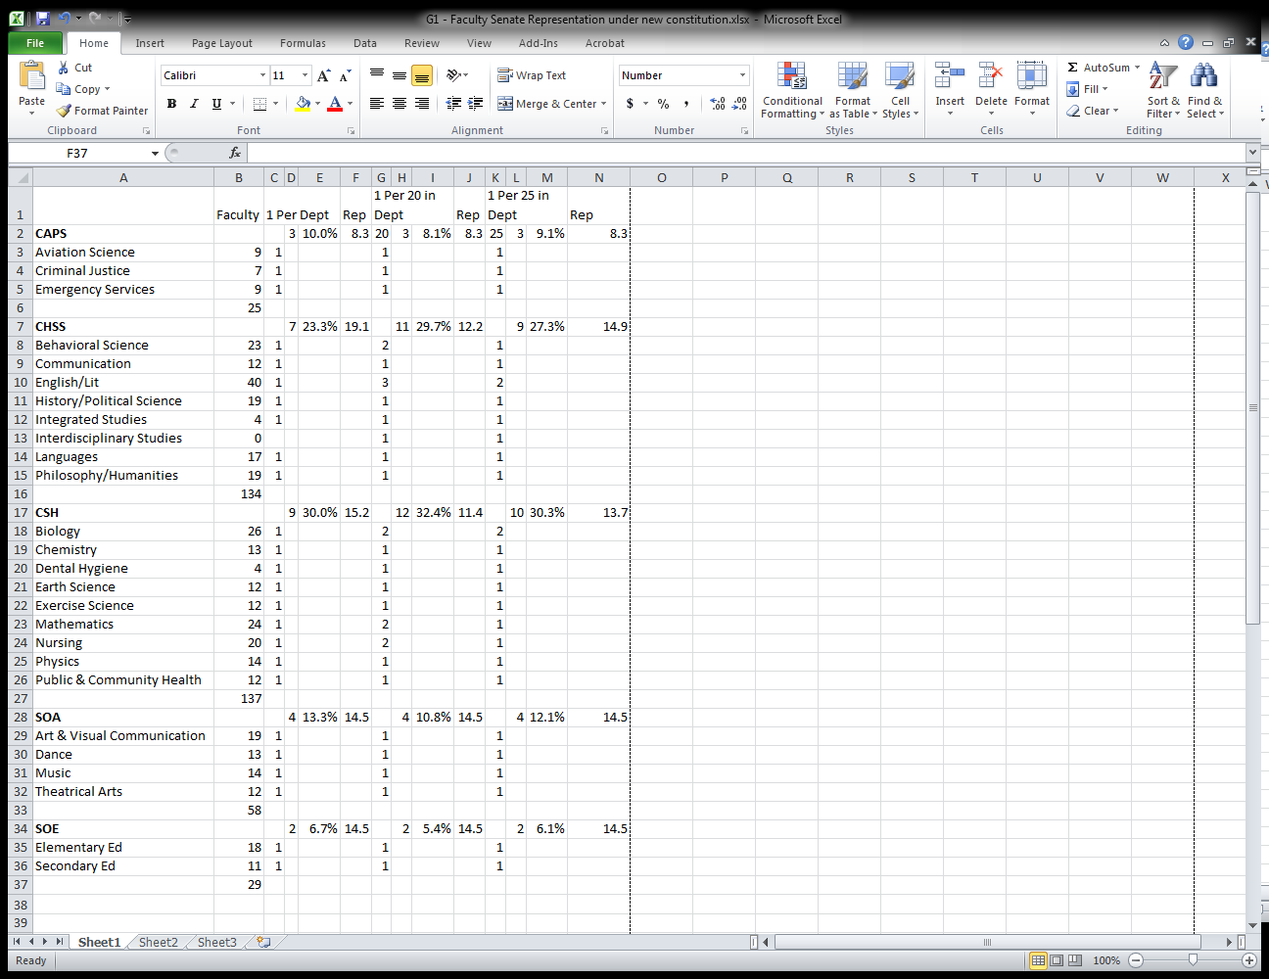

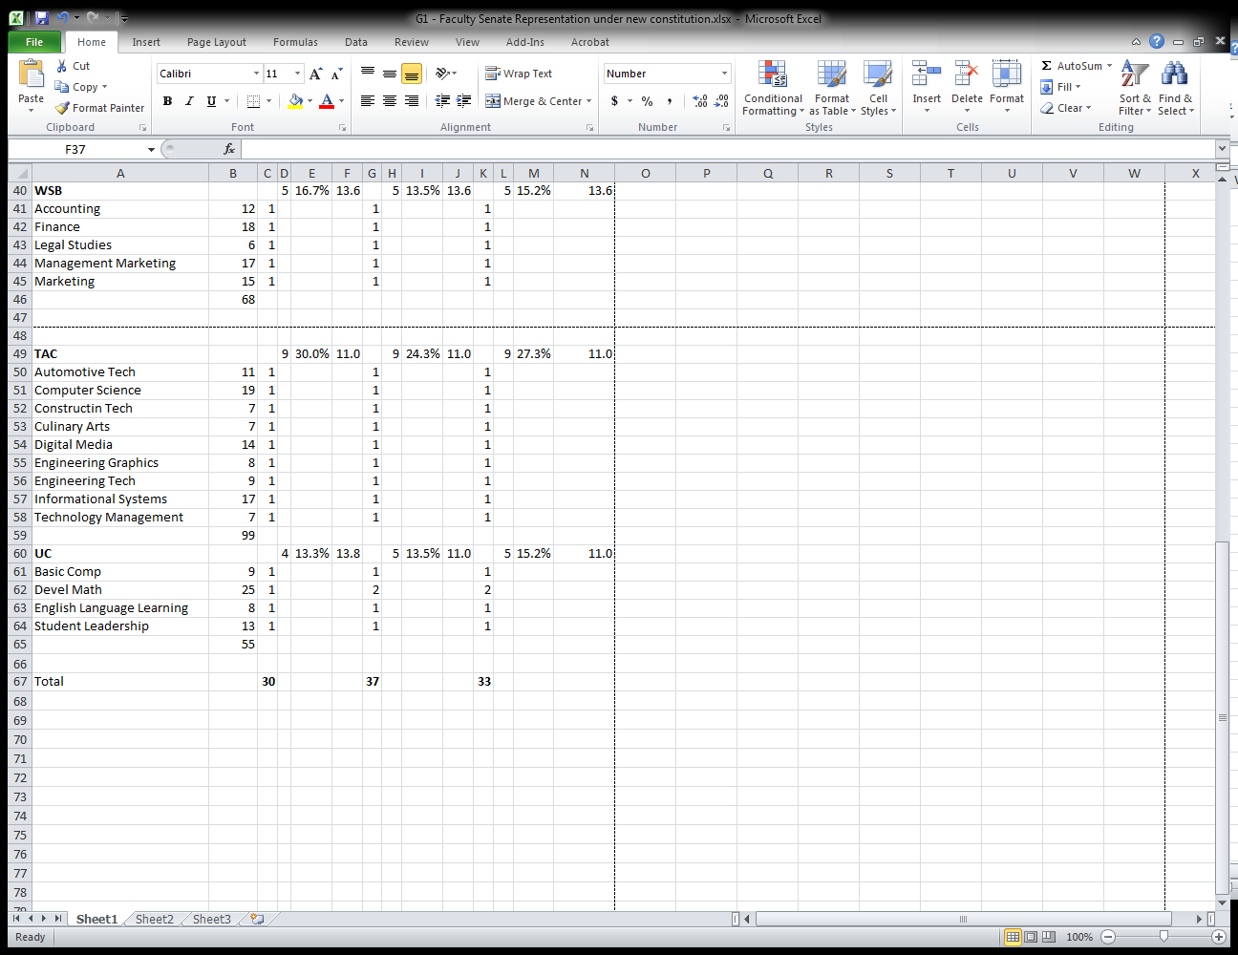

**Council on Admission, Graduation, and Academic Standards (CAGAS)**

The Council on Admission, Graduation, and Academic Standards (CAGAS) is a Faculty Senate council responsible for recommending and evaluating policies concerning admission, retention, graduation, and academic standards and for establishing some of the procedures to carry out such policies. It also serves as an appellate body regarding such policies and procedures. CAGAS (ten faculty and two student members) meets weekly during fall and spring semesters, as well as several times during the summer.

CAGAS has the charge of overseeing academic standards and graduation requirements. Most of the council's activities involve handling individual cases (appeals) and approving policy and procedures. Often subcommittees are formed to provide recommendations for the full council's consideration. Members are expected to vote on cases and policy that would include the following:

* General Education: Total hours; hours in one area or areas of gen. ed.; distribution requirements
* Course Enrollment: Late adds; late withdrawals
* Hour Requirements: Overall hour requirements; hour requirements for majors and minors; degree residency requirement; junior college transfers; 300/400 level courses
* Grades: GPA; pass/fail grading; audit
* Substitution of courses
* Junior College credit for upper-division courses
* Falsification of records
* Grade changes
* Honor point deficiency
* Admission; suspension; dismissal
* Additional academic requirements

Ex-Officio Members

* Advisor
* Registrar
* Student Affairs
* Admissions
* SVPAA Rep.
* Handles approval of University sanctioned events for students missing class- faculty bring proposal forward
* Handles all Grade appeals not resolved at the department level
* Late Withdrawal appeals

Chair usually has at least one course release per semester- sometimes more

Committee usually has some level of support staff- cases are complex and time intensive