**Faculty Senate Executive Council Minutes**

Oct. 4, 2022

Via Microsoft Teams, 3:00-5:00 pm

***Present:*** Hilary Hungerford, Ben Moulton, David Frame, Dianne McAdams-Jones, Jaden Muir, John Hunt, Jon Anderson, Jonathan Allred, Laura Ricaldi, Sam Gedeborg, Sandie Waters, Skyler Simmons, Wayne Vaught, Wioleta Fedeczko

***Excused or Absent:***

***Guests:*** Evelyn Porter

Call to order – Hilary Hungerford called at 3:00 pm

**PROVOST**

**Wayne Vaught & Evelyn Porter**

* There are lots of questions about what RUEC is doing and what are their recommendations and how they are being implemented. This early on, it gives an opportunity for people to think and ask questions. We had a kickoff for the General Education task force that went well. We had a hopes and fears session as well. Fears: will this be different from before? The Task Force will meet again this week to get the ball rolling. There is a website to be as transparent as possible.
* The slide below shows the six questions we are trying to consider and the proposed options that are jump off points. There isn’t a lot of room to play around with because we are not interested in pressuring the state to change to R470. We’ve started to address questions 1-6 and search out big ideas as ways people could see this going. It’s been 40 years so it’s time to take a look at the GE and see if we are doing what’s best for this generation of students.
  + Comment: Reiterate the importance of digital literacy. Keep this at the forefront of your minds while you go over this. This means how to be an appropriate digital citizen, how to utilize digital technology in the job force, etc. There are so many aspects to this.
* There is a website that is being maintained so you can see all the same presentations the GE Review Committee are getting.

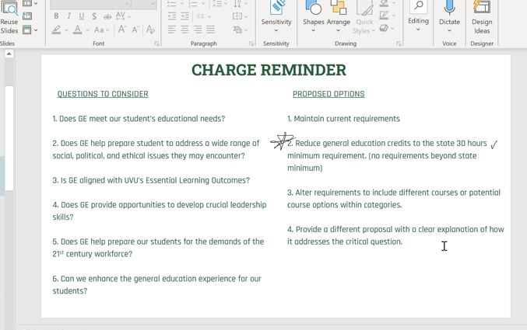

* Question: With the second question on screen, the state has 30 hours of GE and we are looking at reducing it?
  + Evelyn: We are looking at dropping down to the state minimum of 30 and not require anything else (UVU currently requires 35).
  + Wayne: SUU is just 30 hrs. One option is to reduce it, another option to increase it. We can go up to 39 hours, but this isn’t as popular.
  + Jaden Muir (from a student perspective): I’m for it, though there are pros and cons. Cons: giving five hours back to the college because not every college has their degrees equal. On the other hand, this will provide more options for students. More intentional and purposeful generals would be a pro as well.
  + David Frame: I second the idea of reducing general education credits. We are constantly being asked to add more skills and more technology and we don’t have the hours. We would make good use of it.
  + Wioleta Fedeczko: We need to make use of these credits to help students graduate in a timely manner. We are worried that some departments will add on extras which will delay graduation.
  + Evelyn: the committee is concerned about this too. There are currently higher-level courses required for graduation that are taught every other year. We don’t want to create barriers for students.
  + Question: What happens to the faculty of the GE classes that go away as GEs?
    - Evelyn: We have to look at the impact once the decision is made and work with the institution and the administration and find the right way to go about them. We don’t see the institution walking in and saying they need to fire anyone; it treats people better than that.
    - Wayne: we need to be cognitive of this. We need to have a curriculum that meets the needs of our students. The downstream impact is something we need a robust plan to address, maybe a phased-in process. Every one of our schools that can come up with an ethical component to fulfill the ethics will be a GE. The disruption may actually be quite minimal. We want to deal with this in an ethically responsible way. Could the third science be expanded to be more inclusive of digital technologies? This may create problems for adjuncts, but for tenured faculty, we need to find something for them to do. Let’s not become too absorbed. We will do what we can to protect our faculty. Focus more on the content.
* Evelyn: A common theme in the survey data is to open a third science to allow more technology or even engineering. The plan for Senate is to introduce the committee and what the scope of the committee is and list the data that they’ve looked at, then leave it open for questions.
* Question: With CARES going away, do you have a plan to replace it?
  + Wayne: We will get money out of performance-based funding and my office also has some one-time funding that we can pull from.
  + Sam Gedeborg: Wayne and the University have invested close to 3 million dollars and now he has 1 million for all of these needs. We are working with Kat Brown to have these certifications recognized in the transcript to put into your RTP. We won’t be able to pay faculty to go through the certifications though.

**STUDENT REPRESENTATIVE**

* We are working with the Scholarship Office to do an event to show how it works, including nvolvement opportunities that provide scholarships. We are hoping to train people on this in two weeks.
* We are starting to get students reaching out with a lot of frustration/questions of things in policy that faculty aren’t doing (posting grades on canvas, cancelling classes without notice, etc.). We would like training and support from ExCo on the best way to handle this.
  + Question Ben Moulton: Provost Vaught, can you get word out to faculty to remind them about policy?
* Question Sandie Waters: What we can do as faculty to help get word out to students and help them remove the stigma/shame from getting help?
* Jaden would love to talk to Sandie about initiatives to really help students.

**FACULTY SENATE PRESIDENT**

* Hilary will be sending out an email to all the faculty soon. She will be reminding them to post grades on canvas and also of the policy in regards to cancelling classes.

**STANDING COMMITTEES**

* Special Assignments & Investigations: Laura Ricaldi: Compensation Committee: We are working on this and I will have more information at the next meeting.
* Hilary: SUU cost of living allowance from last year—they just figured out how much money it was going to be and divided it evenly between all employees. This could be something we could advocate for in the future. We should partner with PACE in this.
  + Laura will take this back to the committee
* Service & Elections: No updates
* Curriculum: Ben Moulton: We are currently running into a situation with one of our minors, Digital Media. According to policy 522, at least 50% of the classes need to be 3000 level or above for a minor. A lot of these courses need to be lower than 3000 level because there are so many nuances that need to be in place. By the time they get to the 3000 levels, they are far over for their minors. We are working with others to try and get around this.
  + Skyler Simmons: 525 is a currently an open policy that is in the drafting and revision stage. It’s something we are actively pursuing on the policy side. We are getting the right people involved quickly so we don’t have to wait another four years.
  + Hilary: Why not an associate or a certificate instead of a minor? You need to check USHE policy too.
* Retention, Tenure, Promotions & Appeals: John Hunt had to leave early and will provide an update next time.
* Advancement of Teaching: Jonathan Allred:
  + Flexible Learning Council wants the committee to look at rubric revisions. Should we bring this to Faculty Senate?
    - Jon Anderson: Make sure to put it to what end? Do you want the backing of Senate? If it’s just to say we are updating it to make you aware, this shouldn’t come in as a conversation point.
      * Jonathan Allred will email Seth to find out to what end.
* FEA awards are open. We have all but School of the Arts working on this diligently. We are working with them to find another chair right now.

**SENATE AGENDA**

* We have bylaws to elect the new faculty senate president this semester so there will be an overlap. We need to determine when the election should be.
* General Education Updates: Christina Baum. She really wants to hear our feedback.
* Dianne McAdams-Jones: On behalf of SCULPT, we need to get graduation on the Senate Agenda.
  + Five minutes will be allocated for this.
* Debating Remote Work Policy: Hilary invited Drew Burke. Most other universities in the state do not require their faculty to sign a remote work agreement.
* Drug Policy: Hilary met with Drew Burke and James Duncan and invited them to come back and talk to faculty about it and the changes they have made.
* Discussion on policy 332

**GOOD OF THE ORDER**:

* Hilary: I discovered a new Dorito’s flavor: Spicy Sweet Chili
* Wioleta: IT Services are amazing! They had a person to my office in 45 seconds to fix a problem. They also fixed another problem at the same time. Faculty are getting the support they need.
* David Frame: Fall Break is next week.
* Jaden: I appreciate the professors trying to get to know me in my in-person classes.

Session adjourned at 4:50 pm