**LARGE-CAPACITY PASSENGER VEHICLE SAFETY PROTOCOLS**

1. **Purpose & Definition**. This document is intended to provide standards for the safe use of any State-Risk-Management-insured vehicle that is designed to carry 12 or more passengers (hereinafter referred to as “large capacity passenger vehicle” or “LCPV”).
2. **Expectations**. All prospective drivers are expected to read and sign this document biennially, and before they are permitted to operate any LCPV.
3. **Age and License Requirements**. All LCPV drivers must verify that they meet the following minimum standards:
   1. Drivers who are 21 years of age or older may have no more than 70 points on their driving record and may have no reckless driving or drug/alcohol related violations with the previous three (3) years;
4. **Experience/Training**. No one may operate an LCPV without having completed a State-Risk-Management-approved training, including Large Passenger Van Training. All LCPV drivers should also complete a Large Passenger Van refresher training every two years.
5. **Vehicle Familiarity**. Before operating any LCPV, all drivers must ensure they are familiar with the location, purpose, and operation of the following functions: windshield wipers; headlights; turn signals; hazard lights; cruise control; warning lights; and other operational switches/dials.
6. **Inspection Protocols**. All LCPV drivers must inspect their vehicles before each trip.
7. **Safety Rules**. All drivers must comply with the following standards while operating an LCPV:
   1. Every passenger must be properly seat-belted at all times;
   2. The use of cell phones and other electronic devices is prohibited;
   3. Distractions, such as eating, drinking, and other non-driving activities must be avoided;
   4. Baggage cargo should be stored in front of the rear wheels;
   5. No baggage cargo should be placed on the roof of the vehicle;
   6. Never operate a vehicle when impaired by alcohol, illegal drugs, prescription drugs, or non-prescription drugs;
   7. Never engage the cruise control on slick roads;
   8. Total driving time must not exceed 12 hours in a 24-hour period;
   9. Never exceed the posted speed limit and reduce speed appropriately for weather conditions and other hazards;
   10. During longer trips, take a break every two hours and rotate drivers whenever possible;
   11. Never drive between 11:00 p.m. and 5:00 a.m., unless you are returning to your home base and the return time will not exceed one (1) hour; and
   12. Always adhere to applicable state and local laws, rules, and regulations.
8. **Sprinter-Type Seating Capacity and Towing**. Late model LCPVs, such as the Ford Transit, Nissan NV, and Mercedes/Freightliner Sprinter, depicted immediately below, may never exceed the manufacturer’s specified passenger count and weight capacity. Additionally, all insureds must strictly adhere to manufacturer specifications with regard to towing capacity and trailer tongue weight.1

 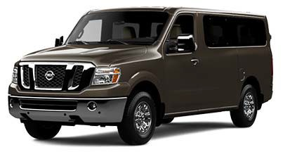 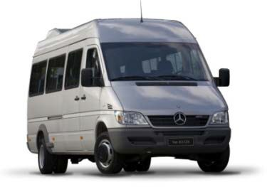

1. **Other LCPV Seating Capacity and Towing**. Notwithstanding manufacturers’ recommendations to the contrary, the LCPVs depicted immediately below may not be used to carry more than nine (9) occupants, including the driver, due to their propensity to roll over. These vehicles should never be used for towing.

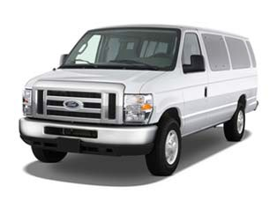 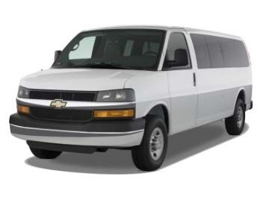 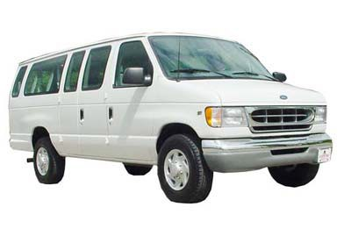

**I have read the foregoing instructions, affirm that I am trained and qualified to operate an LCPV, and agree to abide by all of the protocols listed above.**

Date:

Signature:_ Printed Name: Department: Division:

1 Based upon current information, these vehicles, manufactured after 2012, appear to be relatively stable and less susceptible to a rollover accident, in part because they are equipped with electronic stability controls. State Risk Management may revise this protocol upon the receipt of scientific data indicating that these vehicles present significant risks to passengers.

