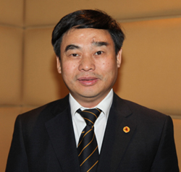

Ambassador Ho Xuan Son
Consul General of Vietnam
San Francisco

Career:
- Ambassador Son was appointed by Deputy Prime Minister, Minister of Foreign Affairs, H.E. Pham Binh Minh as Consul General of Vietnam in San Francisco in March 2016.
- From January 2011 to January 2016, he served as a member of the 11th Central Committee of the Communist Party of Viet Nam.
- He was appointed as Vice Minister of Foreign Affairs of Viet Nam in July 2008, and then First Vice Minister of Foreign Affairs and Chairman of the National Boundary Commission, Ministry of Foreign Affairs of Viet Nam.
- Ambassador Son joined the Foreign Service in 1978. He has served in many important positions, built up profound experience in bilateral diplomacy, particularly with partners in Northeast Asia.

Awards and honors:
In his diplomatic career, Ambassador Ho Xuan Son has been conferred with many awards of high distinction, namely the Third Class Labor Order in 2011 for outstanding contribution in the delimitation and demarcation of land border between Viet Nam and China, contributing to the cause of socialism building and national safeguarding; the Prime Minister’s Certificate of Merit in 2014 for important contribution to realizing political policy tasks in 2012 and 2013, contributing to the cause of socialism building and national safeguarding; and the Prime Minister’s Certificate of Merit in 2012 for excellent performance, contributing to the cause of socialism building and national safeguarding.

Personal: He was born in 1956 in Quang Tri. He is married and has two children.
Education: He graduated in 1978 from Peking University. He is fluent in both Chinese and English.

