## 

## Out of Office Guide

## Information on setting your phone options to receive or redirect messages while you are away

**Option 1**

**FORWARDING:** forward your phone by dialing *609(phone#). Dial *64 when you return to cancel the forward. If you need to forward your phone, and you’re not in your office then email telephone (at) uvu.edu and we’ll do it for you. When you forward calls from your desk phone, the caller ID will show 801-863-8000 on all of the calls since it hits the university phone system first.

**Option 2**

**CHECK VOICEMAIL REMOTELY:** Continue allowing callers to leave you messages on your desk phone, and you can listen to them via the link in the email you receive. *\*this option does not work with iPads\**

**Option 3**

**RECORD A GREETING WITH ALTERNATIVE CONTACT INFORMATION:** instruct callers in your personal greeting on alternative ways to reach you, such as via email or Microsoft Teams.

To record your personal greeting:

**ON CAMPUS** desk phone: use your envelope button to access your own, or **\*9\*** to access any other voicemail (such as a department main number).

**OFF CAMPUS** dial 801-863-4999, then 1 and your extension and password. Option 4 in the menu is to record greetings.

Once you record your greeting, you need to **select** that greeting to play.

Do this with Option 4 and sub-options that match your recorded greeting (personal, alternative one, etc.)

**OR**

Visit [OpenTouch@uvu.edu](mailto:OpenTouch@uvu.edu) and use your UVID (number only, *no domain @uvu.edu)* and your current password. Click on the **Voicemail box** tab and select the greeting you want to play (Activate greeting). Then click **Answer only mode.** This will disable the ability to leave messages to your voicemail and callers will be obliged to contact you in other ways.

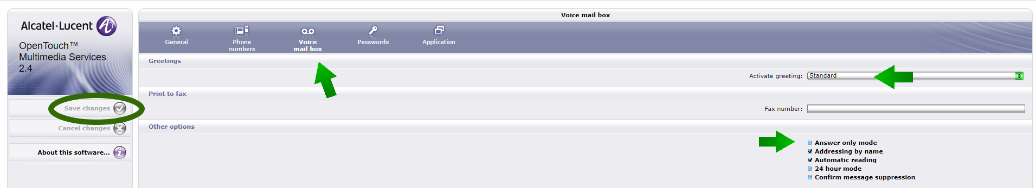

* **Activate greeting:** allows you to toggle between recorded greetings
* **Internal call greeting**: allows you to have different greetings for on campus vs off campus numbers (only available if you are using a personal greeting)
* **Answer only mode:** this will disable the ability to leave messages on your voicemail box
* **Addressing by name:** allows you to find people by name
* **Automatic reading:** jumps straight into new messages instead of playing system options first when checking though the phone option
* **24 hour mode:** switches to military time

**NOTE: Once changes are made, you m*ust SAVE changes by clicking the icon on the left side of the* *screen***