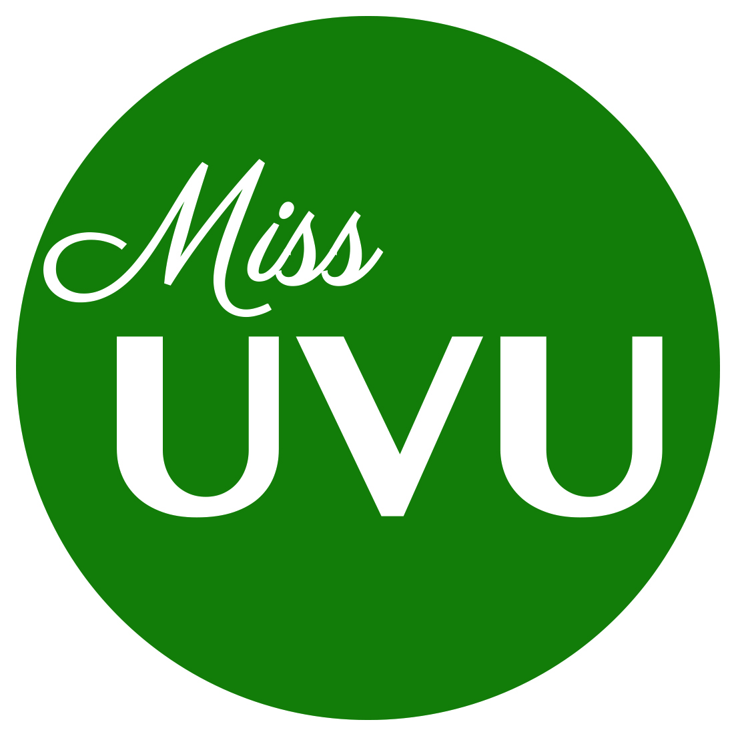

FACT SHEET

Full Name:

Home Town:

Parents:

Scholastic Ambition:

Career Ambition:

Other Accomplishments:

Talent:

Special Training:

Family:

Employment:

Other interesting facts about yourself:

Contestant Signature
Parents Signature (If Under 18)
I understand falsification of any information on this form makes me subject to disqualification. I also give permission to the Miss UVU Pageant to verify information listed above. I have also read, understood and signed the state/local contestant’s contract.

