Account of Professional Practice (APP) for Associate Fellow

Name:
Department:
Assessment Number:

Was there anyone who mentored or assisted you in preparing your application that you would like to recognize:

The account of practice for the HEA award of fellow must demonstrate how the candidate meets the descriptors below as related to the Professional Standards Framework.

Descriptor for Associate Fellow

D.I Successful engagement with at least two of the five Areas of Activity
D.II Successful engagement with appropriate teaching and practices related to these Area of Activity
D.III Appropriate Core Knowledge of at least K1 and K2
D.IV A commitment to appropriate Professional Values in facilitating others’ learning
D.V Relevant professional practices, subject and pedagogical research, and/or scholarship within the above activities
D.VI Successful engagement, where appropriate, in professional development activity related to teaching, learning, and assessment responsibilities

Professional Standards Framework (PSF)

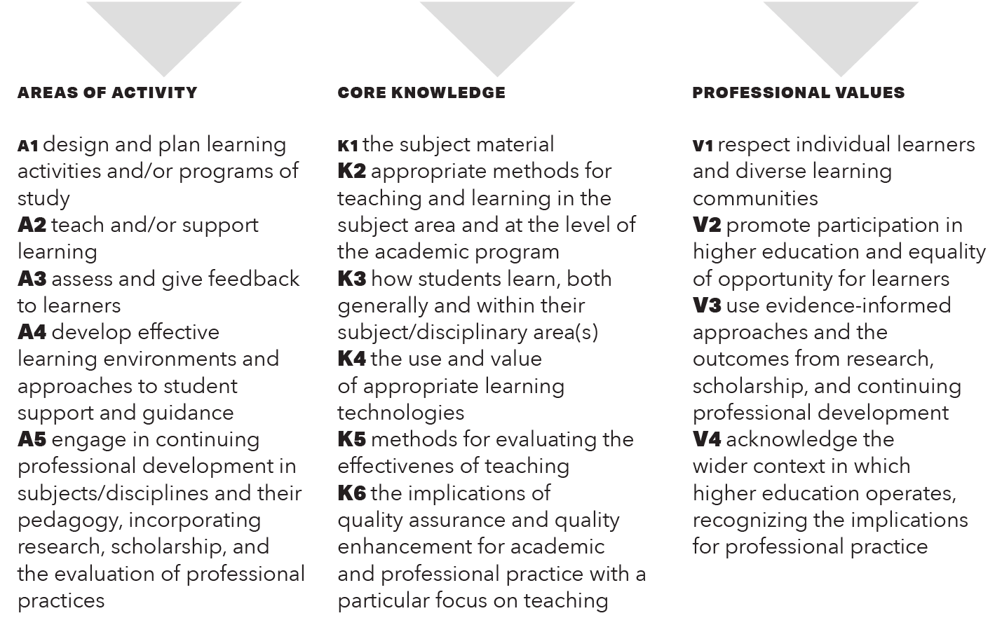
The account of practice consists of four parts. Each part is described in this document.

Part 1: Narrative of Teaching Practice
Part 2: Areas of Activity (OTL Workshops)
Part 3: Reflections and Certificates of Participation
Part 4: Letters of Recommendation

Part 1: Narrative of Teaching Practice

Construct a narrative that provides evidence for how your teaching or professional practice meets the criteria for descriptor for Associate Fellow.

The following questions might be useful in helping you reflect on teaching/supporting learning situations What activities have you planned or designed that have been particularly successful? What did you do? What knowledge did you apply? How did you know the activities were effective?

Reference the framework components as applicable throughout your narrative (e.g., A3, K2, V4, etc.). (Max 1000 words)
Narrative of Teaching Practice

Part 2: Areas of Activity

This section serves as a follow-up on the implementation and evaluation of your learning in your classroom, thereby providing evidence of A5, Continuing Professional Development.

Complete the following record demonstrating continuing professional development related to teaching and supporting learning (see Descriptor for Fellow D. VI and Area of Activity A5 in the Professional Standards Framework). Provide a description of least three OTL workshops you attended, implemented, and evaluated. Or Provide a description of least three modules from Pathway 3 and how implemented and evaluated the changes to your teaching based on Pathway 3 participation. Staff may submit continuing professional development activities they have completed from professional development events in lieu of OTL workshops as long as the event is relevant to their role in supporting teaching, learning, or supporting students. Reference the relevant area of the Professional Standards Framework. (Approximately 300-400 words)

OTL Event | Date(s) | Implementation | Evaluation
E.g.  FlexStudio | 9-12-17  10-9-17 | - Realigned learning activities with objectives in ACCT 1010. (A1)  - Organized online course into modules. (A1) | - Students performed better on quizzes and exam. Average score increased by 5%. (A3)  - Student feedback indicated that Canvas was more organized. (A4)

Part 3: Reflections and Certificate of Participation

Attach the Reflection. Staff may submit Reflections from other professional development events as long as it relates to their role of supporting teaching, learning, or students. Remember the Reflections must be endorsed by the workshop facilitator or an OTL staff member.

Part 4: Recommendations
Complete two reference letters from individuals who can attest to your commitment to the Professional Standards Framework. Blank template to give to your reference writer can be download from the OTL HEA webpage.

Reference 1
Name:
Position:
Email:
In what capacity do you know the applicant:

Evidence for Associate Fellow needs to demonstrate effective approaches to teaching and learning. To award the Associate Fellow of the Higher Education Academy (AFHEA), the applicant needs to meet Descriptor 1. Please refer to the UKPSF for details of the descriptors. Comments about the applicant should be made against the Professional Standards Framework (see below).
Please comment on how the applicant meets the criteria to the best of your knowledge. You are encouraged to show relevance to the different Areas of Activity using shorthand where appropriate (A1, A2, A3, etc.). The applicant needs to demonstrate engagement with at least two Areas of Activity. (About 400 words)

Successful engagement across at least two of the five Areas of Activity

Reference 2
Name:
Position:
Email:
In what capacity do you know the applicant:

Evidence for Associate Fellow needs to demonstrate effective approaches to teaching and learning. To award the Associate Fellow of the Higher Education Academy (AFHEA), the applicant needs to meet Descriptor 1. Please refer to the UKPSF for details of the descriptors. Comments about the applicant should be made against the Professional Standards Framework (see below).
Please comment on how the applicant meets the criteria to the best of your knowledge. You are encouraged to show relevance to the different Areas of Activity using shorthand where appropriate (A1, A2, A3, etc.). The applicant needs to demonstrate engagement with at least two Areas of Activity. (About 400 words)

Successful engagement across at least two of the five Areas of Activity

