UVU’s Teaching Excellence Program and HEA Fellowship Routes

Enhancing and recognizing practice
Participant Handbook 2019-20 Academic Year

Table of Contents
Table of Contents 2
1.0 Welcome to the Teaching Excellence Program! 3
2.0 The Higher Education Academy (HEA) 4
3.0 The Professional Standards Framework (PSF) 5
4.0 Becoming a Fellow of the HEA 6
5.0 Recognition for UVU’s HEA Fellows 12
6.0 Next Steps and Additional Support 12
Appendix 1: Reflection Form 14
Appendix 2: Account of Professional Practice (APP) for Associate Fellow 16
Appendix 3: Associate Fellow Evaluation Rubric to be used by Assessment Team 21
Appendix 4: Account of Professional Practice (APP) for Fellow 23
Appendix 5: Fellow Evaluation Rubric to be used by Assessment Team 28
Appendix 6: Account of Professional Practice (APP) for Senior Fellow 30
Appendix 7: Senior Fellow Evaluation Rubric to be used by Assessment Team 32

1.0 Welcome to the Teaching Excellence Program!
At UVU, teaching excellence is defined as a professional commitment to the intentional, systematic enhancement of teaching practice. The Teaching Excellence Program at UVU provides a framework for engaging in purposeful enhancement activities to improve the student learning experiences. Through this framework, faculty can gain recognition for their commitment to continuous improvement and strengthen the teaching component of their portfolios.

In addition to a wide array of workshops, conferences, and learning circles, the Teaching Excellence Program at UVU offers five formal certifications for which stipends and badges are earned: Global-Intercultural, Teaching Large Classes, Teaching Online, Service Learning, and Writing Enriched (see Figure 1). Several offerings are online and self-paced, and many are hybrid (both face-to-face and online components). The individual development opportunities shown in Figure 1 are advertised on the events page of the Office of Teaching and Learning website: www.uvu.edu/otl/.

Figure 1: Teaching Excellence Program 2018/2019. Five formal teaching certifications are shown in the first five columns. A wide array of additional professional development offerings are highlighted in the right column.

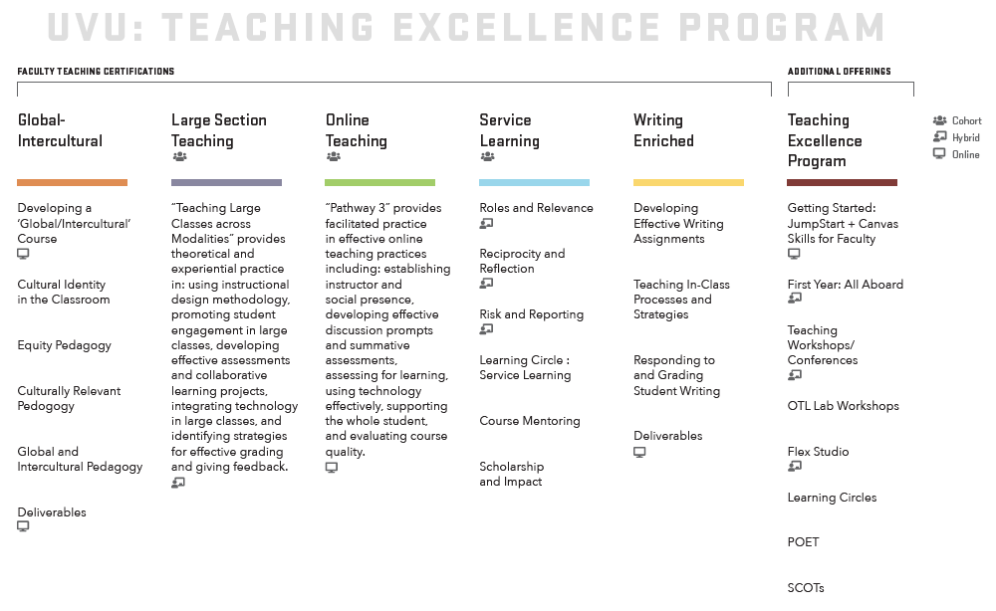

2.0 The Higher Education Academy (HEA)
Faculty and staff who participate in UVU’s Teaching Excellence Program also have the opportunity to gain fellowship within the Higher Education Academy (HEA), an international, non-profit organization that promotes teaching excellence in higher education. The HEA is a subsidiary of the Advance HE organization. Currently, there are more than 120,000 HEA Fellows worldwide (www.heacademy.ac.uk). The HEA partners with individuals and institutions to support student success in higher education. A key way in which the HEA provides support is through professional recognition (awarding of fellowships) of those who teach or support learning in higher education.

UVU is accredited by the HEA to award three categories of HEA fellowship, Associate Fellow (AFHEA), Fellow (FHEA), and Senior Fellow (SFHEA). This translates to an opportunity each semester for UVU faculty to submit fellowship applications to the Office of Teaching and Learning (OTL) for review by an Assessment Panel to earn either AFHEA, FHEA, or SFHEA recognition, with no associated cost. It is also possible for UVU faculty to achieve Principal Fellowship (PFHEA) through direct application to the HEA, for which OTL will pay the application fee. To summarize, UVU can award AFHEA and FHEA recognition on a semester cycle. Faculty who seek PFHEA recognition will directly submit their applications to the Higher Education Academy. These routes to fellowship are diagrammed in Figure 2. Section 4 delves into greater detail about the application routes, but first the Professional Standards Framework will be described which is an international articulation of teaching excellence.

Figure 2. Routes to the four categories of HEA fellowship for UVU faculty.

HEA Fellowship Category | Application Contents |  | Submission Route
AFHEA | Account of Professional Practice + 1 Endorsed Reflection – 1400 words | 2 Reference Letters | Each semester, applications are submitted to OTL (Trevor.Morris@uvu.edu) for review by UVU’s Assessment Panel.
FHEA | Account of Professional Practice +1 Endorsed Reflections – 3000 words | 2 Reference Letters
SFHEA | Account of Professional Practice + 2 Case Studies – 6000 words | 2 Reference Letters
PFHEA | Account of Professional Practice + Record of Educational Practice – 7000 words | 3 Advocate Letters | Submit anytime directly to HEA using MyAcademyPortal. OTL will pay the application fee.

3.0 The Professional Standards Framework (PSF)
The Professional Standards Framework (PSF) is an internationally recognized description of the role of the practitioner in higher education. The PSF describes the role of those who teach or support learning across three dimensions: what practitioners do (i.e. Areas of Activity), what practitioners know (i.e. Core Knowledge), and what practitioners value (i.e. Professional Values).
Each of the faculty development offerings within UVU’s Teaching Excellence Program (see Figure 1) are aligned to the PSF. This provides quality assurance for UVU faculty and other stakeholders that these offerings are underpinned by a widely recognized framework for teaching or supporting learning in higher education.
Figure 3 shows the PSF and provides details of the components comprising each dimension. To earn HEA fellowship, faculty reflect and demonstrate how their teaching practices evidences the dimensions of the PSF.

Figure 3. Professional Standards Framework (Source: HEA, 2011)
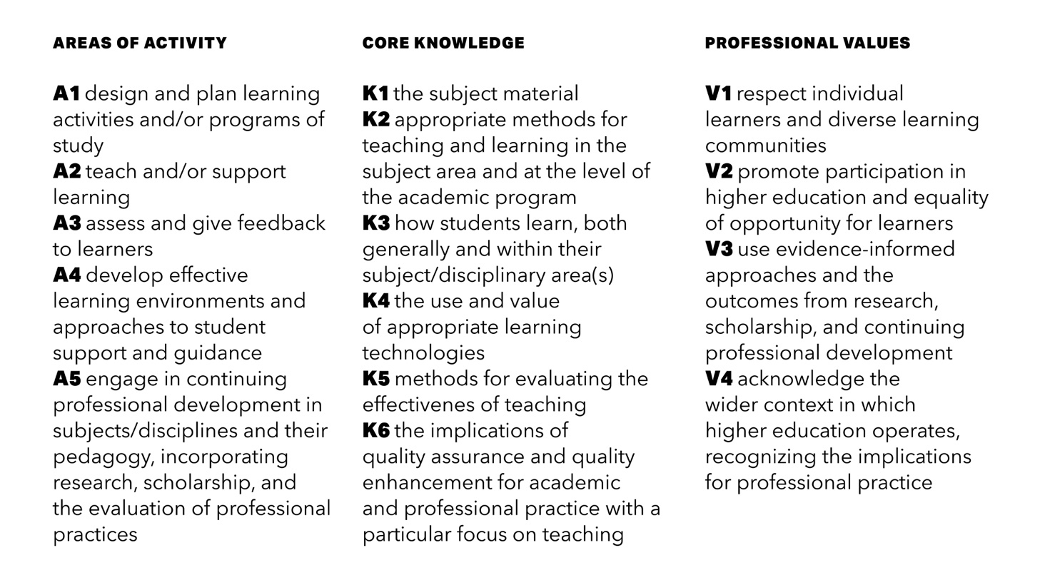

4.0 Becoming a Fellow of the HEA
Becoming a fellow of the HEA is quite a special achievement. It gives you a chance to reflect critically on your own professional journey and to describe your practice using the Professional Standards Framework. It also gives you a sense of achievement and it provides access to a network of other fellows. There are four categories of fellowship within the HEA:

- Associate Fellow— You are able to provide evidence of effective practice related to teaching and/or learning support, either in your current roles and/or through reflection on previous roles. By applying for Associate Fellow of the HEA (AFHEA) you will demonstrate your ability to describe your work in terms of certain aspects of the HEA’s Professional Standards Framework. Examples may include new faculty, teaching assistants, researchers, librarians, instructional designers, technologists, and advisors.

- Fellow— You are able to provide evidence of effective practice across a broad range of teaching and learning support areas. By applying for Fellow of the HEA (FHEA), you will demonstrate your ability to describe your work in terms of all aspects of the HEA’s Professional Standards Framework. This category is suitable for those who have a few years of teaching experience, or significant experience supporting learning without teaching.

- Senior Fellow— You are able to provide evidence of effective approaches to teaching and learning support as a key contribution to high quality student learning. By applying for Senior Fellow of the HEA (SFHEA), you will demonstrate your ability to impact and influence other colleagues through, for example, responsibility for leading, managing or organizing programs, subjects and/or disciplinary areas. This category is suitable for those who have extensive experience teaching or supporting learning, and who have at least three years’ experience supporting the development of others, through supervision, mentoring, coaching, or other support capacities.

- Principal Fellow— You have a sustained record of effective strategic leadership in academic practice and development and you are highly experienced with wide-ranging strategic leadership responsibilities in connection with key aspects of teaching and supporting learning. By applying for Principal Fellow of the HEA (PFHEA), you will demonstrate your extensive experience in teaching or supporting learning, and provide evidence that you have worked across an institution (and often beyond the institution) as a positive change-maker.

From the above description, it may be obvious which category of fellowship is appropriate for you. However, here are a few things to keep in mind:
- Categories of fellowship can be a starting point for you, and you can progress into other categories of fellowship over the years.
- Each of these categories require different levels of engagement with the Professional Standards Framework, as well as other items of evidence to authenticate your application.
- By connecting with the OTL or an existing HEA Fellow mentor, you can get personalized support for your HEA application, including support for choosing a category of fellowship.
The rest of this section outlines the process for becoming a fellow of the HEA for each category of fellowship.

4.1 Gaining recognition as Associate Fellow, Fellow, or Senior Fellow of the HEA

4.1.1. Gaining recognition as Associate Fellow or Fellow of the HEA

Faculty are asked to complete the following steps to complete an application for Associate Fellow or Fellow:

Step 1: Complete the required information session, called Writing Workshop or 1-on-1 information with OTL or an HEA Mentor
Writing Workshops are offered several times each semester and last for approximately one hour. During these sessions, participants are introduced to the PSF and its dimensions. A set of reflective questions helps determine which category of fellowship is appropriate.

Step 2: Faculty development participation
Participants are guided to complete any three workshops within the Teaching Excellence Program (see Figure 1). Alternatively, any of the five formal teaching certifications suffices. Staff my use professional development activities related to their role in lieu of an OTL Teaching Excellence Workshop as long as the professional development activity relates to supporting teaching, learning, or students.

Step 3: Reflection
Reflecting on your professional development and how you are going to use your new skills is a key value of being an HEA fellow. This activity invites participants to reflect on their practice in terms of teaching or supporting learning for the topic of the workshop. For example, participants who attend the workshop, FlexStudio, will be invited to reflect on their own philosophy of instructional design, and specific examples within their practice where they have designed learning activities. The Reflection also asks participants to consider the PSF and to identify the elements that align to their practice. Finally, the Reflection asks participants to ‘reflect forward’ by considering how they might enhance their future practice by trying any new theory or idea introduced in the workshop (see Appendix 1 for Reflection Form). The Reflection Form template can be found online. The Reflection should be a maximum of 500 words. Facilitators may substitute another post event form with approval from the OTL. Reflections must be endorsed by the workshop facilitator or OTL staff with HEA Fellowship.

Step 4: Account of Professional Practice
Once participants have successfully completed the Reflections, they construct a reflective Account of Professional Practice (APP). In the APP the participant demonstrates how they meet the criteria for HEA for Associate Fellow or Fellow. The Associate Fellow applicant must show evidence in support a subset of the PSF (at least 2 of the 5 Areas of Activity) whereas Fellow applicants must address all areas of the PSF.

Step 5: Reference letters
Participants solicit two letters of reference from colleagues who can comment on the applicant’s commitment to professional development, effective teaching, research, scholarship, value, and/or core knowledge. Due to the low numbers of HEA Fellows operating in North America, there is no requirement for references to be fellows of the HEA.

Step 6: Authentication and Submission
Authentication is embedded into the process for 1) certification and 2) submission as follows:

- Authentication: Participants are required to submit Reflections for review and endorsement by the workshop facilitators. When the facilitator signs off on the Reflection, they are endorsing the work as a full and reflective response to the task, and that they believe that the work was written by the participant named on the form.
- Submission: Participants are required to submit a single PDF portfolio by email to the Assessment Coordinator, Trevor Morris (Trevor.Morris@uvu.edu) who reviews each submission against these two criteria:
- Is the submission complete?
- Does the submission appear to be the work of the person who is submitting it?

Checklist for Applicants of Associate Fellow/Fellow
- Attend 1-on-1 information session or HEA Writing Workshop
- Participate in three professional development activities OR complete a formal teaching certification
  - Complete Reflection for each development activity
  - Secure endorsement of workshop facilitator for each Reflection
- Complete Account of Professional Practice
- Secure two reference letters
- Submit application

4.1.2 Gaining recognition as Senior Fellow of the HEA

Faculty are asked to complete the following steps to apply for Senior Fellow. This involves preparing an Account of Professional Practice that includes two case studies (6000 words total). Applicants will also need to provide two reference letters from individuals who can confirm your commitment to enhancing teaching practice.:

Step 1: Participate in a Writing Workshop or 1-on-1 information session with OTL or an HEA Mentor
Writing Workshops are offered several times each semester and introduce the participant to the PSF and its dimensions. You will be asked to describe your various roles and responsibilities in higher education, then select your specific teaching experiences, pedagogical research areas, and evidence to support your fellowship claim. For example, the focus of each case study will be decided upon. A writing plan and schedule will be agreed upon as well as the level of desired support with the mentor, e.g. draft review, classroom observation, artifact review, etc. You will be asked to identify two people to write reference letters for your application.

Step 2: Continuous professional development
One characteristic of a Senior Fellow is a strong commitment to continuous professional development in keeping with Area of Activity 5. For the Senior Fellow applicant, there is no set number of workshops that must be completed, rather the influence of professional development should be evident throughout the Account of Professional Practice (APP) as described below.

Step 3: Account of Professional Practice including two case studies
Applicants construct a reflective commentary in the form of the APP that includes their roles and responsibilities and evidence supporting all areas of the PSF at the level of Senior Fellow. The APP should chronicle the evolution of teaching/learning support expertise and how the applicant has influenced others to improve their teaching/learning support for the betterment of student success. The two case studies should outline contributions you have made to learning and teaching in higher education which demonstrate how you have organised, led and/or managed specific aspects of teaching and learning provisions. The APP should be a maximum of 6000 words and substantiate the Senior Fellow claim. The applicant should share their draft APP with the OTL or HEA Mentor for feedback and guidance before formal submission which includes two reference letters (below).

Step 3: Reference letters
Participants solicit two letters of reference from colleagues who can comment on the applicant’s commitment to professional development, effective teaching, research, leadership, scholarship, value, and/or core knowledge.

Step 4: Authentication and Submission
Authentication is embedded into the process for 1) mentoring and 2) submission as follows:

- Mentoring: Participants interact with either the OTL or HEA Mentor to establish a writing plan and for draft review. The HEA Mentor may engage with artifact or classroom observation with the mentee as part of the application process.
- Submission: Participants are required to submit a single PDF portfolio by email to the Assessment Coordinator, Trevor Morris (Trevor.Morris@uvu.edu) who reviews each submission against these two criteria:
- Is the submission complete?
- Does the submission appear to be the work of the person who is submitting it?

Checklist for Applicants of Senior Fellow
- Attend 1-on-1 information session or HEA Writing Workshop
- Complete Account of Professional Practice
- Engage the OTL or HEA Mentor to review the APP and/or complete classroom/artifact observation
- Secure two reference letters
- Submit application

4.1.3 Assessment of applications
Your application will be reviewed by two internal assessors (i.e. UVU colleagues who are fellows of the HEA). Assessment of your application will follow one of three assessment cycles, which culminate in an Assessment Panel Meeting, where the decision to award (or not award) your fellowship is ratified. These Assessment Panel Meetings take place in December, May, and August of each year. Table 1 outlines the approximate deadlines for each cycle. The actual deadlines will be published on the OTL website and will be communicated to you through the OTL. If you are unable to meet the deadline for one cycle, your application will be considered in the following cycle.
Table 1: Assessment Cycles for Teaching Excellence Program (Accredited Programs)

Fall Cycle
Deadline for submissions | Beginning of November
Distribution of submissions to assessors | Mid-November
Initial judgments reported to Coordinator | End of November
Moderation | Beginning of December
Assessment Panel | Second week in December
Notifications | Third week in December
Spring Cycle
Deadline for submissions | Mid-March
Distribution of submissions to assessors | End of March
Initial judgments reports to Coordinator | Beginning of April
Moderation, if needed | Mid-April
Assessment Panel | End of April
Notifications | First week in May
Summer Cycle
Deadline for submissions | Beginning of July
Distribution of submissions to assessors | Mid-July
Initial judgment reports to Coordinator | End of July
Moderation, if needed | First week in August
Assessment Panel | Second week in August
Notifications | Third week in August

The assessors will use a rubric to determine if the fellowship descriptors are fully met within the application. The assessors have two weeks to complete their review and return their judgments to the Assessment Coordinator. If there are any differences in judgments between the two assessors, the application moves into the moderation phase. The Assessment Coordinator will send the applications and feedback from the two assessors to a third assessor. This assessor will review the two assessors’ rubric and feedback for the applicant, review the application, and make recommendations for the Assessment Panel.

Three times a year, the Assessment Panel convenes. The Assessment Panel comprises the Assessment Coordinator and at least three impartial HEA Fellows that have not assessed the candidates. All members of the Assessment Panel must be suitably trained and hold appropriate category of HEA fellowship and demonstrate current knowledge and understanding of the requirements for the relevant category of HEA fellowship.

The Assessment Coordinator will present the Assessment Panel with documents detailing the judgments and constructive feedback for all submissions in that cycle. The Assessment Panel will proceed in the following order:

- Review of judgments on each submission relative to the appropriate descriptor of the PSF
- Group consensus on judgments for the purposes of ratifying the judgments
- Group discussion on any submissions that entered a ‘moderation’ phase
- Group discussion on any submissions that were exceptional, either as exemplars or as examples of poor practice
- Group activity to improve future assessment cycles

4.1.4 Notification and appeals
- Following the Assessment Panel Meeting, the Assessment Coordinator will have one week to notify applicants of the outcome. This will be in the form of an email. The email will also include written feedback provided from the assessors and Assessment Panel.
- The Assessment Panel may request revisions to APP for applicants that are borderline. The applicants will be given feedback from the Assessment Panel with guidance on what needs to be change to be accepted. Borderline applicants have three months to make the requested changes.
- If applicants are not awarded fellowship, the Assessment Panel will give feedback on what is needed to achieve fellowship in another assessment cycle. The decision to award fellowships is a reflection of professional judgment and cannot be appealed.

4.2 Gaining Recognition as Principal Fellow of the HEA
For UVU faculty and staff, the only way to gain recognition as Principal Fellow is through a direct application to the HEA. This involves preparing a Record of Educational Impact and an Account of Professional Practice. Applicants will also need to provide three “advocate letters” from individuals who can wholeheartedly support your application for Principal Fellow.

All applicants from UVU are supported through this process in three ways:
- Contact OTL or a Principal Fellow to explain the direct submission process and requirements. A Principal Fellow can provide mentoring to develop specific PSF dimensions in preparation for your application.
- Receive formative feedback on a draft application.
- The Office of Teaching and Learning will pay your application fee.

4.4 Application through the direct submission process for SFHEA or PFHEA
Submit your application through the HEA’s MyAcademy portal. You will need to create an account in MyAcademy (choosing UVU as your institution) and then paste your application into the web form. You will need to upload your three advocate letters before submitting the application. You will receive a code corresponding to your application that you should send to OTL (Wendy.Athens@uvu.edu) to cover the application fee.

Once your application has been submitted to the HEA, it will be reviewed by at least two reviewers (in line with the HEA Accreditation Policy). You will be notified by email of the outcome of your application, usually within 12-16 weeks. There are two outcomes: accepted and not accepted. If your application is accepted, you will receive feedback and a certificate to download and print. If your first application attempt is not accepted, you will receive feedback and an opportunity to resubmit within a month.

5.0 Recognition for UVU’s HEA Fellows

Earning an HEA fellowship is a high distinction. Recognition happens in a variety of ways:
- Through earning fellowship with the HEA
- Through receipt of a certificate and badge
- Through an Annual Recognition Luncheon for those who have achieved HEA fellowship
- Through door plaques which show others that you are a fellow of the HEA
- Through wall plaques in the Office of Teaching and Learning and on the OTL website
- Through the use of a signature credential/postnominal (AFHEA, FHEA, SFHEA, PFHEA)
- Through supporting others in earning fellowship and peer networking
- Through participating in HEA’s global fellows network

6.0 Next Steps and Additional Support
- You can read more about the HEA and fellowships on the OTL website and the HEA website.
- You can register for OTL workshops.
- You can contact Trevor Morris (Trevor.Morris@uvu.edu) for more information.

Appendix 1: Reflection Form

Thank you for participating in this Office of Teaching and Learning (OTL) workshop. As part of this development experience, you will have the opportunity to carry out a set of activities to reflect on your own teaching practice. This reflection-on-practice will be demonstrated through your responses to the following questions. The purpose of this task is twofold:
- To engage participants in a deeper, richer professional development experience
- To provide a means to assess and certify participants seeking recognition through the Teaching Excellence Program
Staff may submit a Reflection for professional development activities relevant to their role that is not part of the Teaching Excellence Program as long as the professional development is related to supporting teaching, learning, or students. The professional development activity should be within the last few years. Staff need to address 2.a.iv in their Reflection.
Once you have completed this Reflection, please return a copy to your workshop facilitator or Trevor Morris in the OTL for their feedback. If the facilitator accepts your Reflection as evidence of critical reflection on practice, you will receive a signed copy with feedback.
This Reflection provides important evidence toward recognition for HEA-Track participants.

Name: __________________________________
Department: __________________________________
Workshop or Event: __________________________________
Date: __________________________________

- Reflecting on what you learned in this workshop or professional development event, how does what you learned relate to your past teaching experiences or professional practices? (approximately 200 words)

- Reflecting forward, develop an implementation plan to apply these principles. You will be asked on the HEA application to provide evidence of this implementation. (approximately 300 words)
  - Consider the following:
    - What specific principles or practices from the workshop will you use in future practice?
    - Why do you feel these principles or practices will benefit student learning?
    - What evidence will you collect to inform your practice?
    - In what ways will the changes you implement to your practice relate to PSF?
  - Experienced faculty can waive this section and expand their response to prompt 1 to 500 words.

Facilitator’s feedback
Assessment criteria | Facilitator’s response
- The participant made a plausible connection to the workshop topic and their prior practice.
- The proposed implementation and evaluation plan will provide substantive evidence in support of the HEA fellowship application. For experienced faculty, there were multiple substantive connections to practice shared in part 1.

Statement of acceptance and authentication (for facilitator)
As the facilitator of this workshop, I accept this participant’s Reflection as critical reflection on their practice and plans to implement changes to their practice.

Facilitator signature:

Date:

Appendix 2: Account of Professional Practice (APP) for Associate Fellow

Name:
Department:
Assessment Number:

Was there anyone who mentored or assisted you in preparing your application that you would like to recognize:

The account of practice for the HEA award of fellow must demonstrate how the candidate meets the descriptors below as related to the Professional Standards Framework.

Descriptor for Associate Fellow
D.I Successful engagement with at least two of the five Areas of Activity
D.II Successful engagement with appropriate teaching and practices related to these Area of Activity
D.III Appropriate Core Knowledge of at least K1 and K2
D.IV A commitment to appropriate Professional Values in facilitating others’ learning
D.V Relevant professional practices, subject and pedagogical research, and/or scholarship within the above activities
D.VI Successful engagement, where appropriate, in professional development activity related to teaching, learning, and assessment responsibilities

Professional Standards Framework (PSF)
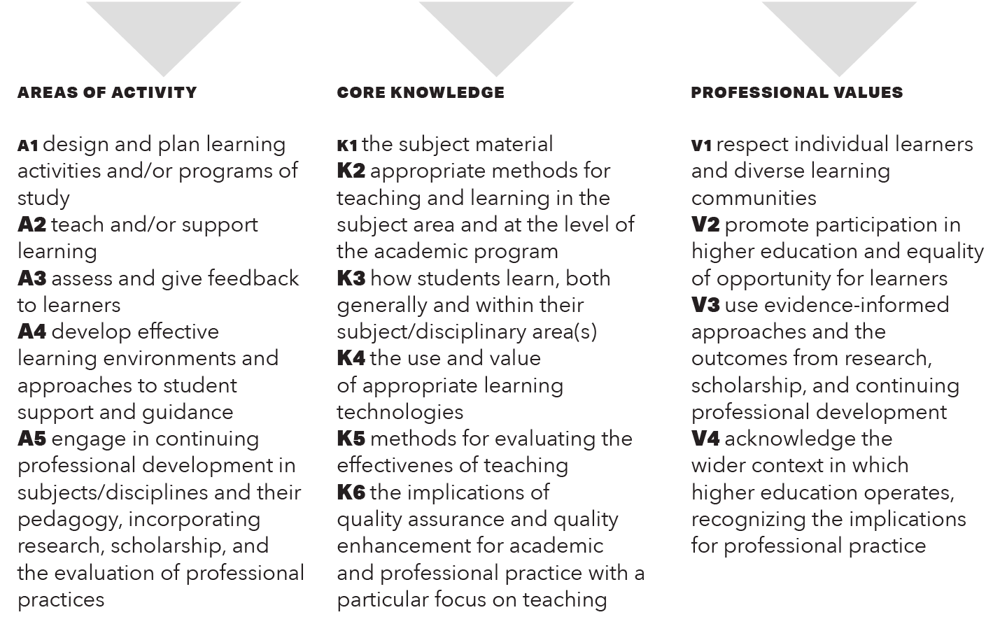

Account of Professional Practice (APP)
The Account of Professional Practice consists of four parts. Each part is described in this document:
Part 1: Narrative of Teaching Practice
Part 2: Areas of Activity
Part 3: Reflections
Part 4: Letters of Recommendation

Part 1: Narrative of Teaching Practice
Construct a narrative that provides evidence for how your teaching or professional practice meets the criteria for descriptor for Associate Fellow.

The following questions might be useful in helping you reflect on teaching/supporting learning situations What activities have you planned or designed that have been particularly successful? What did you do? What knowledge did you apply? How did you know the activities were effective? How did you assess them? What technologies did you use? What did you learn? How did you improve your practice? How do your examples show evidence of the professional values?

Reference the framework components as applicable throughout your narrative (e.g., A3, K2, V4, etc.). (Max 1000 words)
Narrative of Teaching Practice

Part 2: Areas of Activity
This section serves as a follow-up on the implementation and evaluation of your learning in your classroom, thereby providing evidence of A5, Continuing Professional Development.

Complete the following record demonstrating continuing professional development related to teaching and supporting learning (see Descriptor for Fellow D. VI and Area of Activity A5 in the Professional Standards Framework). Provide a description of least three OTL workshops you attended, implemented, and evaluated. Or Provide a description of least three modules from Pathway 3 and how implemented and evaluated the changes to your teaching based on Pathway 3 participation. Staff may submit continuing professional development activities they have completed from professional development events in lieu of OTL workshops as long as the event is relevant to their role in supporting teaching, learning, or supporting students. Reference the relevant area of the Professional Standards Framework. (Approximately 300-400 words)

OTL Event | Date(s) | Implementation | Evaluation
E.g.  FlexStudio | 9-12-17  10-9-17 | - Realigned learning activities with objectives in ACCT 1010. (A1)  - Organized online course into modules. (A1) | - Students performed better on quizzes and exam. Average score increased by 5%. (A3)  - Student feedback indicated that Canvas was more organized. (A4)

Part 3: Reflections
Attach the Reflection. Staff may submit Reflections from other professional development events as long as it relates to their role of supporting teaching, learning, or students. Remember the Reflections must be endorsed by the workshop facilitator or an OTL staff member.

Part 4: Recommendation Letters
Complete two reference letters from individuals who can attest to your commitment to the Professional Standards Framework. Blank template to give to your reference writer can be downloaded from the OTL HEA webpage.

Reference 1
Name:
Position:
Email:
In what capacity do you know the applicant:

Evidence for Associate Fellow needs to demonstrate effective approaches to teaching and learning. To award the Associate Fellow of the Higher Education Academy (AFHEA), the applicant needs to meet Descriptor 1. Please refer to the UKPSF for details of the descriptors. Comments about the applicant should be made against the Professional Standards Framework (see below).
Please comment on how the applicant meets the criteria to the best of your knowledge. You are encouraged to show relevance to the different Areas of Activity using shorthand where appropriate (A1, A2, A3, etc.). The applicant needs to demonstrate engagement with at least two Areas of Activity. (About 400 words)

Successful engagement across at least two of the five Areas of Activity

Reference 2
Name:
Position:
Email:
In what capacity do you know the applicant:

Evidence for Associate Fellow needs to demonstrate effective approaches to teaching and learning. To award the Associate Fellow of the Higher Education Academy (AFHEA), the applicant needs to meet Descriptor 1. Please refer to the UKPSF for details of the descriptors. Comments about the applicant should be made against the Professional Standards Framework (see below).
Please comment on how the applicant meets the criteria to the best of your knowledge. You are encouraged to show relevance to the different Areas of Activity using shorthand where appropriate (A1, A2, A3, etc.). The applicant needs to demonstrate engagement with at least two Areas of Activity. (About 400 words)

Successful engagement across at least two of the five Areas of Activity

Appendix 3: Associate Fellow Evaluation Rubric to be used by Assessment Team

Applicant: Recognition reference:
Assessor:
Overall decision of Accept or Refer:

Being an Associate Fellow recognizes effectiveness in specific aspects of teaching and enhancing the student learning experience, combined with scholarship, research and/or other professional activities. It is awarded to professionals who can demonstrate that they meet the criteria of Descriptor 1 of the Professional Standards Framework for teaching and supporting learning in higher education.
Descriptors relating to Areas of Activity |  | Accept | Refer
1.I | Successful engagement with at least two of the five areas of Activity.
1.II | Successful engagement in appropriate teaching practices related to the Areas of Activity.
Comments
If accepted, only comment if there are substantial strengths which it would be good to share with the applicant. If referred, indicate what the applicant needs to do to be Accepted.
Assessor Comments:

Descriptor relating to Professional Values |  | Accept | Refer
1.IV | A commitment to appropriate Professional Values.
Comments
If accepted, only comment if there are substantial strengths which it would be good to share with the applicant. If referred, indicate what the applicant needs to do to be Accepted.
Assessor Comments:

Descriptors relating to Core Knowledge |  | Accept | Refer
1.III | Appropriate knowledge and understanding of at least K1 and K2
1.V | Successful incorporation of relevant professional practices, subject and pedagogic research and/or scholarship as part of an integrated approach to academic practice.
1.VI | Successful engagement, where appropriate in professional development activity related to teaching, learning and assessment responsibilities.
Comments
If accepted, only comment if there are substantial strengths which would be good to share with the applicant. If referred, indicate what the applicant needs to do to be Accepted.
Assessor Comments:

Do the referees broadly corroborate the applicants account? | Accept | Refer

Summary remarks.
If successful - use this section to provide the applicant with any constructive feedback that would be valuable for them to know in terms of their claim and/or future development. Comment if there are substantial strengths which would be good to share more widely.
If referred - use this space to list the recommendations for what the applicant needs to do to be accepted:

Appendix 4: Account of Professional Practice (APP) for Fellow

Name:
Department:
Assessment Number:

Was there anyone who mentored or assisted you in preparing your application that you would like to recognize:

The account of practice for the HEA award of fellow must demonstrate how the candidate meets the descriptors below as related to the Professional Standards Framework.

Descriptor for Fellow

D.I Successful engagement across all five Areas of Activity
D.II Appropriate knowledge and understanding across all aspects of Core Knowledge
D.III A commitment to all the Professional Values
D.IV Successful engagement in appropriate teaching practices related to the Areas of Activity
D.V Successful incorporation of subject and pedagogical research and/or scholarship within the above activities, as part of an integrated approach to academic practice
D.VI Successful engagement in continuing professional development in relation to teaching, learning, assessment, and where appropriate, related to professional practices

Professional Standards Framework (PSF)

Account of Professional Practice (APP)

The Account of Professional Practice consists of four parts. Each part is described in this document:
Part 1: Narrative of Teaching Practice
Part 2: Evidence of Engagement in Continuing Professional Development (OTL Workshops)
Part 3: Reflection and Certificates of Participation
Part 4: Letters of Recommendation

Part 1: Narrative of Teaching Practice
Construct a narrative that provides evidence for how your teaching practice or professional practice that meets the criteria for Descriptor for Fellow.

The following questions might be useful in helping you reflect on teaching/supporting learning situations What activities have you planned or designed that have been particularly successful? What did you do? What knowledge did you apply? How did you know the activities were effective? How did you assess them? What technologies did you use? What did you learn? How did you improve your practice? How do your examples show evidence of the professional values?

Reference the framework components as applicable throughout your narrative (e.g., A3, K2, V4, etc.). (Max 2,000 words)
Narrative of Teaching Practice

Part 2: Evidence of Engagement in Continuing Professional Development (OTL Workshops, A5)

This section serves as a follow-up on the implementation and evaluation of your learning in your classroom, thereby providing evidence of A5, Continuing Professional Development.

Complete the following record demonstrating continuing professional development related to teaching and supporting learning (see Descriptor for Fellow D. VI and Area of Activity A5 in the Professional Standards Framework). Provide a description of least three OTL workshops you attended, implemented, and evaluated. Or Provide a description of least three modules from Pathway 3 and how implemented and evaluated the changes to your teaching based on Pathway 3 participation. Staff may submit continuing professional development activities they have completed from professional development events in lieu of OTL workshops as long as the event is relevant to their role in supporting teaching, learning, or supporting students. Reference the relevant area of the Professional Standards Framework. (Approximately 300-400 words.)

OTL Event | Date(s) | Implementation | Evaluation
E.g.  FlexStudio | 9-12-17  10-9-17 | - Realigned learning activities with objectives in ACCT 1010. (A1)  - Organized online course into modules. (A1) | - Students performed better on quizzes and exam. Average score increased by 5%. (A3)  - Student feedback indicated that Canvas was more organized. (A4)

Part 3: Reflections
Attach the Reflection. Staff may submit Reflections from other professional development events as long as it relates to their role of supporting teaching, learning, or students. Remember the Reflections must be endorsed by the workshop facilitator or an OTL staff member.

Part 4: Recommendation Letters
Complete two reference letters from individuals who can attest to your commitment to the Professional Standards Framework. Blank template to give to your reference writer can be downloaded from the OTL HEA webpage.

Reference 1
Name:
Position:
Email:
In what capacity do you know the applicant:

Evidence for Fellow needs to demonstrate effective approaches to teaching and learning. To award the Fellow of the Higher Education Academy (AFHEA), the applicant needs to meet Descriptor 2. Please refer to the UKPSF for details of the descriptors. Comments about the applicant should be made against the Professional Standards Framework (see below).
Please comment on how the applicant meets the criteria to the best of your knowledge. You are encouraged to show relevance to the different Areas of Activity using shorthand where appropriate (A1, A2, A3, etc.).

Successful engagement across all five Areas of Activity (About 500 words)

Reference 2
Name:
Position:
Email:
In what capacity do you know the applicant:

Evidence for Fellow needs to demonstrate effective approaches to teaching and learning. To award the Fellow of the Higher Education Academy (AFHEA), the applicant needs to meet Descriptor 2. Please refer to the UKPSF for details of the descriptors. Comments about the applicant should be made against the Professional Standards Framework (see below).
Please comment on how the applicant meets the criteria to the best of your knowledge. You are encouraged to show relevance to the different Areas of Activity using shorthand where appropriate (A1, A2, A3, etc.).

Successful engagement across all five Areas of Activity (About 500 words)

Appendix 5: Fellow Evaluation Rubric to be used by Assessment Team

Applicant:
Assessor:
Overall decision of Accept or Refer:

Being a Fellow demonstrates a broad understanding of effective approaches to teaching and learning support as key contributions to high quality student learning. It is awarded to professionals who can demonstrate that they meet the criteria of Descriptor 2 of the Professional Standards Framework for teaching and supporting learning in higher education.

Descriptor relating to Areas of Activity |  | Accept | Refer
2.I | Successful engagement with all five areas of Activity
2.IV | Successful engagement in appropriate teaching practices related to the Areas of Activity
Comments
If accepted, only comment if there are substantial strengths which it would be good to share with the applicant. If referred, indicate what the applicant needs to do to be Accepted.

Assessor Comments:

Descriptor relating to Professional Values |  | Accept | Refer
2.III | A commitment to all the Professional Values
Comments
If accepted, only comment if there are substantial strengths which it would be good to share with the applicant. If referred, indicate what the applicant needs to do to be Accepted.
Assessor Comments:

Descriptors relating to Core Knowledge |  | Accept | Refer
2.II | Appropriate knowledge and understanding across all aspects of Core Knowledge
2.V | Successful incorporation of subject and pedagogic research and/or scholarship within activities, as part of an integrated approach to academic practice
2.VI | Successful engagement in continuing professional development in relation to teaching, learning, assessment and, where appropriate, related professional practices
Comments
If accepted, only comment if there are substantial strengths which it would be good to share with the applicant. If referred, indicate what the applicant needs to do to be Accepted
Assessor Comments:

Do the referees broadly corroborate the applicants account? |  | Accept |  | Refer

Summary remarks:

If successful - use this section to provide the applicant with any constructive feedback that would be valuable for them to know in terms of their claim and/or future development. Comment if there are substantial strengths which would be good to share more widely.
If referred - use this space to list the recommendations for what the applicant needs to do to be accepted:

Appendix 6: Account of Professional Practice (APP) for Senior Fellow

Name:
Department:
Assessment Number:

By applying to be a Senior Fellow of the HEA you will present a thorough understanding of effective approaches to teaching and learning support as a key contribution to high quality student learning. You should be able to provide evidence of:

D3.I Successful engagement across all five Areas of Activity.
D3.II Appropriate knowledge and understanding across all aspects of Core Knowledge.
D3.III A commitment to all the Professional Values.
D3.IV Successful engagement in appropriate teaching practices related to the Areas of Activity.
D3.V Successful incorporation of subject and pedagogic research and/or scholarship within the above activities, as part of an integrated approach to academic practice.
D3.VI Successful engagement in continuing professional development in relation to teaching, learning, assessment, scholarship and, as appropriate, related academic or professional practices.
D3.VII Successful coordination, support, supervision, management and/or mentoring of others (whether individuals and/or teams) in relation to learning and teaching.

Account of Professional Practice (APP)

The Account of Professional Practice consists of four parts. Each part is described in this document.

Part 1: Narrative of Teaching Practice
Part 2: Two Case Studies
Part 3: Two Letters of Recommendation
Part 4: Acknowledge Mentor

Part 1: Narrative of Teaching Practice
In preparing your reflective commentary, focus in particular on the education, training, employment, roles and experience which have contributed to your professional development as teacher, mentor, facilitator of learning and academic leader. You might include informal activities whether individual, collaborative or team-based, that you believe have had a significant impact on your academic practice and/or on the practice of others.
Highlight the primary influences on your own development, focusing on the progressive attainment of your professional capabilities and how you and others have benefitted from the continuous learning and development process involved.

Narrative of Teaching Practice

Part 2: Two Case Studies

In this section of your application, provide reflective accounts of two particular contributions or experiences which:

- have had a significant impact upon the co-ordination, support, supervision, management and/or mentoring of others (whether individuals and/or teams), in relation to learning and teaching
- demonstrate your sustained effectiveness in relation to learning and teaching and that you meet the criteria for Senior Fellowship

References:

Part 3: Recommendation Letters
Complete two reference letters from individuals who can attest to your commitment to the Professional Standards Framework. Blank template to give to your reference writer can be download from the OTL HEA webpage.

Part 4: HEA Mentor
Use this space to identify who mentored you in the fellowship writing process, if anyone. This HEA Mentor will be recognized for his/her service.

Appendix 7: Senior Fellow Evaluation Rubric to be used by Assessment Team

Applicant:
Assessor:
Overall decision of Accept or Refer:

Being a Senior Fellow demonstrates a broad understanding of effective approaches to teaching and learning support as key contributions to high quality student learning. It is awarded to professionals who can demonstrate that they meet the criteria of Descriptor 3 of the Professional Standards Framework for teaching and supporting learning in higher education.

Descriptor relating to Areas of Activity |  | Accept | Refer
3.I | Successful engagement with all five areas of Activity
3.IV | Successful engagement in appropriate teaching practices related to the Areas of Activity
Comments
If accepted, only comment if there are substantial strengths which it would be good to share with the applicant. If referred, indicate what the applicant needs to do to be Accepted.

Assessor Comments:

Descriptor relating to Professional Values |  | Accept | Refer
3.III | A commitment to all the Professional Values
Comments
If accepted, only comment if there are substantial strengths which it would be good to share with the applicant. If referred, indicate what the applicant needs to do to be Accepted.
Assessor Comments:

Descriptors relating to Core Knowledge |  | Accept | Refer
3.II | Appropriate knowledge and understanding across all aspects of Core Knowledge
3.V | Successful incorporation of subject and pedagogic research and/or scholarship within activities, as part of an integrated approach to academic practice
3.VI | Successful engagement in continuing professional development in relation to teaching, learning, assessment and, where appropriate, related professional practices
Comments
If accepted, only comment if there are substantial strengths which it would be good to share with the applicant. If referred, indicate what the applicant needs to do to be Accepted
Assessor Comments:

Descriptions related to developing others |  | Accept | Refer
3.VII | Successful coordination, support, supervision, management and/or mentoring of others (whether individuals and/or teams) in relation to learning and teaching.
Comments
If accepted, only comment if there are substantial strengths which it would be good to share with the applicant. If referred, indicate what the applicant needs to do to be Accepted
Assessor Comments:

Do the referees broadly corroborate the applicants account? | Accept | Refer

Summary remarks:

If successful - use this section to provide the applicant with any constructive feedback that would be valuable for them to know in terms of their claim and/or future development. Comment if there are substantial strengths which would be good to share more widely.
If referred - use this space to list the recommendations for what the applicant needs to do to be accepted:

