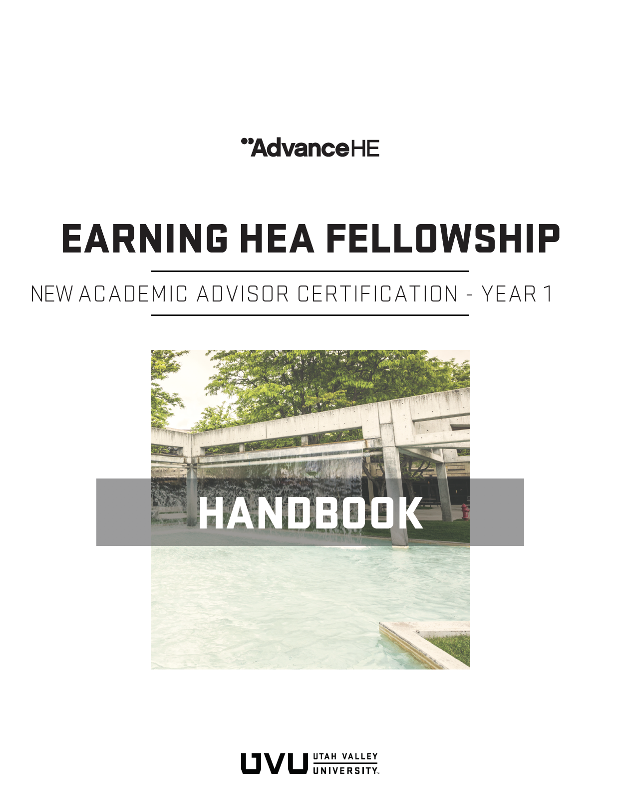

New Academic Advisor Certification - Year 1

Introduction
Welcome to the New Academic Advisor Certification Program! This program supports the success of students as they interact with advisors who are professionally trained and engaged in continuous professional improvement.

The New Academic Advisor Certification program has been accredited by the Advance HE, an international, non-profit organization that promotes teaching/supporting learning excellence in higher education. Advance HE stewards the Higher Education Academy (HEA) fellowship program and there are more than 140,000 HEA fellows in the world. UVU is the first American institution to be accredited by Advance HE to offer fellowship recognition to faculty, administrators, and staff supporting learning. HEA fellowship is professional recognition for teaching/supporting learning within higher education. It is an internationally recognized credential.

When you successfully complete New Academic Advisor Year 1 certification, you in effect also complete Associate Fellowship within the HEA fellowship program (Descriptor 1 fellowship). This is possible because we have mapped each of the workshops and assignments of New Academic Advisor Certification Year 1 to meet the Descriptor and Dimension requirements of the Professional Standards Framework (UKPSF). The UKPSF is the heart of the Higher Education Academy fellowship recognition program. The UKPSF articulates the areas of activity, values, and knowledge to that Academic Advisors must demonstrate to be effective.

This participant handbook will guide you in making the connections between your Academic Advisor professional development and HEA fellowship.

What is the value of becoming an HEA fellow?
Benefits of HEA fellowship include:
- External validation of your effectiveness in supporting learning
- An internationally recognized teaching/supporting learning credential
- Global community of practice with others committed to teaching and supporting learning
- Framework for reflection and improvement of one's support of learning practice
- Service and leadership opportunities through nurturing colleagues to fellowship
Learn more about HEA fellowship at UVU.

Professional Standards Framework (UKPSF)
The New Academic Advisor Certification program is aligned to the Professional Standards Framework (UKPSF). The UKPSF is an internationally recognized model that represents the Activities, Knowledge, and Professional Values that should be held by anyone who teaches or supports learning in higher education. The Dimensions of the UKPSF appear in Figure 1 and describe:
- Areas of Activity: Describe what an Academic Advisor does;
- Core Knowledge: Outlines what they need to know;
- Professional Values: Outlines the manner in which they should carry out their activities.

In this handbook, we have aligned the assignments that you will complete within the New Academic Advisor Certification pathway to the UKPSF to assist you in seeing the connections (Image source: UKPSF, 2011).

Figure 1. UKPSF dimensions of Areas of Activity, Core Knowledge, and Professional Values. 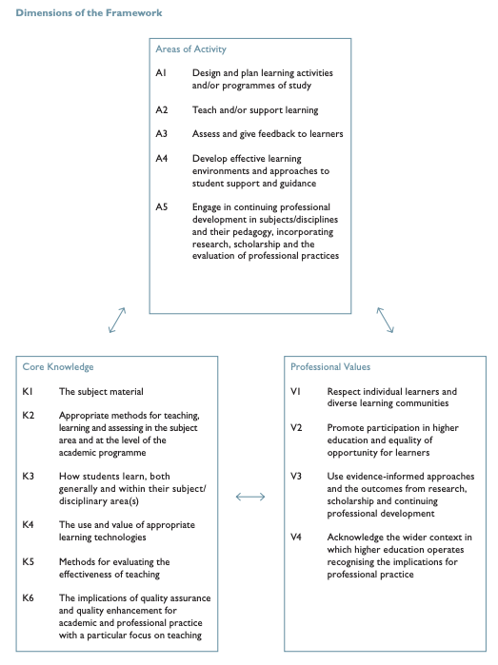

Program Description

NEW ADVISOR CERTIFICATION – YEAR ONE (Y1)
New advisors must fulfil the following requirements within one (1) year of their
start date and will receive a plaque and printed certificate upon completion.
New Advisor Training: includes the completion of both online training modules and in-person workshops.
Online Modules are housed in Canvas and are immediately available upon hire. The first five modules should be completed as soon as possible (ideally within the first week of hire).
Module 1: Introduction to Advising and UVU  Module 2: FERPA  Module 3: Advisement Technologies  Module 4: WolverineTrack and Degree Fundamentals  Module 5: Day to Day Needs  Module 6: Campus Resources and Services | Module 7: Career and Graduate Resources  Module 8: Advising Theories and Pedagogies  Module 9: Inclusive Advising  Module 10: Communication Skills  Module 11: Gaining Skills and Professional Development  Module 12: Proactive Academic Advising (Civitas)
In-Person Workshops are designed to discuss the application of material in the online training modules. Workshops are scheduled multiple times each year.
Workshop A: Mission of Academic Advising at UVU
Workshop B: Graduation Requirements
Workshop C: Career Advising
Workshop D: Developing Your Own Advising Style
Workshop E: Communication Skills

Observations: includes both observing experienced advisors and being observed by others while advising to receive valuable feedback.
Observe a minimum of 9 certified advisors (no more than 2 advisors per college/school/center).
Be Observed a minimum of 3 times within the first year by the following:
- Office of University Advising (choice of Director, Training Manager, Technology Coordinator)
- Certified Academic Advisor (from any college/school/center)
- Supervisor (can be done in conjunction with performance assessment)
Complete a reflection/action plan for each of the 12 observations.
Performance Assessment: completed with supervisor at 3/6/9/12 months on the job to assess understanding of various job duties, set goals, and evaluate any changes that need to be made.
Notes
- Advisors who begin on June 30th or earlier in a calendar year will have until December 31st of that same year to complete the second year of New Advisor Certification.
- Advisors who begin on July 1st or later in a calendar year will have until December 31st of the following year to complete their second year of New Advisor Certification.
- New Advisor Certification requirements are reported and tracked through the Advisor Certification System (ACS).
- In addition to meeting the certification requirements for their position, new advisors will receive an additional universal credential as a Higher Education Academy Associate Fellow.

Program Outcomes & UKPSF Connections
The six Academic Advisor Competencies form the framework for Academic Advisor continuing professional development (CPD) across the career. In Years 1 to 3, Academic Advisors must complete CPD in each of the competencies. After Year 3, Academic Advisors must complete CPD in each competency every other year. There are an array of workshops offered throughout the year through which you can earn Advisor Education Units (AEUs).

In Table 1 below, we have mapped the six Academic Advisor Competencies to the dimensions of the UKPSF. To assist you in seeing the connections, refer to Figure 1 where the dimensions are defined.

Table 1. Academic Advising Competencies mapped to UKPSF dimensions
Academic Advising Competencies Mapped to UKPSF Dimensions
1 | Advisors model professional behavior | A5, K1, V1, V3, V4
2 | Advisors thoroughly understand program requirements, and resources and services available to students at UVU | K1
3 | Advisors provide information to their students using a variety of communication methods and soft skills | A2, A4, K2, K3, K5, K6, V1, V2, V3
4 | Advisors effectively operate necessary technologies, and use data and assessment to guide and inform their work | K4, K5, K6, V3
5 | Advisors are inclusive in nature and care about the individual needs and circumstances of every student | V1, V2
6 | Advisors employ a variety of advising approaches and methods to impact the success of students | A1, A2, A3, A4, K2, K6, V1, V2, V3, V4

In Year 1, Academic Advisors are expected to develop evidence of specific aspects of supporting learning. Specifically, they should develop evidence of A2, support of learning, and A4, effective approaches to student support and guidance. They are also expected to develop evidence of at least K1, core knowledge about academic advising, and K2, effective methods of supporting learning. By the end of the first year, Academic Advisors should demonstrate all of the appropriate professional values (V1-V4).

Associate Fellow (AFHEA, Descriptor 1, D1) is a level of fellowship suitable for anyone who doesn’t have an extensive learning support background (i.e. new Academic Advisors). UKPSF Descriptor 1 (Associate Fellow) is fully described in Figure 2.

Figure 2. UKPSF Descriptor 1 (Associate Fellow) description.
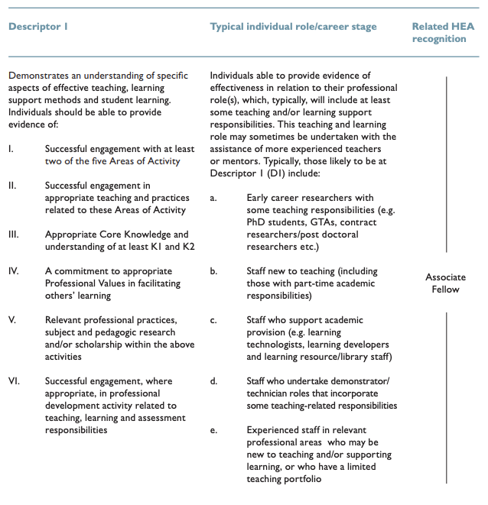

Program Facilitators

The course facilitators are Academic Advising experts and HEA fellows. The course facilitators are familiar with UVU’s unique work environment, policies, expectations and challenges as well as best practices in academic advising. They are also familiar with the UKPSF and will assess your work against the six Academic Advisor competencies and UKPSF.

Commitment & Attendance
New Academic Advisor Certification provides 30 hours of continued professional development (CPD). There are 10 online modules with assessments (2 hours each) and 5 in-person application workshops (2 hours each).

Program Deliverables & Assessment
The New Academic Advisor Certification includes a number of deliverables of four types listed below.

1. There are key assignments within the Canvas modules listed in Table 2 that have been mapped to the corresponding UKPSF dimensions.

Table 2. Key Assignments Mapped to UKPSF in New Advisor Certification - Year 1 (D1)
Key Assignment - New Academic Advisor Certification | UKPSF Connection
Observation Reflections (100 words minimum/each * 9 of these)—submitted in Module 5: Advisor’s Day to Day | A4, A5, K5, V3
Advising Philosophy Statement (100 words minimum)—submitted in Module 11: Gaining Skills and Professional Development | A2, A4, K1, K2, V1, V2
Workshop A: Mission of Academic Advising at UVU Reflection (100 words minimum)—submitted in Module 1: Introduction to Advising and UVU | K1
Workshop B: Graduation Requirements Reflection (100 words minimum)—submitted in Module 4: WolverineTrack and Degree Fundamentals | K1, K4
Workshop C: Career Advising Reflection (100 words minimum)—submitted in Module 7: Career and Graduate Resources | K1
Workshop D: Developing Your Own Advising Style Reflection (100 words minimum)—submitted in Module 8: Advising Theories and Pedagogies | A4, K2, K3
Workshop E: Communication Skills Reflection (100 words minimum)—submitted in Module 10: Communication Skills | A3, A4, K3, V1, V2
Total word count ~1500

2. In addition, you must complete 12 observations (observe 9 times and be observed 3 times) and write a reflection/action plan following each. The qualified leaders will review your reflections following peer observations using the rubric shown in Figure 3. They will look for evidence of the six Advising Competencies and dimensions of the UKPSF.

Figure 3. Example of rubric used to assess the reflections written following observation of peers. Note the rubric alignment with specific Advising Competencies and specific dimensions of the UKPSF.
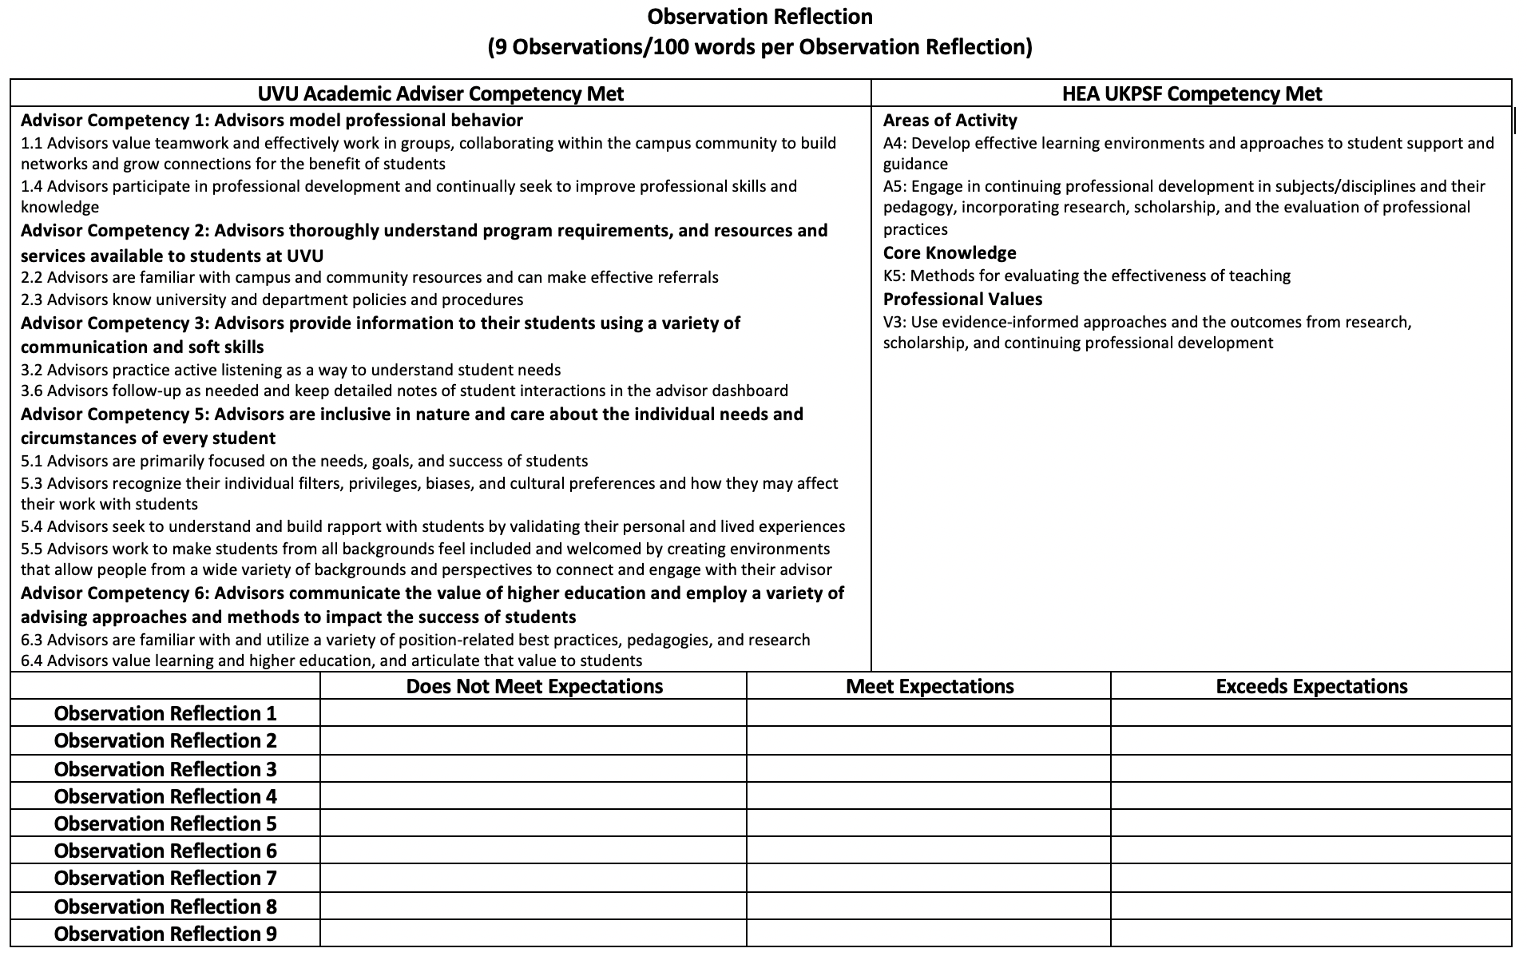
3. You must complete performance assessments with your supervisor at 3/6/9/12 months on the job.

4. You will write an Advising Philosophy statement. Qualified leaders will use the rubric shown in Figure 4 to assess your Advising Philosophy statement and seek connections to the six Advising Competencies and dimensions of the UKPSF. Note you will revisit your Advising Statement in Years 2 & 3. The qualified leaders will look for greater breadth in your practice and that you are evidencing all dimensions of the UKPSF (more on this in the HEA Fellowship section).

Figure 4. Example of rubric used to assess the Advising Philosophy statement. Note the rubric alignment with specific Advising Competencies and specific dimensions of the UKPSF.
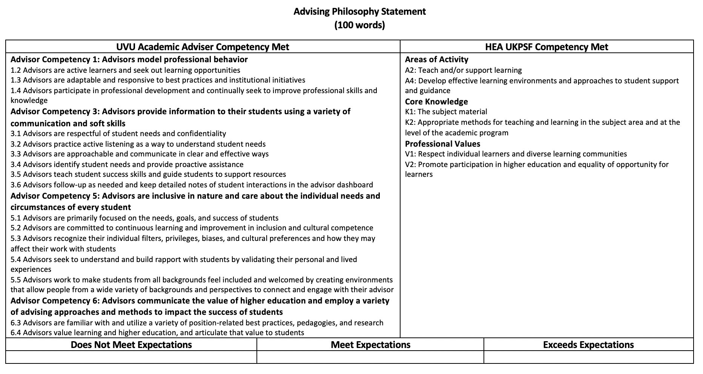
You can see the full set of rubrics that will be used to review your key assignments in Appendix A.

Program Alignment with the UKPSF
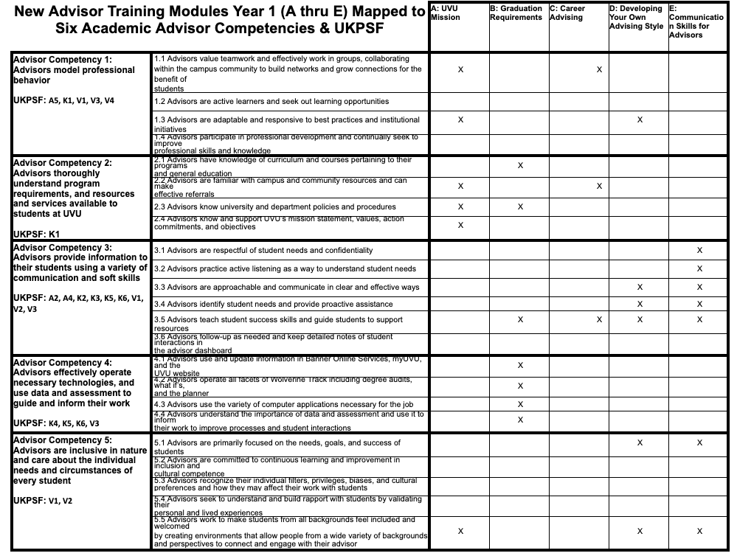
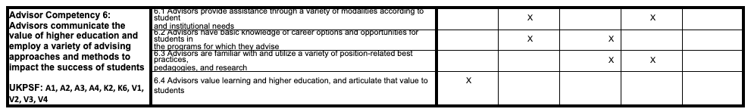

HEA Fellowship
After completing New Academic Advisor Certification - Year 1, you will earn Associate Fellow recognition from Advance HE. You will enter into the community of UVU’s HEA fellows (more than 100 to date) and the broader international community of more than 140,000 fellows.

Fellowships are awarded at the end of Fall, Spring, and Summer terms. Once awarded fellowship, you will be recognized in several ways:
- Your name, department, and college will be added to the OTL/HEA webpage, Academic Affairs homepage, and OTL Professional Development dashboard.
- You will receive a door plaque and certificate.
- In April, you will receive a trophy at the Annual HEA Fellows Recognition Luncheon.
- In the summer, your picture will be added to the HEA Fellowship wall in the OTL lobby.

You will be invited to mentor future applicants after first completing the HEA Mentors and Assessors course. You will also be invited to HEA Fellowship Forums and may be asked to provide input to your academic department and university on educational issues. These opportunities for peer support and mentoring will contribute to your future professional development.

The New Academic Advisor Certification - Years 2 & 3 is accredited by Advance HE to award Descriptor 2 (Fellow) fellowship. As you continue the New Academic Advisor Certification program, you will widen the scope of your practice and build experience to evidence all dimensions of the UKPSF. For more information, see the New Academic Advisor Certification - Years 2 & 3 participant handbook.

Appeals & Matters of Concern

Appeals and matters of concern may be submitted within 15 working days of receiving a final written notice of the decision. For further information on appeals, participants are encouraged to contact the Office of University Advising.

Appendix A: Rubrics Used by Qualified Leaders to Review Key Assignments for Academic Advisor Certification Program Year 1
Observation Reflection
(9 Observations/100 words per Observation Reflection)
UVU Academic Adviser Competency Met |  |  | HEA UKPSF Competency Met
Advisor Competency 1: Advisors model professional behavior  1.1 Advisors value teamwork and effectively work in groups, collaborating within the campus community to build networks and grow connections for the benefit of students  1.4 Advisors participate in professional development and continually seek to improve professional skills and knowledge  Advisor Competency 2: Advisors thoroughly understand program requirements, and resources and services available to students at UVU  2.2 Advisors are familiar with campus and community resources and can make effective referrals  2.3 Advisors know university and department policies and procedures  Advisor Competency 3: Advisors provide information to their students using a variety of communication and soft skills  3.2 Advisors practice active listening as a way to understand student needs  3.6 Advisors follow-up as needed and keep detailed notes of student interactions in the advisor dashboard  Advisor Competency 5: Advisors are inclusive in nature and care about the individual needs and circumstances of every student  5.1 Advisors are primarily focused on the needs, goals, and success of students  5.3 Advisors recognize their individual filters, privileges, biases, and cultural preferences and how they may affect their work with students  5.4 Advisors seek to understand and build rapport with students by validating their personal and lived experiences  5.5 Advisors work to make students from all backgrounds feel included and welcomed by creating environments that allow people from a wide variety of backgrounds and perspectives to connect and engage with their advisor  Advisor Competency 6: Advisors communicate the value of higher education and employ a variety of advising approaches and methods to impact the success of students  6.3 Advisors are familiar with and utilize a variety of position-related best practices, pedagogies, and research  6.4 Advisors value learning and higher education, and articulate that value to students |  |  | Areas of Activity  A4: Develop effective learning environments and approaches to student support and guidance  A5: Engage in continuing professional development in subjects/disciplines and their pedagogy, incorporating research, scholarship, and the evaluation of professional practices  Core Knowledge  K5: Methods for evaluating the effectiveness of teaching  Professional Values  V3: Use evidence-informed approaches and the outcomes from research, scholarship, and continuing professional development
 | Does Not Meet Expectations | Meet Expectations |  | Exceeds Expectations
Observation Reflection 1
Observation Reflection 2
Observation Reflection 3
Observation Reflection 4
Observation Reflection 5
Observation Reflection 6
Observation Reflection 7
Observation Reflection 8
Observation Reflection 9
Advising Philosophy Statement
(100 words)
UVU Academic Adviser Competency Met |  | HEA UKPSF Competency Met
Advisor Competency 1: Advisors model professional behavior  1.2 Advisors are active learners and seek out learning opportunities  1.3 Advisors are adaptable and responsive to best practices and institutional initiatives  1.4 Advisors participate in professional development and continually seek to improve professional skills and knowledge  Advisor Competency 3: Advisors provide information to their students using a variety of communication and soft skills  3.1 Advisors are respectful of student needs and confidentiality  3.2 Advisors practice active listening as a way to understand student needs  3.3 Advisors are approachable and communicate in clear and effective ways  3.4 Advisors identify student needs and provide proactive assistance  3.5 Advisors teach student success skills and guide students to support resources  3.6 Advisors follow-up as needed and keep detailed notes of student interactions in the advisor dashboard  Advisor Competency 5: Advisors are inclusive in nature and care about the individual needs and circumstances of every student  5.1 Advisors are primarily focused on the needs, goals, and success of students  5.2 Advisors are committed to continuous learning and improvement in inclusion and cultural competence  5.3 Advisors recognize their individual filters, privileges, biases, and cultural preferences and how they may affect their work with students  5.4 Advisors seek to understand and build rapport with students by validating their personal and lived experiences  5.5 Advisors work to make students from all backgrounds feel included and welcomed by creating environments that allow people from a wide variety of backgrounds and perspectives to connect and engage with their advisor  Advisor Competency 6: Advisors communicate the value of higher education and employ a variety of advising approaches and methods to impact the success of students  6.3 Advisors are familiar with and utilize a variety of position-related best practices, pedagogies, and research  6.4 Advisors value learning and higher education, and articulate that value to students |  | Areas of Activity  A2: Teach and/or support learning  A4: Develop effective learning environments and approaches to student support and guidance  Core Knowledge  K1: The subject material  K2: Appropriate methods for teaching and learning in the subject area and at the level of the academic program  Professional Values  V1: Respect individual learners and diverse learning communities  V2: Promote participation in higher education and equality of opportunity for learners
Does Not Meet Expectations | Meet Expectations |  | Exceeds Expectations

Workshop A: Mission of Academic Advising at UVU Reflection
(100 words)
UVU Academic Adviser Competency Met |  | HEA UKPSF Competency Met
Advisor Competency 1: Advisors model professional behavior  1.1 Advisors value teamwork and effectively work in groups, collaborating within the campus community to build networks and grow connections for the benefit of students  1.3 Advisors are adaptable and responsive to best practices and institutional initiatives  Advisor Competency 2: Advisors thoroughly understand program requirements, and resources and services available to students at UVU  2.2 Advisors are familiar with campus and community resources and can make effective referrals  2.3 Advisors know university and department policies and procedures  2.4 Advisors know and support UVU’s mission statement, values, action, commitments, and objectives  Advisor Competency 5: Advisors are inclusive in nature and care about the individual needs and circumstances of every student  5.5 Advisors work to make students from all backgrounds feel included and welcomed by creating environments that allow people from a wide variety of backgrounds and perspectives to connect and engage with their advisor  Advisor Competency 6: Advisors communicate the value of higher education and employ a variety of advising approaches and methods to impact the success of students  6.4 Advisors value learning and higher education, and articulate that value to students |  | Core Knowledge  K1: The subject material
Does Not Meet Expectations | Meet Expectations |  | Exceeds Expectations

Workshop B: Graduation Requirements Reflection
(100 words)
UVU Academic Adviser Competency Met |  | HEA UKPSF Competency Met
Advisor Competency 2: Advisors thoroughly understand program requirements, and resources and services available to students at UVU  2.1 Advisors have knowledge of curriculum and courses pertaining to their programs and general education  2.3 Advisors know university and department policies and procedures  Advisor Competency 3: Advisors provide information to their students using a variety of communication and soft skills  3.5 Advisors teach student success skills and guide students to support resources  Advisor Competency 4: Advisors effectively operate necessary technologies, and use data and assessment to guide and inform their work  4.1 Advisors use and update information in Banner Online Services, myUVU, and the UVU website  4.2 Advisors operate all facets of Wolverine Track including degree audits, what if’s, and the planner  4.3 Advisors use the variety of computer applications necessary for the job  4.4 Advisors understand the importance of data and assessment and use it to inform their work to improve processes and student interactions  Advisor Competency 6: Advisors communicate the value of higher education and employ a variety of advising approaches and methods to impact the success of students  6.1 Advisors provide assistance through a variety of modalities according to student and institutional needs  6.2 Advisors have basic knowledge of career options and opportunities for students in the programs for which they advise |  | Core Knowledge  K1: The subject material  K4: The use and value of appropriate learning technologies
Does Not Meet Expectations | Meet Expectations |  | Exceeds Expectations

Workshop C: Career Advising Reflection
(100 words)
UVU Academic Adviser Competency Met |  | HEA UKPSF Competency Met
Advisor Competency 1  1.1 Advisors value teamwork and effectively work in groups, collaborating within the campus community to build networks and grow connections for the benefit of students  Advisor Competency 2: Advisors thoroughly understand program requirements, and resources and services available to students at UVU  2.2 Advisors are familiar with campus and community resources and can make effective referrals  Advisor Competency 3: Advisors provide information to their students using a variety of communication and soft skills  3.5 Advisors teach student success skills and guide students to support resources  Advisor Competency 6: Advisors communicate the value of higher education and employ a variety of advising approaches and methods to impact the success of students  6.2 Advisors have basic knowledge of career options and opportunities for students in the programs for which they advise  6.3 Advisors are familiar with and utilize a variety of position-related best practices, pedagogies, and research |  | Core Knowledge  K1: The subject material
Does Not Meet Expectations | Meet Expectations |  | Exceeds Expectations

Workshop D: Developing Your Own Advising Style Reflection
(100 words)
UVU Academic Adviser Competency Met |  | HEA UKPSF Competency Met
Advisor Competency 1: Advisors model professional behavior  1.3 Advisors are adaptable and responsive to best practices and institutional initiatives  Advisor Competency 3: Advisors provide information to their students using a variety of communication and soft skills  3.3 Advisors are approachable and communicate in clear and effective ways  3.4 Advisors identify student needs and provide proactive assistance  3.5 Advisors teach student success skills and guide students to support resources  Advisor Competency 5: Advisors are inclusive in nature and care about the individual needs and circumstances of every student  5.1 Advisors are primarily focused on the needs, goals, and success of students  5.5 Advisors work to make students from all backgrounds feel included and welcomed by creating environments that allow people from a wide variety of backgrounds and perspectives to connect and engage with their advisor  Advisor Competency 6: Advisors communicate the value of higher education and employ a variety of advising approaches and methods to impact the success of students  6.1 Advisors provide assistance through a variety of modalities according to student and institutional needs  6.3 Advisors are familiar with and utilize a variety of position-related best practices, pedagogies, and research |  | Areas of Activity  A4: Develop effective learning environments and approaches to student support and guidance  Core Knowledge  K2: Appropriate methods for teaching and learning in the subject area and at the level of the academic program  K3: How students learn, both generally and within their subject/disciplinary area(s)
Does Not Meet Expectations | Meet Expectations |  | Exceeds Expectations

Workshop E: Communication Skills Reflection
(100 words)
UVU Academic Adviser Competency Met |  | HEA UKPSF Competency Met
Advisor Competency 3: Advisors provide information to their students using a variety of communication and soft skills  3.1 Advisors are respectful of student needs and confidentiality  3.2 Advisors practice active listening as a way to understand student needs  3.3 Advisors are approachable and communicate in clear and effective ways  3.4 Advisors identify student needs and provide proactive assistance  3.5 Advisors teach student success skills and guide students to support resources  Advisor Competency 5: Advisors are inclusive in nature and care about the individual needs and circumstances of every student  5.1 Advisors are primarily focused on the needs, goals, and success of students  5.5 Advisors work to make students from all backgrounds feel included and welcomed by creating environments that allow people from a wide variety of backgrounds and perspectives to connect and engage with their advisor  Advisor Competency 6: Advisors communicate the value of higher education and employ a variety of advising approaches and methods to impact the success of students  6.1 Advisors provide assistance through a variety of modalities according to student and institutional needs  6.3 Advisors are familiar with and utilize a variety of position-related best practices, pedagogies, and research |  | Areas of Activity  A3: Assess and give feedback to learners  A4: Develop effective learning environments and approaches to student support and guidance  Core Knowledge  K3: How students learn, both generally and within their subject/disciplinary area(s)  Professional Values  V1: Respect individual learners and diverse learning communities  V2: Promote participation in higher education and equality of opportunity for learners
Does Not Meet Expectations | Meet Expectations |  | Exceeds Expectations

