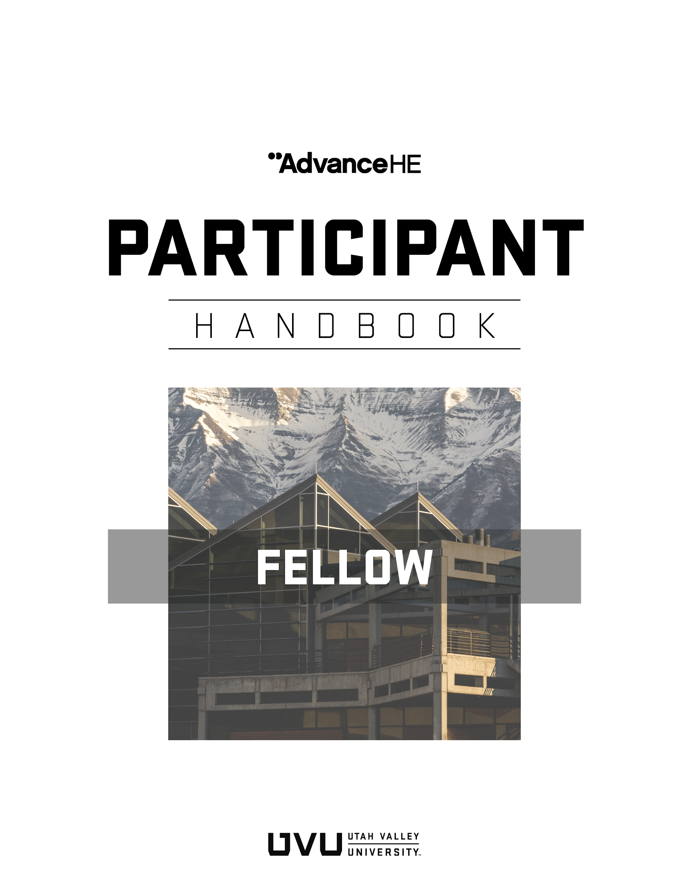

Introduction to Higher Education Academy Fellowship Program 4
Professional Standards Framework 5
UKPSF Dimensions 5
UKPSF Descriptors: Which Category of Fellowship is Right for You? 6
Experiential Route to Fellowship 6
Becoming a Fellow of the Higher Education Academy 8
Fellow Descriptor (D2) 8
Account of Professional Practice (APP) 10
Writing Tips 10
Evidence-based Professional Practice 11
Evidencing Areas of Activity 11
Evidencing Areas of Activity 1 (A1): Design and Plan Learning Activities and/or Programs of Study 11
Evidencing Areas of Activity 2 (A2): Teaching and/or Support Learning 12
Evidencing Areas of Activity 3 (A3): Assess and Give Feedback to Learners 12
Evidencing Areas of Activity 4 (A4): Developing Effective Learning Environments and Approaches to Student Support and Guidance 13
Evidencing Areas of Activity 5 (A5): Engaging in Continuing Professional Development in Subjects/Disciplines and Their Pedagogy; Incorporating Research, Scholarship and the Evaluation of Professional Practice 13
Evidencing Core Knowledge and Professional Values 13
Supporting Statements (Reference Letters) 14
Importance of a Mentor 14
Submitting Your Application 15
How Your Application Will Be Reviewed 15
Appeals and Matters of Concern 16
Your Opportunity for University Service 16
Good Standing 17
Learn More 17
APPENDIX A: FHEA Application Template (Experiential Route) 17
APPENDIX B: Review Grid for FHEA Applications 27

Introduction to Higher Education Academy Fellowship Program
Advance HE (AHE) is an international, non-profit organization that promotes effectiveness in teaching and supporting learning in higher education through the Higher Education Academy (HEA) Fellowship Program. Currently, there are more than 140,000 HEA Fellows worldwide (www.heacademy.ac.uk). A key way in which HEA fellowship supports student success is through professional recognition (awarding of fellowships) of those who teach or support learning in higher education.

UVU is accredited by Advance HE to award three categories of HEA fellowship: Associate Fellow (AFHEA), Fellow (FHEA), and Senior Fellow (SFHEA). This translates to an opportunity each semester for UVU faculty and staff to submit fellowship applications to the Office of Teaching and Learning (OTL). When you apply, you will have the opportunity to:
- Gain recognition in higher education for your teaching/support of learning
- Benchmark your practice against an international standard of teaching/support of learning
- Reflect on your teaching/support of learning practice and celebrate your journey
- Demonstrate commitment to teaching and student learning
- Identify and strengthen your teaching/support of learning by incorporating continual professional development and evidence-based practice in your professional practice.

To be eligible for participation in the fellowship program, you must have at least one year of experience in higher education. Even if you have teaching and learning experience outside of higher education, only examples from higher education can be used.
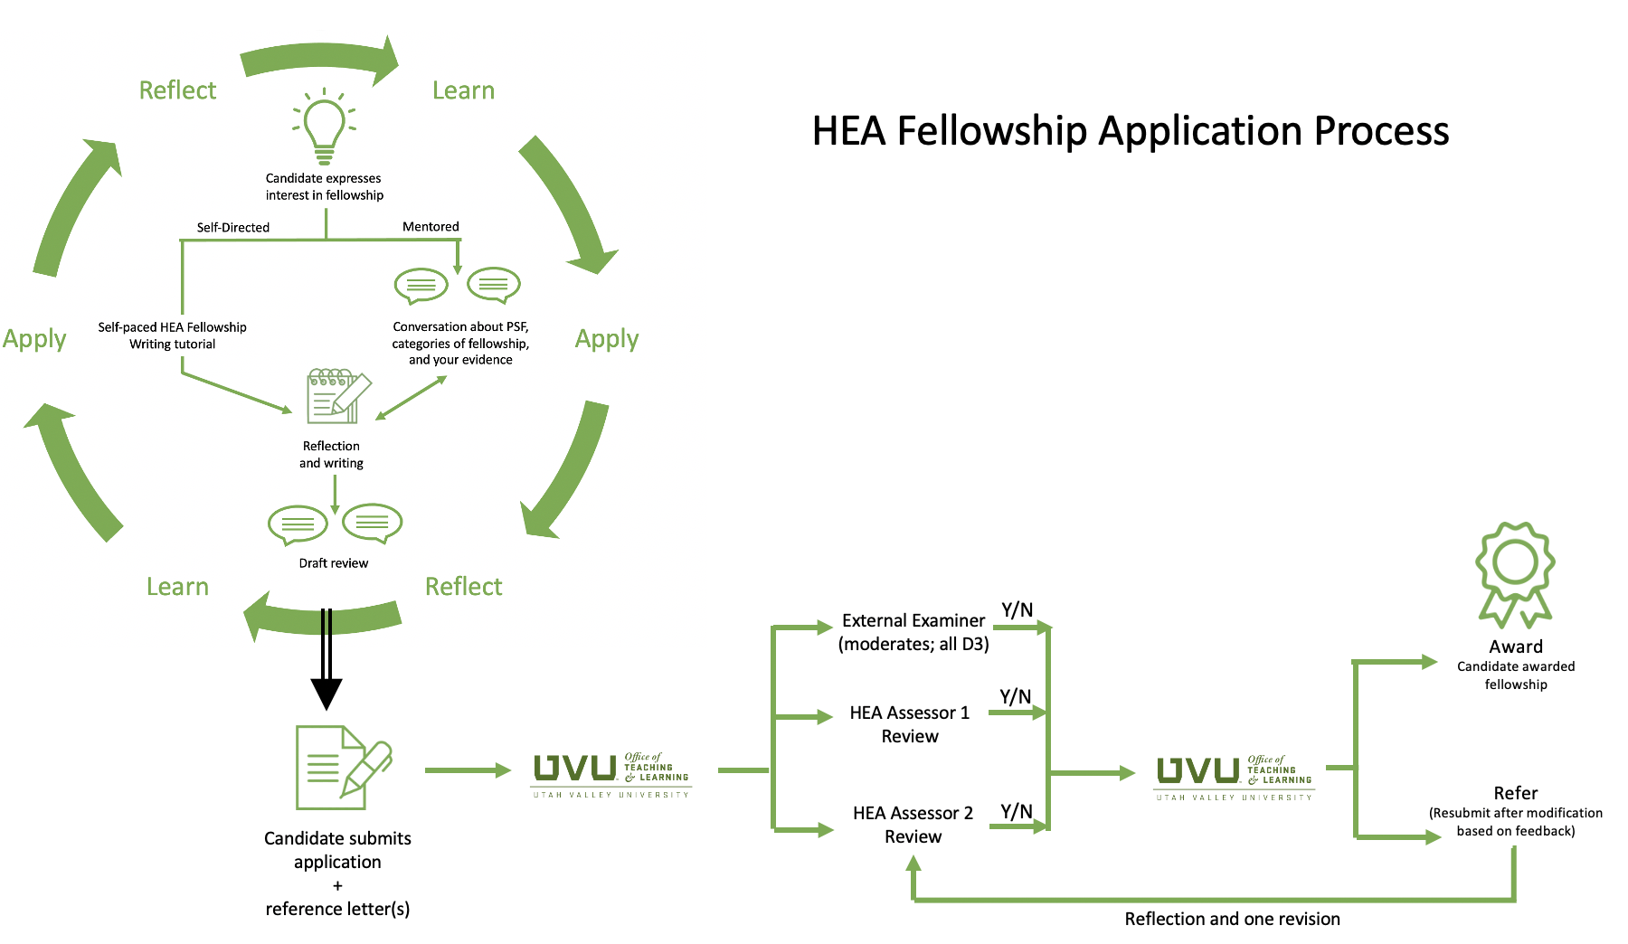
Figure 1. HEA Fellowship application process at UVU.

The process of applying for fellowship generally follows the path illustrated in Figure 1. The starting point is understanding the fellowship program (the light bulb in the top left of the diagram), the Professional Standards Framework (UKPSF), and the appropriate category of fellowship based on one’s experience (see next section). An applicant engages in continuing professional development (CPD), applies new ideas in practice, and evaluates results. The application involves narrating one’s approach to teaching/supporting learning while reflecting on the evidence in alignment with the UKPSF. Applicants are highly recommended to confer with the mentor in writing their applications. Applications are assessed by a panel of two qualified peer assessors who hold HEA fellowship.

Professional Standards Framework
The Professional Standards Framework (UKPSF) is an internationally recognized description of the role of the teaching/supporting learning practitioner in higher education (Figure 2). The UKPSF is organized into dimensions and descriptors. The UKPSF guides the applicant to reflect on the types of evidence necessary to support one’s claim for fellowship.

UKPSF Dimensions
The dimensions include:
- Areas of Activity: Describe what a teaching and learning professional does;
- Core Knowledge: Outlines what they need to know;
- Professional Values: Outlines the manner in which they should carry out their activities.
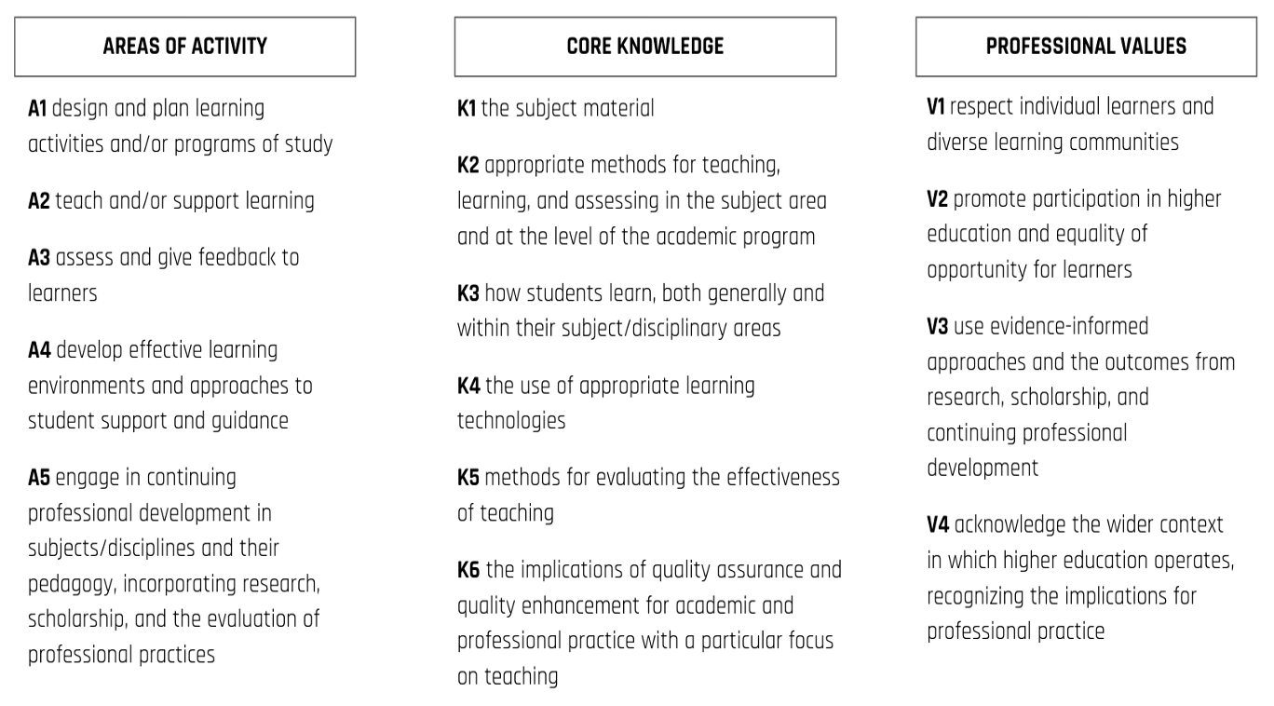
Figure 2. Professional Standards Framework (Source: HEA, 2011)

UKPSF Descriptors: Which Category of Fellowship is Right for You?
- Associate Fellow (AFHEA, Descriptor 1, D1). This category of Fellowship is suitable for anyone who doesn’t have an extensive teaching background, or who only teaches part-time (i.e., an Adjunct Professor). Associate Fellow is also suitable for anyone who supports student learning without directly teaching them (librarians, educational researchers, advisors, etc.)
- Fellow (FHEA, Descriptor 2, D2). This category of Fellowship is suitable for anyone who has a solid teaching background in higher education or who supports student learning more broadly (experienced advisors, instructional designers, instructional technologists, etc.).
- Senior Fellow (SFHEA, Descriptor 3, D3). This category of Fellowship is suitable for anyone who has a solid teaching background and who has done significant work to develop others and/or lead key initiatives within the institution (faculty program leaders, department chairs, associate deans, etc.).
- Principal Fellow (PFHEA, Descriptor 4, D4). This category of Fellowship is suitable for a select few who have instigated significant change and can demonstrate significant impact in teaching and learning within the institution and beyond.

Experiential Route to Fellowship
The Experiential route is a flexible route to HEA fellowship that allows the applicant to draw from recent professional development and teaching/supporting learning experience to write a fellowship application. You must have at least one year of experience in teaching/supporting learning in higher education to apply for fellowship. In the case of Senior Fellow, you must have at least three years of experience. UVU is accredited to assess AFHEA, FHEA, and SFHEA applications through the Experiential route. PFHEA applications must be submitted directly to Advance HE (see Figure 3).
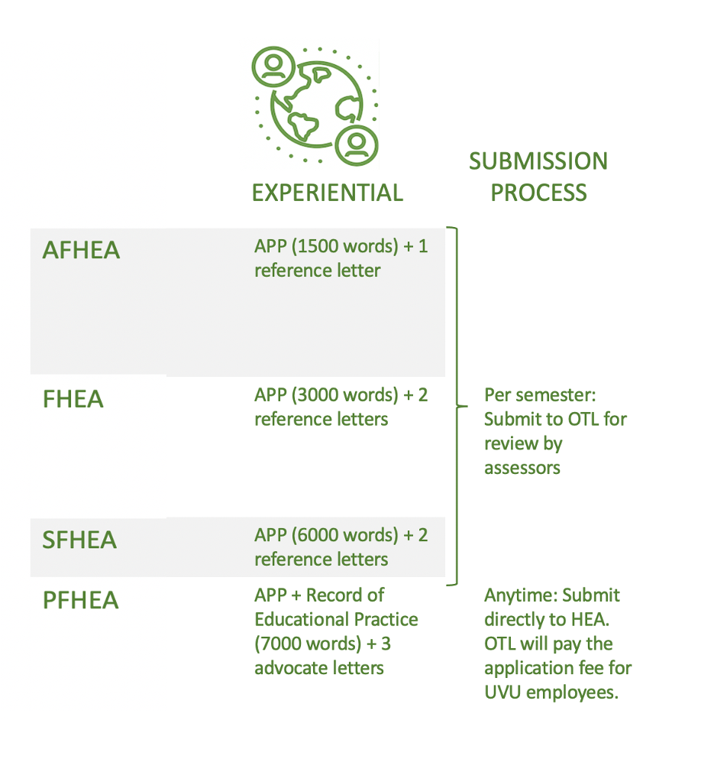
Figure 3. Application and submission details for fellowship applications.

The remainder of this handbook provides specific guidance for FHEA candidates with respect to writing the APP or mini-APP, collecting reference letters, and submitting for review. The assessment process will be described including the scoring rubric used by assessors.

Becoming a Fellow of the Higher Education Academy

Fellow Descriptor (D2)
Fellow of the HEA (FHEA) is the category of professional recognition that is relevant to most staff with broad experience in learning and teaching.
FHEA requires you to meet PSF Descriptor 2. You may be ready to apply for FHEA if you are:
- A full-time, part-time or sessional academic experienced in university teaching (e.g. unit coordinator);
- An early career researcher or experienced research-intensive academic with significant research-led teaching experience related to undergraduates, postgraduates and/or HDR students (e.g. teaching through research projects); or
- An experienced supporter of university learners (e.g. learning technologist, educational designer, librarian, teaching laboratory technician, academic skills specialist, student services support).

The HEA offers specific guidance to the dimensions of the PSF for staff involved in learning support roles.

Advance HE has a Fellowship Category Tool that you might find useful. It is highly recommended that you talk to an HEA Mentor early in the process of seeking fellowship. You can request a mentor on the OTL/HEA webpage.

By applying to be a Fellow of the HEA you will demonstrate a broad understanding of effective approaches to learning and teaching support as a key contribution to high quality student learning. The application provides you with the opportunity to:
- Think deeply about and thereby enhance the quality and effectiveness of your work in the area of teaching and supporting learning in higher education;
- Gain international recognition for your role as a teacher and/or supporter of learning within the higher education context.
- Entitlement to use the post-nominal letters FHEA.
Descriptor 2 Criteria of the UKPSF
Individuals will demonstrate a broad understanding of effective approaches to teaching and learning support as key contributions to high quality student learning. Individuals should be able to provide evidence of:
D2.I. Successful engagement across all five Areas of Activity
D2.II. Appropriate knowledge and understanding across all aspects of Core Knowledge
D2.III. A commitment to all the Professional Values
D2.IV. Successful engagement in appropriate teaching practices related to the Areas of Activity
D2.V. Successful incorporation of subject and pedagogic research and/ or scholarship within the above activities, as part of an integrated approach to academic practice
D2.VI. Successful engagement in continuing professional development in relation to teaching, learning, assessment and, where appropriate, related professional practices.
Therefore, for the award of Fellow, the applicant must demonstrate that their HE practice evidenced all Areas of Activity, Core Knowledge and Professional Values of the UKPSF.

Account of Professional Practice (APP)
The Account of Professional Practice (APP) is the core of your claim. The first part of the claim is a personal narrative in which you will demonstrate your teaching or professional practice against the PSF. Be specific in the teaching and professional activities you use to evidence your practice. Draw from your most recent experience within the last three years. If you include examples of your practice from a team or group, be specific about what you contributed.

As an applicant for FHEA, you are expected to demonstrate a broad experience of university teaching or learner support. This reflective account is the story of that experience, showing how you have reflected on your practice and learned from your engagement in professional development. The focus is on reflection, not description, and should address all the elements of Descriptor 2 of the PSF.

Writing Tips
Unlike most academic writing, reflective writing is subjective. Your annotated reflective account requires you to demonstrate self-awareness and self-inquiry in relating and interpreting your university learning and teaching practices and your engagement in professional development. Through reflection you surface and frame the learning and insight you have gained from your activities and practices.
In considering your teaching and learner support experiences (e.g. e.g. tutoring, lecturing, assessing, research supervision, student advising and mentoring) ask yourself:
- Why do you teach/support learning in that way? What models or perspectives underpin your practice?
- How do you know your practices have impact and are effective in supporting learning?
- How have the activities you’ve undertaken contributed to your professional practice in teaching?
- What lessons have you learned and how has your practice changed as a result?
You can develop your account with reference to a range of experiences, including
- roles and responsibilities,
- awards for learning and teaching,
- formal and informal professional learning and development activities,
- curriculum design,
- research in learning and teaching or
- other relevant initiatives or critical incidents in your experience teaching or supporting learning.
Ensure that you are not simply describing or listing these experiences. Make sure that you reflect on how these experiences have influenced your understanding and your ongoing learning and teaching practice and how this practice aligns with the PSF. You may find it helpful to use the Ryan and Ryan (2012) 4R model of Reflective Thinking (Reporting, Relating, Reasoning and Reconstructing).
The word limit for the APP is 3000 words not including citations. You should include 5 to 8 scholarly citations. For those completing the Taught Route, the mini-APP word limit is 2000 words not including citations. Appendix A contains the FHEA application template for the Experiential route. For the Taught route application templates, see the specific participant handbook for each, found on the OTL/HEA website.
The examples you use in your reflection should be related back to the UKPSF where appropriate. One common way is to annotate the Dimensions within your text, e.g inserting (A1) (A1, A2, & K3) or (A2, K3, & V2) after statements providing that specific evidence (see the examples in the next sections). Avoid using long lists of links to the Dimensions such as (A1, A3, A4, A5, K1, K3, V1, V2, V3) or (A1-A5, K1-K6, & V1-V4); this does not demonstrate meaningful engagement or understanding of the UKPSF.

Evidence-based Professional Practice
In your personal narrative, you will need to evidence both how you use evidence-based practices from scholarship and literature, and your continuing professional development as it relates to teaching and learning. This deepens your reflection and communicates to the assessor why you chose certain activities.
When writing, you should cite/refer to evidence-based sources such articles or other scholarly sources that inform your practice. You should cite as appropriate (e.g. Smith, 2020). When you cite, it should be apparent how that scholarly source relates to your teaching practice. Do not just drop in citations when it does not influence your practice. Include the citation in the reference section of the template.
Continuing professional development relates to teaching and learning should be included in your personal narrative. This shows a commitment to continual development of your professional skills and provides a rationale for your practice as it relates to teaching, student learning, or student academic success.

Evidencing Areas of Activity
In your APP, you need to evidence all five Areas of Activity for Descriptor 2. Below is a description of the five Areas of Activity. Additional Advance HE guidance found here (https://www.advance-he.ac.uk/knowledge-hub/dimensions-framework).

Evidencing Areas of Activity 1 (A1): Design and Plan Learning Activities and/or Programs of Study
A1 relates to the design and preparing of learning activities, in any mode of delivery. This is not that actual teaching. It is focused on the preparation for teaching. The activity in this element may vary depending on your role and discipline and may include activities such as creating a module, course, or an academic program of study; preparing materials for teaching or assessment; redesign a course or learning activity based on feedback from students or peers; or redesigning programs or curricula based on feedback from advisory boards or accreditation standards.
Annotated Example:
I use Team-Based Learning (TBL) in my course to develop critical thinking, teamwork, and writing skills in my students as research has shown students to develop those skills in a POGIL class (Smith, 2018). To implement TBL, I created activity assessments that are part of the TBL process and application exercises that students work on as a team(A1, K2).

Evidencing Areas of Activity 2 (A2): Teaching and/or Support Learning
A2 relates to the engagement and interaction with learners in any mode of delivery and the strategies used to assist student learning. Engagement and interaction with students is the focus of this element. Activities that evidence this activity may include leading students through lectures, discussions, demonstrations, projects, and teamwork.
Annotated Example:
In TBL, students work in teams on application exercises for each unit. This is done in class. I pose a prompt with three answer choices that require the students to think deeply about the question. As a team, they choose a specific answer. As a class, all the teams reveal their answers at the same time and I lead the discussion on why the teams choose the answers they did (A2). This has been a way for students to engage with authentic problems and work together to come up with reasons for their answer.

Evidencing Areas of Activity 3 (A3): Assess and Give Feedback to Learners
A3 relates to providing feedback to learners and assessment of their learning, and progress toward learning outcomes. This may include any formative or summative assessment techniques; how you give feedback on learning progress including feedback-feedforward strategies, criterion-referenced rubrics, or dialogue with students; reflective journals; or observations.
Annotated Example:
To gauge students’ understanding of the material, I use Mazur’s (1997) strategy of peer instruction. In class I pose a question on the material and students answer via clickers. Then students discuss the question with each other before answering the question again. More students select the correct answer the second time. I find this technique useful for assessing student understanding and engaging students in class (A2, A3, A5, K3, V3).

Evidencing Areas of Activity 4 (A4): Developing Effective Learning Environments and Approaches to Student Support and Guidance
A4 relates to effective use of the learning environment in any mode of delivery and how you need the educational needs of your learners. The learning environment can be the physical environment in face-to-face courses or virtual that use learning management systems like Canvas. The second part relates to supporting students which can include personal or academic tutoring, supporting individual needs, developing support for individual students, or supporting diverse learning communities.
Annotated Example:
I assign my students a 10-page research paper. I arrange for a librarian to come talk to my students about doing research and what Library support exists for students doing research. Additionally, I have my students visit the Writing Lab at least once before submitting their research paper (A4, K3, V2).

Evidencing Areas of Activity 5 (A5): Engaging in Continuing Professional Development in Subjects/Disciplines and Their Pedagogy; Incorporating Research, Scholarship and the Evaluation of Professional Practice
A5 relates to continuing professional development, incorporating research and scholarship to inform your teaching, and how you gain feedback into your teaching and professional practice. This broad element relates to three areas of your teaching or professional practice: 1) continuing professional development, 2) using evidenced-informed practices from scholarship or research to inform your teaching, and 3) how do you evaluate your teaching or professional practice.
Annotated Example:
Mazur’s (1997) strategy of peer instruction (A2, A3, A5, K2, V3). In this technique, I pose a question to my class. The class responds via clickers and the results are shown to the class. The students discuss with each other their choices and then the class responds to the same question. The right answer almost always increases after the second attempt.
This simple formative assessment technique has shown to be effective in students understanding the topic and aligns with Mazur’s (1997) findings.
The Areas of Activity link to the other dimensions of Core Knowledge and Professional Values. In the FHEA application, you must make connections to all dimensions of Core Knowledge as well as all Professional Values.

Evidencing Core Knowledge and Professional Values
Your narrative should also show evidence of the following:

Core Knowledge related to:
- K1 The subject material (of your discipline)
- K2 Appropriate methods for teaching and learning in the subject area and at the level of academic program
- K3 How students learn, both generally and within their discipline area(s)
- K4 The use and value of appropriate learning technologies
- K5 Methods for evaluating the effectiveness of teaching
- K6 The implications of quality assurance and quality enhancement for academic and professional practice, with a particular focus on teaching

Commitment to appropriate Professional Values in facilitating learning:
- V1 Respect individual learners and diverse learning communities
- V2 Promote participation in higher education and equality of opportunity for learners
- V3 Use evidence-informed approaches and the outcomes from research, scholarship and continuing professional development
- V4 Acknowledge the wider context in which higher education operates recognising the implications for professional practice

Throughout the narrative, include examples of relevant professional practice, subject and pedagogic research and/or scholarship related to the above activities, and involvement in professional development related to teaching and learning.

Supporting Statements (Reference Letters)
Your APP must include two reference letters that support your claim. The two writers should have recently worked with you to endorse your teaching and professional activities related to student learning. Specific examples should be included rather than vague statements such as “so-and-so is a great asset to our department.” The writers should refer to the guidance document and template (FHEA Supporting Statement Guidance and Template).

Importance of a Mentor
It is highly recommended that you confer with an HEA Mentor 1) before you begin writing to discuss your strategy for completing the application, and 2) to review your draft. Most applicants need help in making effective connections to the PSF and the HEA Mentor will assist you. Your mentor will also help you decide which evidence is most relevant to include in the application. You can request a mentor on the OTL/HEA webpage.

Submitting Your Application
A complete application includes Part A (for the Taught route, Part A consists of endorsed key assignments and for the Experiential route, Part A consists of your CV), APP, and two reference letters. You will submit your application by clicking the “Apply for HEA Fellowship” box on the OTL/HEA webpage. Note the approximate application deadlines in Table 1 below. If you have any questions about the submission process, contact hea@uvu.edu.

How Your Application Will Be Reviewed
Your application will be reviewed by two assessors who hold FHEA/SFHEA/PFHEA fellowship and have completed an annual calibration exercise. Assessment of your application will follow one of three assessment cycles (Table 1).
Table 1. Assessment cycles
Fall Cycle
Deadline for submissions | Early November
Distribution of submissions to assessors and moderation, if needed | Mid-November
Notifications | Early December
Spring Cycle
Deadline for submissions | Early March
Distribution of submissions to assessors and moderation, if needed | Mid-March
Notifications | Early to Mid April
Summer Cycle
Deadline for submissions | Early July
Distribution of submissions to assessors and moderation, if needed | Mid-July
Notifications | Early August
The assessors use a review grid based on the descriptor (see Appendix B). Assessors will review individually, then meet to come to a final consensus and draft feedback to you with one of the following possible outcomes:
- Award: After coming to a consensus, it is in the assessors’ judgement that you have met the requirements for fellowship.
- Refer: After coming to a consensus, it is in the assessors’ judgement that your APP is borderline and needs revisions or additions to achieve fellowship. You will be given instructions on how to document your revisions, offered HEA Mentor support, and have one opportunity to resubmit within one month. The same assessors will review your APP changes and make a final decision on whether to award or refer.
- Apply Anew / Second Refer: [After resubmission] After coming to a consensus, it is in the assessors’ judgement that your experience does not fully meet the criteria for fellowship at this time. Assessors will give feedback on what needs to be done to be successful in the future. A new APP will need to be submitted at a future deadline.
The assessment cycle takes approximately 3-4 weeks.

Appeals and Matters of Concern
Appeals may be submitted within 15 working days of receiving a final written notice of the decision. For further information on appeals, contact hea@uvu.edu. Appeals may be submitted on the following grounds:
- Procedural requirements in relation to the application or review process were not followed, resulting in a decision which was unfair.
- Relevant evidence was not considered in reaching the decision.

The applicant should submit any information or evidence relevant to the grounds for their appeal. Applicants lodging an appeal will receive a notification from OTL within 5 working days indicating receipt of their appeal and outlining the procedure that will be followed. All appeals will be submitted to the HEA Fellowship Oversight Council who will make one of the following recommendations:
- Appeal is dismissed – confirm the original outcome
- Appeal is upheld – the original outcome will be reviewed

To raise a matter of concern about any aspect of UVU’s HEA Fellowship Scheme, email the Senior Director of OTL, Wendy Athens at wendy.athens@uvu.edu. All matters of concern are treated in a confidential manner and will be investigated without disadvantage to the complainant. Any action resulting will feed into the fellowship scheme’s enhancement process.

Your Opportunity for University Service
Once awarded FHEA you will be recognized as an HEA Fellow in several ways:
- Your name, department, and college will be added to the OTL/HEA webpage, Academic Affairs homepage, and OTL Faculty Development dashboard.
- You will receive a door plaque and certificate.
- In April, you will receive a trophy at the annual Faculty Recognition Luncheon.
- In the summer, your picture will be added to the HEA Fellowship wall in the OTL lobby.

You will be invited to mentor future applicants for AFHEA or FHEA after first completing the HEA Mentors and Assessors course. You will also be invited to HEA Fellowship Forums and may be asked to provide input to your academic department and university on educational issues. These opportunities for peer support and mentoring will contribute to your future professional development. It is expected that many Fellows will wish to prepare themselves for an application for SFHEA as they gain more experience in leading initiatives and peers. OTL will provide opportunities for peer support and mentoring with this in mind.

Good Standing
It is implicit within the PSF and required by the HEA that all Fellows remain in good standing. It is the responsibility of individuals to ensure they remain in good standing by continuing to work in line with their relevant Fellow descriptor standard (as outlined in the Framework) and the Fellowship of the HEA Code of Practice.

We expect HEA Fellows to be working towards their next award and be performing, or out-performing, their current Fellow descriptor standard. All Fellows should therefore be able to demonstrate compliance with (at least) their awarded level at any given time.

HEA Fellows should maintain a personal record of their professional development activity to demonstrate that they remain in good standing. OTL supports development, and compliance with Fellowship descriptors through a broad range of modules, workshops, seminars and conferences. In addition, you are encouraged to continue to read and engage with scholarship of learning and teaching through peer-reviewed journals, research and resources.

Learn More
If you require further assistance, please view the resources available on the OTL/HEA webpage or email hea@uvu.edu.

APPENDIX A: FHEA Application Template
Use this template to prepare your application, then access the live form at the “Click here to apply for HEA fellowship” button on the OTL/HEA website. Copy and paste from this template into the appropriate sections. Note you will be asked to upload a copy of your CV and reference letter at that time. Your referee should receive a copy of your application, referee guidance document/template in advance in order to prepare a reference letter for you.

Name:

Job Title:

Department:

Email:

Telephone:

Name of Your Mentor:

Your teaching/supporting learning context:
Please describe the context of your practice and why you have chosen to pursue FHEA fellowship (300 words or less - not included in overall word count).

Statement: Please check the box below to indicate that you certify and agree to the following statements:
All personal information shared in this application will be held confidential, secured, and accessed only by authorized staff for assessment and evaluation purposes, including Advance HE staff. There will be no public sharing of information contained in this application without my written permission.
The information I have provided is true and correct and meets all standards of academic integrity. If I am successful in this application, I will commit to remain in good standing with HEA by continuing my professional development and enhancement of my teaching/supporting learning skills, knowledge and practice. HEA Code of Practice

- I have read and understood the above statements. Date:___________

Guidance Notes
This form has three Parts – A, B and C. You should refer to the guidance provided in the section “Applying through the Experiential Program” in the Fellow Handbook when you write your application.
Part A - Your Fellowship Claim
Applicants need to demonstrate engagement with all the Dimensions of the UKPSF and illustrate how they are integrated, embedded and demonstrated in practice.
Applicants should demonstrate Core Knowledge relevant to the Areas of Activity and an awareness and commitment to the Professional Values. Annotate your statements by inserting the appropriate UKPSF dimension(s) after evidence is presented, e.g. “I converted my classrooms to flipped model after attending a session at the AAC&U Conference and creating a number of video lectures (A1, K4).”
Fellowship Claim for PART A should not exceed 3,000 words (excluding references). You must provide evidence of all five Areas of Activity (around 600 words for each Activity) and meet other Descriptor 2 requirements as described in Part A below.
Part B – Your supporting documents
Please attach the following:
- Your CV

Part C – Identify Your Referees
Applicants should name their referees and provide their contact details. In this part of the application, you will also be advised how to submit your claim including your referees’ statement.

Descriptor for Fellow (D2)
Individuals will demonstrate a broad understanding of effective approaches to teaching and learning support as key contributions to high quality student learning. Individuals should be able to provide evidence of:
D2.I. Successful engagement across all five Areas of Activity
D2.II. Appropriate knowledge and understanding across all aspects of Core Knowledge
D2.III. A commitment to all the Professional Values
D2.IV. Successful engagement in appropriate teaching practices related to the Areas of Activity
D2.V. Successful incorporation of subject and pedagogic research and/ or scholarship within the above activities, as part of an integrated approach to academic practice
D2.VI. Successful engagement in continuing professional development in relation to teaching, learning, assessment and, where appropriate, related professional practices.
Therefore, for the award of Fellow, the applicant must demonstrate that their HE practice evidences all Areas of Activity, Core Knowledge and Professional Values of the UKPSF.

Dimensions of the Professional Standards Framework (UKPSF)
Intersperse within your narrative evidence of all Core Knowledge and Professional Values dimensions according to the figure below. Throughout the narrative, include examples of relevant professional practice, subject and pedagogic research and/or scholarship related to the above activities, and involvement in professional development related to teaching and learning.

Part A
Applicants should complete ALL Areas of Activity

A1. Evidencing Area of Activity 1: Design and plan learning activities and/or programmes of study
This Area of Activity refers to all your professional educational activities where you are preparing for engagement with learners in any mode of delivery. This is not the actual teaching. It is focused on the preparation for teaching. The activity in this element may vary depending on your role and discipline and may include activities such as creating a module, course, or an academic program of study; preparing materials for teaching or assessment; redesign a course or learning activity based on feedback from students or peers; or redesigning programs or curricula based on feedback from advisory boards or accreditation standards. The design of your learning activities should reflect a developing knowledge and understanding of the Core Knowledge and Professional Values Dimensions.
Evidence for Area of Activity 1 (start typing here)

A2. Evidencing Area of Activity 2: Teach and/or support learning
This Area of Activity relates to the direct engagement and interaction with learners in any mode of delivery and the strategies used to assist student learning. Engagement and interaction with students are the focus of this element. These interactions may take place in a wide range of environments, such as teaching rooms, seminar rooms, lecture theatres, labs, learning support centers, Activities that evidence this activity may include leading students through lectures, discussions, demonstrations, tutorials, seminar work, projects and teamwork, studio, laboratory, supervision, workplace-based teaching.
In demonstrating the activities of teaching and supporting learning, ensure your evidence demonstrates a current and ongoing awareness of different approaches to and methods of teaching and supporting learning, as well as a growing ability to choose the most appropriate approach for the achievement of learning aims.

Evidence for Area of Activity 2 (start typing here)

A3. Evidencing Area of Activity 3: Assess and give feedback to learners
A3 relates to demonstrating an increasing awareness of different methods of, and approaches to, assessment and feedback/feed-forward approaches in the context of your work with learners, as well as a growing ability to choose the most appropriate approach for the achievement of your learning outcomes. to providing feedback to learners and assessment of their learning, and progress toward learning outcomes. This may include any formative or summative assessment techniques; how you give feedback on learning progress including feedback-feedforward strategies, criterion-referenced rubrics, or dialogue with students; reflective journals; or observations.

Evidence for Area of Activity 3 (start typing here)

A4. Evidencing Area of Activity 4: Develop effective learning environments and approaches to student support and guidance

This Area of Activity is about how you make effective use of both the formal and informal learning environment to facilitate learning and how you meet the needs of your learners in terms of educational support and guidance. It includes how you:
- Utilize and manage a range of physical or virtual learning environments so that they are appropriate to your learners’ needs;
- Work with learners and service providers to ensure that your learners can access and use a broad range of learning opportunities. Learner support might include such activities as personal and academic tutoring, one-to-one advice, counselling, developing practice to meet the learning implications of widening access and supporting learners with disabilities.
Evidence for Area of Activity 4 (start typing here)

A5. Evidencing Area of Activity 5: Engage in continuing professional development in subjects/disciplines and their pedagogy, incorporating research, scholarship and the evaluation of professional practices
The UKPSF provides a powerful means of articulating the varied aspects of your role and the potential for development in a range of areas in respect of teaching and/or supporting learning. A5 relates to continuing professional development, incorporating research and scholarship to inform your teaching, and how you gain feedback into your teaching and professional practice.
This Area of Activity is about how you maintain and develop your capability to perform your teaching and learning support roles. It includes:
- Continuing professional development
- How you incorporate subject and pedagogic research and/or scholarship within your professional practice as a teacher/supporter of learning;
- How you gather and utilize information from your own activities to evaluate your teaching or professional practice.
Evidence for Area of Activity 5 (start typing here)

Reference List (start typing here)

Part B
Your Account of Professional Practice (APP) must include your CV. You will be asked to upload a copy of your CV when you click on the “Apply for HEA Fellowship” box on the OTL/HEA webpage. If you have any questions about the submission process, contact otl@uvu.edu.

Part C

Referees
Your Account of Professional Practice (APP) must include two reference letters that supports your claim from experienced colleagues or senior staff who work directly with you and can comment, from first-hand experience, on your teaching and professional activities related to student learning. Your referees should comment on the effectiveness and quality of your learning support practices, appropriate to the requirements for Descriptor 2. Specific examples should be included rather than vague statements such as “so-and-so is a great asset to our department.” Guidance for referees is supplied in the guidance document found on the website.

Please complete the following table:
 | Referee 1 | Referee 2

Name of Referee:

Job Title:

Department:

Email:

Phone:

Submitting Your Application
A complete application includes your CV, APP/mini-APP, and one reference letter. You will submit your CV, APP/mini-APP, and one reference letter by clicking the “Apply for HEA Fellowship” box on the OTL/HEA webpage. If you have any questions about the submission process, contact otl@uvu.edu.

Your application will be reviewed by two assessors who hold HEA fellowship and have completed an annual calibration exercise. They will individually score your application, then collaborate in summarizing their feedback to you. Assessment of your application will follow one of three assessment cycles.

APPENDIX B: Review Grid for FHEA Applications

Fellow Review Grid

Applicant name
Outcome first submission | Award |  | Refer |  | Date
Assessor 1
Assessor 2
Outcome following resubmission | Award |  | Unsuccessful |  | Date

Section 1: Assessor judgement and feedback against Descriptor 2 Criteria
Each Assessor to complete their section of the review grid below to note their judgement against each criterion (please tick Met or Not Met) and add comments to explain your judgement.

SECTION 1: Review of application against Descriptor 2 Criteria
D2.I Successful engagement across all five Areas of Activity |  | Met  (X) | Not Met  (X)
Assessor 1
Assessor 2
D2. II Appropriate knowledge and understanding across all aspects of Core Knowledge |  | Met  (X) | Not Met  (X)
Assessor 1
Assessor 2
D2.III A commitment to all the Professional Values |  | Met  (X) | Not Met  (X)
Assessor 1
Assessor 2
D2. IV Successful engagement in appropriate teaching practices related to the Areas of Activity |  | Met  (X) | Not Met  (X)
Assessor 1
Assessor 2
D2.V Successful incorporation of subject and pedagogic research and/or scholarship within the above activities, as part of an integrated approach to academic practice |  | Met  (X) | Not Met  (X)
Assessor 1
Assessor 2
D2.VI Successful engagement in continuing professional development in relation to teaching, learning, assessment and, where appropriate, related professional practices |  | Met  (X) | Not Met  (X)
Assessor 1
Assessor 2
Do Supporting Statements (references) broadly corroborate the account?  (If ‘no’ add comments below) |  | Yes (X) | No (X)
Assessor 1
Assessor 2
SECTION 2: Initial individual Accreditor judgement and feedback to referred applicants. This is the section where you enter your individual feedback) |  | Award  (X) | Refer  (X)
Assessor 1
Assessor 2
SECTION 3: Record of Panel discussions (This is the section where you enter your joint feedback)
Record agreed first Panel Outcome (Award or Refer) and, if relevant, second Panel Outcome (Award or Unsuccessful) in the sections at the top of this form.

