Planning Your Claim – SFHEA (D3)
Use this worksheet to plan your Senior Fellow of the Higher Education Academy (HEA) claim. This category of Fellowship is suitable for anyone who has a solid teaching background and who has done significant work to develop others and/or lead key initiatives within the institution (faculty program leaders, department chairs, associate deans, etc.).

D3 Requirements:
Demonstrates a thorough understanding of effective approaches to teaching and learning support as a key contribution to high quality student learning. Individuals should be able to provide evidence of:

D3.I Successful engagement across all five Areas of Activity
D3.II Appropriate knowledge and understanding across all aspects of Core Knowledge
D3.III A commitment to all the Professional Values
D3.IV Successful engagement in appropriate teaching practices related to the Areas of Activity
D3.V Successful incorporation of subject and pedagogic research and/ or scholarship within the above activities, as part of an integrated approach to academic practice
D3.VI Successful engagement in continuing professional development in relation to teaching, learning, assessment, scholarship and, as appropriate, related academic or professional practices
D3.VII Successful coordination, support, supervision, management and/ or mentoring of others (whether individuals and/or teams) in relation to teaching and support of learning

Professional Standards Framework (UKPSF)
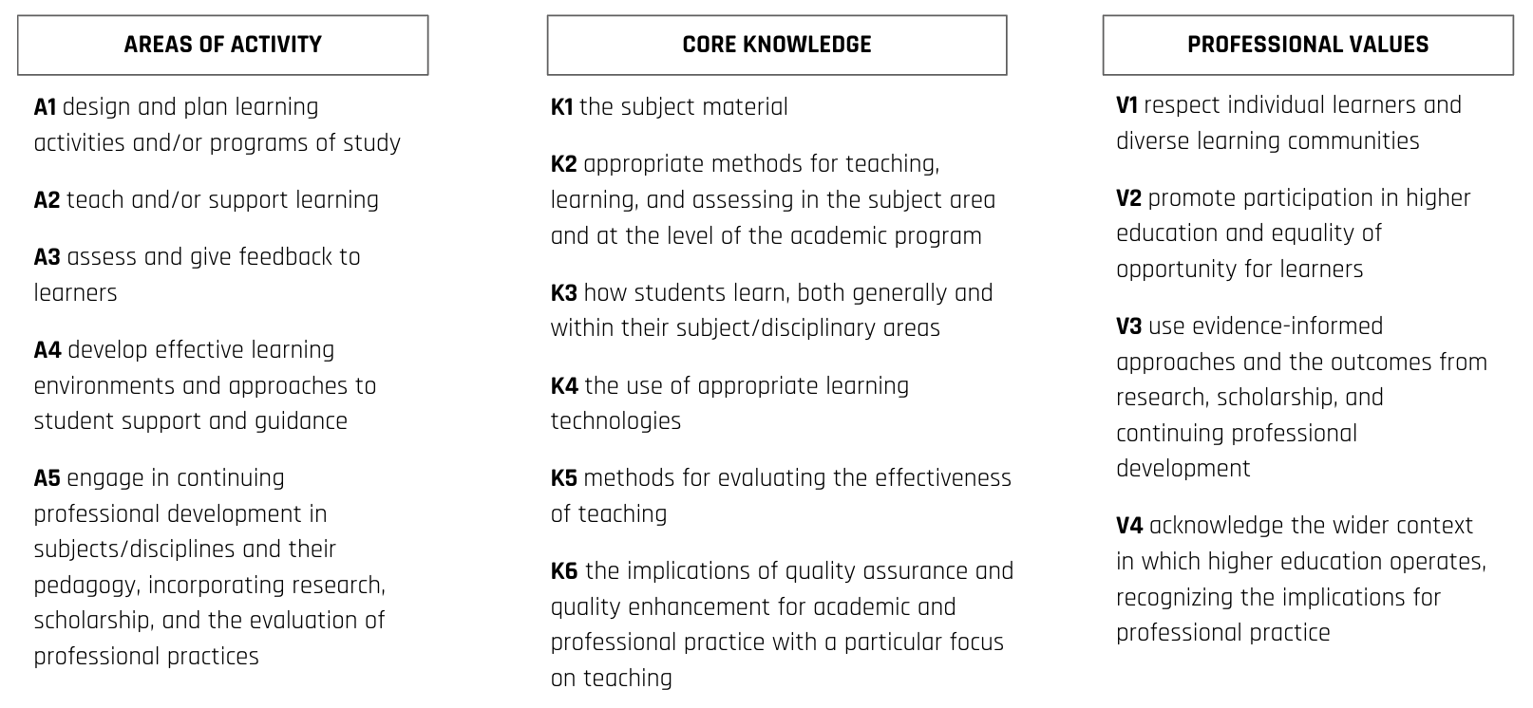

In the following worksheet, provide two examples of your teaching or professional practice and evidence of impact.
Areas of Activity | Your 2 best examples: | Which areas of Core Knowledge are associated | Which areas of Professional Values are associated | What is the evidence of impact
A1: Design and plan learning activities and/or programs of study
A2: Teach and/or support learning
A3: Assess and give feedback to learners
A4: Develop effective learning environments and approaches to student support & guidance
A5: Engage in continuing professional development in subjects/disciplines and their pedagogy, incorporating research, scholarship and the evaluation of teaching practice.
Case Study 1

Case Study 2

The D3 claim should include 8-10 examples of scholarship/research that informs your teaching or professional practice.
Citation or source | Brief description on how it informs your teaching or professional practice

