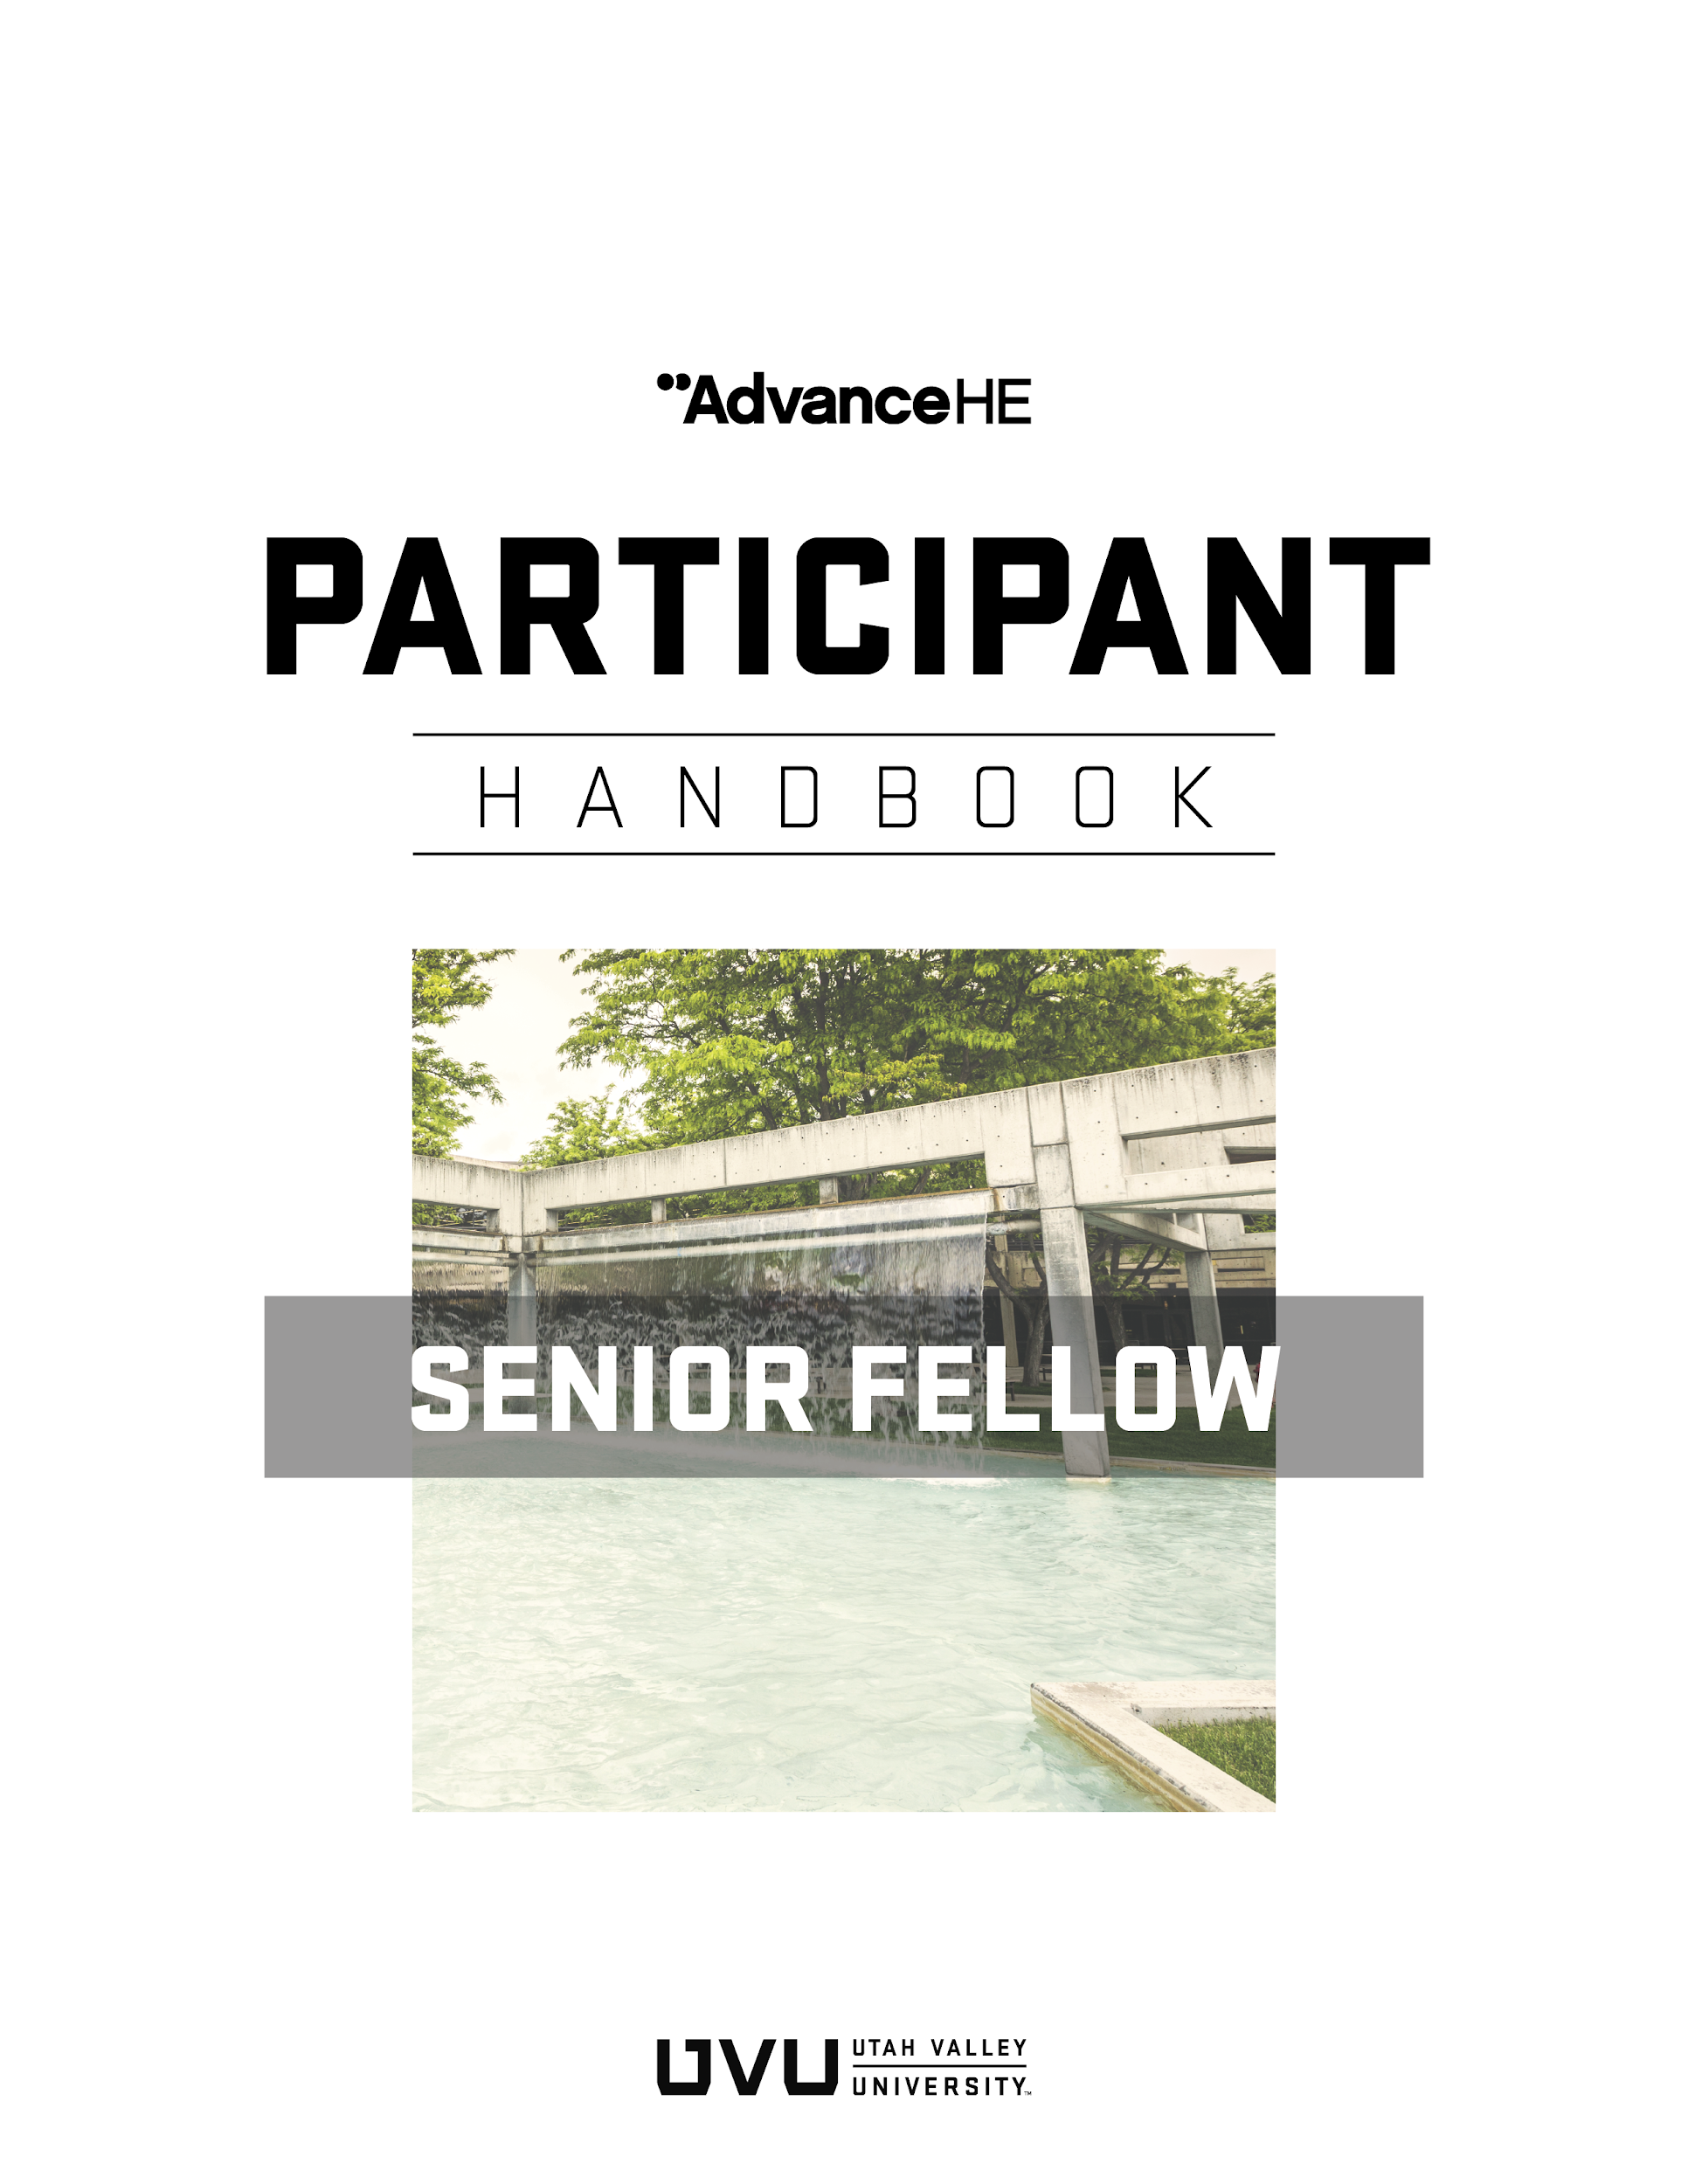

Introduction to Higher Education Academy Fellowship Program 4
Professional Standards Framework 5
UKPSF Dimensions 5
UKPSF Descriptors 6
Routes to Fellowship: SFHEA Uses Experiential Route 7
Senior Fellow Descriptor (D3) 9
SFHEA requires you to meet UKPSF Descriptor 3 (D3) criteria: 9
Evidence-based Professional Practice 10
Evidencing D3.VII 10
Evidencing Areas of Activity 10
Evidencing Areas of Activity 1 (A1): Design and Plan Learning Activities and/or Programs of Study 10
Evidencing Areas of Activity 2 (A2): Teaching and/or Support Learning 11
Evidencing Areas of Activity 3 (A3): Assess and Give Feedback to Learners 11
Evidencing Areas of Activity 4 (A4): Developing Effective Learning Environments and Approaches to Student Support and Guidance 12
Evidencing Areas of Activity 5 (A5): Engaging in Continuing Professional Development in Subjects/Disciplines and Their Pedagogy; Incorporating Research, Scholarship and the Evaluation of Professional Practice 12
Evidencing Core Knowledge and Professional Values 12
Account of Professional Practice (APP) 13
Writing Tips 14
Writing the Case Studies 15
Supporting Statements (Reference Letters) 16
Importance of a Mentor 16
Submitting Your Application 16
How Your Application Will Be Reviewed 17
Appeals and Matters of Concern 18
Your Opportunity for University Service 18
Good Standing 19
Learn More 19
APPENDIX A: SFHEA Application Template (Experiential Route) 20
APPENDIX B: Case Study Exemplar 26
APPENDIX C: Review Grid for SFHEA Assessors 28

Introduction to Higher Education Academy Fellowship Program
Advance HE (AHE) is an international, non-profit organization that promotes effectiveness in teaching and supporting learning in higher education through the Higher Education Academy (HEA) Fellowship Program. Currently, there are more than 140,000 HEA Fellows worldwide (www.heacademy.ac.uk). A key way in which HEA fellowship supports student success is through professional recognition (awarding of fellowships) of those who teach or support learning in higher education.

UVU is accredited by Advance HE to award three categories of HEA fellowship: Associate Fellow (AFHEA), Fellow (FHEA), and Senior Fellow (SFHEA). This translates to an opportunity each semester for UVU faculty and staff to submit fellowship applications to the Office of Teaching and Learning (OTL). When you apply, you will have the opportunity to:
- Gain recognition in higher education for your teaching/support of learning
- Benchmark your practice against an international standard of teaching/support of learning
- Reflect on your teaching/support of learning practice and celebrate your journey
- Demonstrate commitment to teaching and student learning
- Identify and strengthen your teaching/support of learning by incorporating continual professional development and evidence-based practice in your professional practice.

To be eligible for participation in the fellowship program, you must have experience in higher education. Even if you have teaching and learning experience outside of higher education, only examples from higher education can be used.
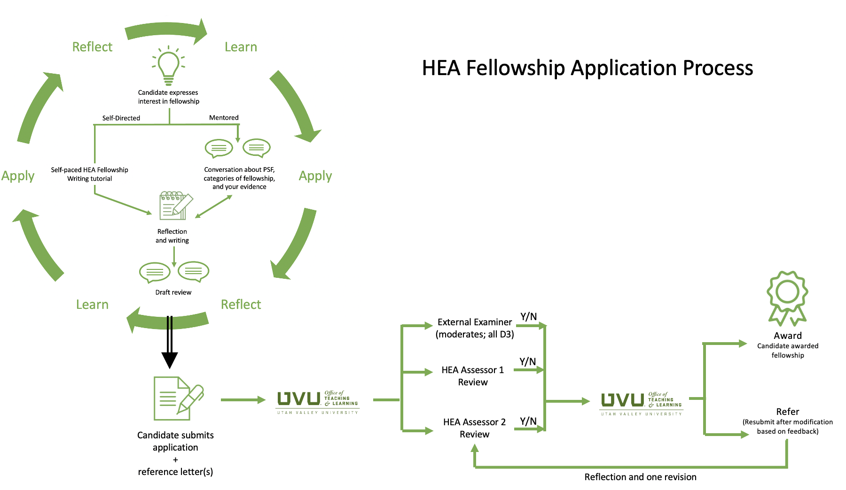
Figure 1. HEA Fellowship application process at UVU.

The process of applying for fellowship generally follows the path illustrated in Figure 1. The starting point is understanding the fellowship program, the Professional Standards Framework (PSF), and the appropriate category of fellowship based on one’s experience (see next section). An applicant engages in continuing professional development (CPD), applies new ideas in practice, and evaluates results. The application involves narrating one’s approach to teaching/supporting learning while reflecting on the evidence in alignment with the PSF. Applicants are highly recommended to confer with the mentor in writing their applications. Applications are assessed by a panel of two assessors.

Professional Standards Framework
The Professional Standards Framework (UKPSF) is an internationally recognized description of the role of the teaching/supporting learning practitioner in higher education (Figure 2). The PSF is organized into dimensions and descriptors. The PSF guides the applicant to reflect on the types of evidence necessary to support one’s claim for fellowship.

UKPSF Dimensions
The dimensions include:
- Areas of Activity: Describe what a teaching and learning professional does;
- Core Knowledge: Outlines what they need to know;
- Professional Values: Outlines the manner in which they should carry out their activities.
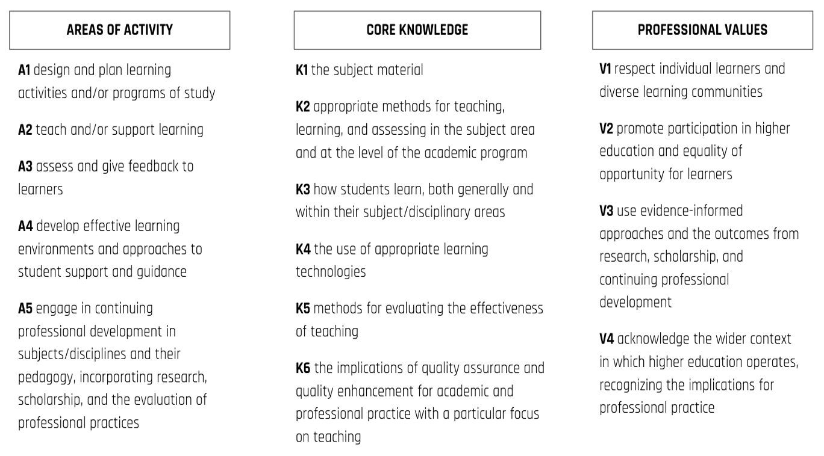
Figure 2. Professional Standards Framework (Source: HEA, 2011)

UKPSF Descriptors
- Associate Fellow (AFHEA, Descriptor 1, D1). This category of Fellowship is suitable for anyone who doesn’t have an extensive teaching background, or who only teaches part-time (i.e. an Adjunct Professor). Associate Fellow is also suitable for anyone who supports student learning without directly teaching them (librarians, educational researchers, advisors, etc.)
- Fellow (FHEA, Descriptor 2, D2). This category of Fellowship is suitable for anyone who has a solid teaching background in higher education or who supports student learning more broadly (experienced advisors, instructional designers, instructional technologists, etc.).
- Senior Fellow (SFHEA, Descriptor 3, D3). This category of Fellowship is suitable for anyone who has a solid teaching background and who has done significant work to develop others and/or lead key initiatives within the institution (faculty program leaders, department chairs, associate deans, etc.).
- Principal Fellow (PFHEA, Descriptor 4, D4). This category of Fellowship is suitable for a select few who have instigated significant change and can demonstrate significant impact in teaching and learning within the institution and beyond.

Experiential Route to Fellowship
The Experiential route is a flexible route to HEA fellowship that allows the applicant to draw from recent professional development and teaching/supporting learning experience to write a fellowship application. You must have at least three years of experience in teaching/supporting learning in higher education to apply for Senior Fellowship. UVU is accredited to assess AFHEA, FHEA, and SFHEA applications through the Experiential route. PFHEA applications must be submitted directly to Advance HE (see Figure 3).
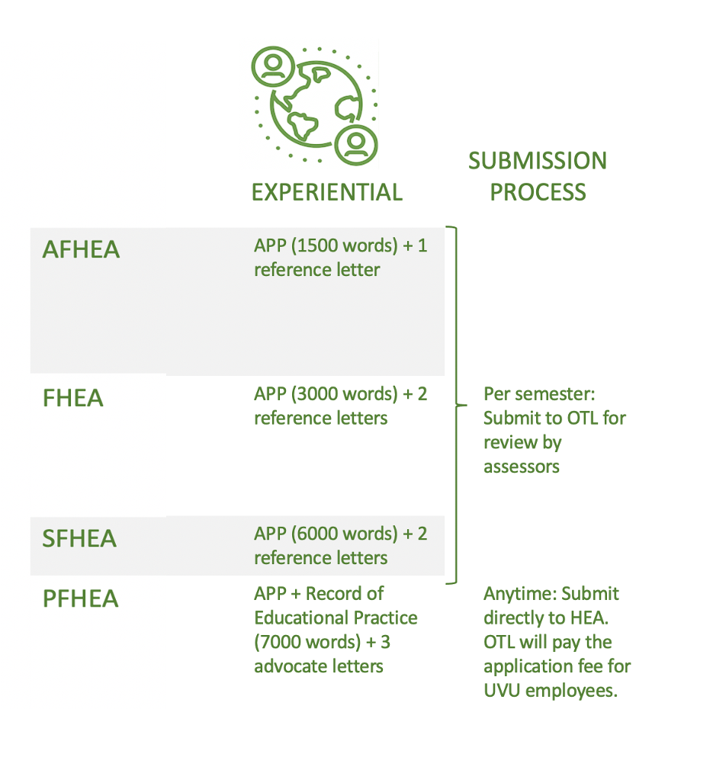
Figure 3. Application and submission details for fellowship applications.

The remainder of this handbook provides specific guidance for SFHEA candidates with respect to writing the APP including two case studies, collecting reference letters, and submitting for review. The assessment process will be described including the review grid used by assessors.

Senior Fellow Descriptor (D3)
Senior Fellow of the HEA (FHEA) is an advanced category of professional recognition for those with a sustained record of effectiveness in relation to learning and teaching. Typical roles include individuals able to provide evidence of a sustained record of effectiveness in relation to teaching and learning, incorporating for example, the organisation, leadership and/or teaching and learning provision. Such individuals are likely to lead or be members of established academic teams. Typically, those likely to be at Descriptor 3 (D3) include:
- Experienced staff able to impact and influence through, for example, responsibility for leading, managing or organizing programmes, subjects and/or disciplinary areas
- Experienced subject mentors and staff who support those new to teaching
- Experienced staff with departmental and/or wider teaching and learning support advisory responsibilities within an institution

By applying to be a Senior Fellow of the HEA you will demonstrate a thorough understanding of effective approaches to learning and teaching support as a key contribution to high quality student learning. The application provides you with the opportunity to:
- Think deeply about and thereby enhance the quality and effectiveness of your work in the area of teaching and supporting learning in higher education;
- Gain international recognition for your role as a teacher and/or supporter of learning within the higher education context;
- Entitlement to use the post-nominal letters SFHEA.

SFHEA requires you to meet UKPSF Descriptor 3 (D3) criteria:

Demonstrates a thorough understanding of effective approaches to teaching and learning support as a key contribution to high quality student learning. Individuals should be able to provide evidence of:

D3.I. Successful engagement across all five Areas of Activity
D3.II. Appropriate knowledge and understanding across all aspects of Core Knowledge
D3.III. A commitment to all the Professional Values
D3.IV. Successful engagement in appropriate teaching practices related to the Areas of Activity D3.V. Successful incorporation of subject and pedagogic research and/ or scholarship within the above activities, as part of an integrated approach to academic practice
D3.VI. Successful engagement in continuing professional development in relation to teaching, learning, assessment, scholarship and, as appropriate, related academic or professional practices
D3.VII. Successful coordination, support, supervision, management and/ or mentoring of others (whether individuals and/or teams) in relation to teaching and learning

Evidence-based Professional Practice
In your personal narrative, you will need to evidence both how you use evidence-based practices from scholarship and literature, and your continuing professional development as it relates to teaching and learning. This deepens your reflection and communicates to the assessor why you chose certain activities.
When writing, you should cite/refer to evidence-based sources such articles or other scholarly sources that inform your practice. You should cite as appropriate (e.g. Smith, 2020). When you cite, it should be apparent how that scholarly source relates to your teaching practice. Do not just drop in citations when it does not influence your practice. Include the citation in the reference section of the template. Five to eight references are expected within the FHEA application.
Continuing professional development relates to teaching and learning should be included in your personal narrative. This shows a commitment to continual development of your professional skills and provides a rationale for your practice as it relates to teaching, student learning, or student academic success.

Evidencing D3.VII
The hallmark of the SFHEA application is evidence of successful coordination, support, supervision, management and/or mentoring of others (whether individuals and/or teams) in relation to teaching and learning. This evidence should be integrated across the application and focused upon in the case studies. See Appendix B for a case study exemplar.

Evidencing Areas of Activity
In your APP, you need to evidence all five Areas of Activity for Descriptor 3. Below is a description of the five Areas of Activity. Additional Advance HE guidance found here (https://www.advance-he.ac.uk/knowledge-hub/dimensions-framework).

Evidencing Areas of Activity 1 (A1): Design and Plan Learning Activities and/or Programs of Study
A1 relates to the design and preparing of learning activities, in any mode of delivery. This is not that actual teaching. It is focused on the preparation for teaching. The activity in this element may vary depending on your role and discipline and may include activities such as creating a module, course, or an academic program of study; preparing materials for teaching or assessment; redesign a course or learning activity based on feedback from students or peers; or redesigning programs or curricula based on feedback from advisory boards or accreditation standards.
Annotated Example:
I use Team-Based Learning (TBL) in my course to develop critical thinking, teamwork, and writing skills in my students as research has shown students to develop those skills in a POGIL class (Smith, 2018). To implement TBL, I created activity assessments that are part of the TBL process and application exercises that students work on as a team(A1, K2).

Evidencing Areas of Activity 2 (A2): Teaching and/or Support Learning
A2 relates to the engagement and interaction with learners in any mode of delivery and the strategies used to assist student learning. Engagement and interaction with students is the focus of this element. Activities that evidence this activity may include leading students through lectures, discussions, demonstrations, projects, and teamwork.
Annotated Example:
In TBL, students work in teams on application exercises for each unit. This is done in class. I pose a prompt with three answer choices that require the students to think deeply about the question. As a team, they choose a specific answer. As a class, all the teams reveal their answers at the same time and I lead the discussion on why the teams choose the answers they did (A2). This has been a way for students to engage with authentic problems and work together to come up with reasons for their answer.

Evidencing Areas of Activity 3 (A3): Assess and Give Feedback to Learners
A3 relates to providing feedback to learners and assessment of their learning, and progress toward learning outcomes. This may include any formative or summative assessment techniques; how you give feedback on learning progress including feedback-feedforward strategies, criterion-referenced rubrics, or dialogue with students; reflective journals; or observations.
Annotated Example:
To gauge students’ understanding of the material, I use Mazur’s (1997) strategy of peer instruction. In class I pose a question on the material and students answer via clickers. Then students discuss the question with each other before answering the question again. More students select the correct answer the second time. I find this technique useful for assessing student understanding and engaging students in class (A2, A3, A5, K3, V3).

Evidencing Areas of Activity 4 (A4): Developing Effective Learning Environments and Approaches to Student Support and Guidance
A4 relates to effective use of the learning environment in any mode of delivery and how you need the educational needs of your learners. The learning environment can be the physical environment in face-to-face courses or virtual that use learning management systems like Canvas. The second part relates to supporting students which can include personal or academic tutoring, supporting individual needs, developing support for individual students, or supporting diverse learning communities.
Annotated Example:
I assign my students a 10-page research paper. I arrange for a librarian to come talk to my students about doing research and what Library support exists for students doing research. Additionally, I have my students visit the Writing Lab at least once before submitting their research paper (A4, K3, V2).

Evidencing Areas of Activity 5 (A5): Engaging in Continuing Professional Development in Subjects/Disciplines and Their Pedagogy; Incorporating Research, Scholarship and the Evaluation of Professional Practice
A5 relates to continuing professional development, incorporating research and scholarship to inform your teaching, and how you gain feedback into your teaching and professional practice. This broad element relates to three areas of your teaching or professional practice: 1) continuing professional development, 2) using evidenced-informed practices from scholarship or research to inform your teaching, and 3) how do you evaluate your teaching or professional practice.
Annotated Example:
Mazur’s (1997) strategy of peer instruction (A2, A3, A5, K2, V3). In this technique, I pose a question to my class. The class responds via clickers and the results are shown to the class. The students discuss with each other their choices and then the class responds to the same question. The right answer almost always increases after the second attempt.
This simple formative assessment technique has shown to be effective in students understanding the topic and aligns with Mazur’s (1997) findings.
The Areas of Activity link to the other dimensions of Core Knowledge and Professional Values. In the FHEA application, you must make connections to all dimensions of Core Knowledge as well as all Professional Values.

Evidencing Core Knowledge and Professional Values
Your narrative should also show evidence of the following:

Core Knowledge related to:
- K1 The subject material (of your discipline)
- K2 Appropriate methods for teaching, learning, and assessing in the subject area and at the level of academic program
- K3 How students learn, both generally and within their discipline area(s)
- K4 The use and value of appropriate learning technologies
- K5 Methods for evaluating the effectiveness of teaching
- K6 The implications of quality assurance and quality enhancement for academic and professional practice, with a particular focus on teaching

Commitment to appropriate Professional Values in facilitating learning:
- V1 Respect individual learners and diverse learning communities
- V2 Promote participation in higher education and equality of opportunity for learners
- V3 Use evidence-informed approaches and the outcomes from research, scholarship and continuing professional development
- V4 Acknowledge the wider context in which higher education operates recognising the implications for professional practice

Throughout the narrative, include examples of relevant professional practice, subject and pedagogic research and/or scholarship related to the above activities, and involvement in professional development related to teaching and learning.

Account of Professional Practice (APP)
The Account of Professional Practice (APP) is the core of your claim. The first part of the claim is a personal narrative in which you will demonstrate your teaching or professional practice against the PSF. Be specific in the teaching and professional activities you use to evidence your practice. Draw from your most recent experience within the last three-five years. If you include examples of your practice from a team or group, be specific about what you contributed.

A Senior Fellow can demonstrate successful coordination, supervision, management and/or mentoring of other staff members in relation to teaching and learning. This criterion (D3.VII) is the lens through which applications for SFHEA should be written and is scrutinized intently; it is the key difference between the FHEA and SFHEA descriptors in the PSF.

In addition, as an applicant for SFHEA, you are expected to demonstrate a broad experience of university teaching or learner support. This reflective account is the story of that experience, showing how you have reflected on your practice and learned from your engagement in professional development. The focus is on reflection, not description, and should address all the elements of Descriptor 3 of the PSF.

Writing Tips
Unlike most academic writing, reflective writing is subjective. Your annotated reflective account requires you to demonstrate self-awareness and self-inquiry in relating and interpreting your university learning and teaching practices and your engagement in professional development. Through reflection you surface and frame the learning and insight you have gained from your activities and practices.
In considering your teaching and learner support experiences (e.g. e.g. tutoring, lecturing, assessing, research supervision, student advising and mentoring) ask yourself:
- Why do you teach/support learning in that way? What models or perspectives underpin your practice?
- How do you know your practices have impact and are effective in supporting learning?
- How have the activities you’ve undertaken contributed to your professional practice in teaching?
- What lessons have you learned and how has your practice changed as a result?
You can develop your account with reference to a range of experiences, including
- roles and responsibilities,
- awards for learning and teaching,
- formal and informal professional learning and development activities,
- curriculum design,
- research in learning and teaching or
- other relevant initiatives or critical incidents in your experience teaching or supporting learning.
Your APP should take a highly integrated approach to your academic practice that clearly incorporates real-world insights, relevant research or scholarship related to teaching and learning. Make sure that you reflect on how these experiences have influenced your understanding and your ongoing learning and teaching practice and how this practice aligns with the PSF. You may find it helpful to use the Ryan and Ryan (2012) 4R model of Reflective Thinking (Reporting, Relating, Reasoning and Reconstructing).
The word limit for the APP is 6000 words (3000 words for the narrative and 1500 for each of the two case studies). These case studies allow you to give in-depth reflections on two examples of your professional practice in teaching that demonstrate your successful and sustained contribution to other staff that helps them on their journey as university teachers or supporters of learning, through leadership, supervision (of teaching or learning support staff), formal or informal mentoring, or collegial activities. Annotate your case studies with reference to the PSF and Descriptor 3. Both should illustrate how you meet PSF Descriptor 3.vii. Including between 8-10 citations to the literature, the maximum word count is 6200 words. Use the Word templates on the website to construct your APP.
The examples you use in your reflection should be related back to the UKPSF where appropriate.

Writing the Case Studies
(Adapted from the HEA Guide for Senior Fellowships, December 2014)

In this section of your application, provide reflective accounts of two particular contributions or experiences which:
- have had a significant impact upon the coordination, support, supervision, management and/or mentoring of other staff members (whether individuals and/or teams), in relation to learning and teaching;
- demonstrate your sustained effectiveness in relation to learning and teaching and that you meet the criteria for Senior Fellowship.

Use the two case studies to address different aspects of Descriptor 3, with a focus on your organisation, leadership and/or management of specific aspects of learning and teaching provision. The emphasis should be on your effectiveness in relation to learning and teaching and should incorporate how you have led, organised or managed specific aspects of learning and teaching provision. Both cases should evidence how you have mentored or supported other staff members involved in learning and teaching using your skills, knowledge and awareness in leading, managing or organising programmes, subjects and/or disciplinary areas. You should clearly demonstrate an integrated and reflective approach to academic practice that incorporates research, scholarship and/or professional practice.

Focus on particular aspects of your work such as:

Developing quality enhancement
- ways you coordinate, support, manage or mentor others to ensure appropriate alignment of teaching, learning and assessment practices;
- how you ensure that student learning within the context of your responsibilities is enriched by disciplinary and pedagogic research, scholarship and professional practice (your own and that of others);
- ways you have fostered dynamic approaches to learning and teaching through creativity and innovation.

Supporting other colleagues involved in learning and teaching
- how you have supported other colleagues to enhance their own practices teaching and or supporting learning;
- specific examples of how you have enhanced academic practice through coordinating/managing others;
- your roles in learning and teaching projects and initiatives at departmental, institutional or in the wider HE context;
- course and programme development, review and revalidation.

Sustained engagement with educational and staff development
- staff development activities you have facilitated (informal and formal) that enhance your colleagues’ abilities to meet the dimensions of the UKPSF;
- how your contributions have promoted the student learning experience through professional development of staff under your influence and guidance e.g. through informal or formal mentoring arrangements;
- how you have disseminated your knowledge and skills in teaching and supporting learning to audiences both within and external to your institution.

Evaluation of academic practice
- steps you have taken to develop your own practice and how you have used your own experience to enable others to reflect on and critique their own practice;
- how you support, encourage and implement evaluation processes designed to enhance the student learning experience.

Refer to Appendix B for a case study exemplar.

Supporting Statements (Reference Letters)
Your APP must include two reference letters that support your claim. The two writers should have recently worked with you to endorse your teaching and professional activities related to student learning. Specific examples should be included rather than vague statements such as “so-and-so is a great asset to our department.” The writers should refer to the guidance document and template (SFHEA Supporting Statement Guidance and Template).

Importance of a Mentor
It is highly recommended that you confer with an HEA Mentor 1) before you begin writing to discuss your strategy for completing the application, and 2) to review your draft. Most applicants need help in making effective connections to the PSF and the HEA Mentor will assist you. Your mentor will also help you decide which evidence is most relevant to include in the application. You can request a mentor on the OTL/HEA webpage.

Submitting Your Application
A complete application includes your CV, APP, and two reference letters. You will submit your application by clicking the “Click here to apply for HEA Fellowship” box on the OTL/HEA webpage. Note the approximate application deadlines in Table 1 below. If you have any questions about the submission process, contact hea@uvu.edu.

How Your Application Will Be Reviewed
Your application will be reviewed by two assessors and an external reviewer who hold at least SFHEA fellowship and who have completed an annual calibration exercise. They will individually score your application, then collaborate in summarizing their feedback to you. Assessment of your application will follow one of three assessment cycles (Table 1).
Table 1. Assessment cycles
Fall Cycle
Deadline for submissions | Early November
Distribution of submissions to assessors and moderation, if needed | Mid-November
Notifications | Early December
Spring Cycle
Deadline for submissions | Early March
Distribution of submissions to assessors and moderation, if needed | Mid-March
Notifications | Early to Mid April
Summer Cycle
Deadline for submissions | Early July
Distribution of submissions to assessors and moderation, if needed | Mid-July
Notifications | Early August
The assessors use a review grid based on the descriptor for the category of fellowship (see Appendix B). Assessors will review individually, then meet to come to a final consensus and draft feedback to you with one of the following possible outcomes:
- Award: After coming to a consensus, it is in the assessors’ judgement that you have met the requirements for fellowship.
- Borderline: After coming to a consensus, it is in the assessors’ judgement that your APP is borderline and needs some minor revisions or additions to achieve fellowship. You will be given instructions on how to document your revisions, offered HEA Mentor support, and have one opportunity to resubmit within one month. The same assessors will review your APP changes and make a final decision on whether to award or refer.
- Refer: After coming to a consensus, it is in the assessors’ judgement that your experience does not fully meet the criteria for fellowship at this time. Assessors will give feedback on what needs to be done to be successful in the future. A new APP will need to be submitted at a future deadline.
The assessment cycle takes approximately 3-4 weeks.

Appeals and Matters of Concern
Appeals may be submitted within 15 working days of receiving a final written notice of the decision. For further information on appeals, contact hea@uvu.edu. Appeals may be submitted on the following grounds:
- Procedural requirements in relation to the application or review process were not followed, resulting in a decision which was unfair.
- Relevant evidence was not considered in reaching the decision.

The applicant should submit any information or evidence relevant to the grounds for their appeal. Applicants lodging an appeal will receive a notification from OTL within 5 working days indicating receipt of their appeal and outlining the procedure that will be followed. All appeals will be submitted to the HEA Fellowship Oversight Council who will make one of the following recommendations:
- Appeal is dismissed – confirm the original outcome
- Appeal is upheld – the original outcome will be reviewed

To raise a matter of concern about any aspect of UVU’s HEA Fellowship Scheme, email the Senior Director of OTL, Wendy Athens at wendy.athens@uvu.edu. All matters of concern are treated in a confidential manner and will be investigated without disadvantage to the complainant. Any action resulting will feed into the fellowship scheme’s enhancement process.

Your Opportunity for University Service
Once awarded SFHEA you will be recognized as an HEA Senior Fellow in several ways:
- Your name, department, and college will be added to the OTL/HEA webpage, Academic Affairs homepage, and OTL Faculty Development dashboard.
- You will receive a door plaque and certificate.
- In April, you will receive a trophy at the annual Faculty Recognition Luncheon.
- In the summer, your picture will be added to the HEA Fellowship wall in the OTL lobby.

You will be invited to mentor future applicants for AFHEA/FHEA/SFHEA after first completing the HEA Mentors and Assessors course. You will also be invited to HEA Fellowship Forums and may be asked to provide input to your academic department and university on educational issues. These opportunities for peer support and mentoring will contribute to your future professional development.

Good Standing
It is implicit within the PSF and required by the HEA that all Senior Fellows remain in good standing. It is the responsibility of individuals to ensure they remain in good standing by continuing to work in line with their relevant Senior Fellow descriptor standard (as outlined in the Framework) and the Fellowship of the HEA Code of Practice.

We expect HEA Senior Fellows to be working towards PFHEA and be performing, or out-performing, their current Senior Fellow descriptor standard. All Senior Fellows should therefore be able to demonstrate compliance with (at least) their awarded level at any given time.

HEA Senior Fellows should maintain a personal record of their professional development activity to demonstrate that they remain in good standing. OTL supports development, and compliance with fellowship descriptors through a broad range of modules, workshops, seminars and conferences. In addition, you are encouraged to continue to read and engage with scholarship of learning and teaching through peer-reviewed journals, research and resources.

Learn More
If you require further assistance, please view the resources available on the OTL/HEA webpage or email hea@uvu.edu.

APPENDIX A Application Template for HEA Senior Fellow (FHEA)
Name:

Job Title:

Department:

Email:

Telephone:

Name of Your Mentor:

Your teaching/supporting learning context:
Please describe the context of your practice and why you have chosen the Senior Fellow category of fellowship (300 words or less - not included in overall word count).

Statement Please check the box below to indicate that you certify and agree to the following statements:

All personal information shared in this application will be held confidential, secured, and accessed only by authorized staff for assessment and evaluation purposes, including Advance HE staff. There will be no public sharing of information contained in this application without my written permission.

The information I have provided is true and correct and meets all standards of academic integrity. If I am successful in this application, I will commit to remain in good standing with HEA by continuing my professional development and enhancement of my teaching/supporting learning skills, knowledge and practice. HEA Code of Practice

- I have read and understood the above statement. Date:___________

Guidance Notes
This form has three Parts – A, B and C. You should refer to the guidance provided in the section. You should refer to the guidance provided in the section “Applying through the Experiential Program” in the Senior Fellow Handbook when you write your application.
Part A – Your Fellowship Claim
Your Senior Fellowship Claim for Section A comprises three components:
- Account of Professional Practice which demonstrates how your practice aligns to the requirements for Descriptor 3.
- Case Study One which provides an example of how you lead, manage and enhance the curriculum of programmes in your subject and/or discipline area demonstrating influence and impact.
- Case Study Two which provides an example of your successful coordination, support, supervision or mentoring of other staff.
Part B – Your supporting documents
Please attach the following:
- Your CV

Part C – Identify Your Referees
Applicants should name their referees and provide their contact details. In this part of the application, you will also be advised how to submit your claim including your referees’ statements.

Descriptor for Senior Fellow (D3)
Individuals will demonstrate a broad understanding of effective approaches to teaching and learning support as key contributions to high quality student learning. Individuals should be able to provide evidence of:

D3.I. Successful engagement across all five Areas of Activity
D3.II. Appropriate knowledge and understanding across all aspects of Core Knowledge
D3.III. A commitment to all the Professional Values
D3.IV. Successful engagement in appropriate teaching practices related to the Areas of Activity
D3.V. Successful incorporation of subject and pedagogic research and/ or scholarship within the above activities, as part of an integrated approach to academic practice
D3.VI. Successful engagement in continuing professional development in relation to teaching, learning, assessment and, where appropriate, related professional practices.
D3. VII. VII. Successful coordination, support, supervision, management and/or mentoring of others (whether individuals and/or teams) in relation to teaching and learning.

Dimensions of the Professional Standards Framework (UKPSF)
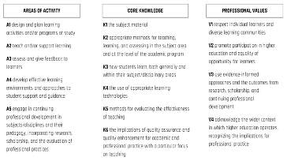
Intersperse within your narrative evidence of all Core Knowledge and Professional Values dimensions according to the figure below. Throughout the narrative, include examples of relevant professional practice, subject and pedagogic research and/or scholarship related to the above activities, and involvement in professional development related to teaching and learning.

Part A
Account of Professional Practice
Your Account of Professional Practice (APP) should demonstrate how your practice aligns to the requirements for Descriptor 3. It should outline the philosophy that underpins your teaching practice and how this impacts your students' learning. You can draw on relevant literature and on experience/knowledge gained through engaging in professional development activities. When referring to specific methodologies and/or approaches to teaching, you will need to present a rationale and indicate how you measure their effectiveness and their impact on students’ learning.
This account can also include your education, training, employment, roles and experience which have contributed to your professional development as a teacher, mentor, facilitator of learning and academic leader.
Your Account of Professional Practice (~ 3000 words start typing here)

Case Study One

In this section, you should provide an example of a particular contribution or experience which has had sustained effectiveness in relation to learning and teaching.
Elements to consider in this case study include:
- Examples of leading, managing and enhancing the curriculum in your subject and/or discipline area.
- The ways in which you liaise with others to ensure appropriate alignment of teaching, learning and assessment practices;
- How you ensure that student learning within the context of your responsibilities is enriched by disciplinary and pedagogic research, scholarship and professional practice (your own and that of others);
- The ways you have fostered dynamic approaches to learning and teaching through creativity and innovation;
- How you support, encourage and implement evaluation processes designed to enhance the student learning experience;
- Your roles in learning and teaching projects and initiatives at departmental, institutional or in the wider HE context;
- Course and program development, review and revalidation.

Case Study One (~1500 - start typing here)

Case Study Two
You should provide an example of successful coordination, support, supervision or mentoring of others.
Elements to consider in this case study include:
- How you have supported other colleagues to enhance their practices;
- Specific examples of how you have enhanced academic practice through coordinating/managing others
- Faculty development activities you have facilitated (informal and formal) that enhance your colleagues’ abilities to meet the dimensions of the UKPSF
- How your contributions have promoted the student learning experience through professional development of faculty under your influence and guidance (e.g. through informal or formal mentoring arrangements
- How you have disseminated your knowledge and skills in teaching and supporting learning to audiences both within and external to your institution
- Steps you have taken to develop your own practice and how you have used your own experience to enable others to reflect on and critique their own practice.

Case Study Two (~ 1500 - start typing here)

Reference List (start typing here)

Part B

Your Account of Professional Practice (APP) must include your CV. You will be asked to upload a copy of your CV when you click on the “Apply for HEA Fellowship” box on the OTL/HEA webpage. If you have any questions about the submission process, contact otl@uvu.edu.

Part C

Referee

Your APP must include two reference letters that support your claim from an experienced colleague or senior staff who works directly with you and can comment, from first-hand experience, on your teaching and professional activities related to student learning. Your referee should comment on the effectiveness and quality of your teaching practices, appropriate to the requirements for Descriptor 3.

Specific examples should be included rather than vague statements such as “so-and-so is a great asset to our department.” Guidance for referees is supplied in the guidance document found on the website.

Please complete the following table:
 | Referee 1 | Referee 2
Name of Referee:
Job Title:
Department:
Email:

Submitting Your Application
A complete application includes your CV, APP, and two reference letters. You will submit your application by clicking the “Apply for HEA Fellowship” box on the OTL/HEA webpage. If you have any questions about the submission process, contact otl@uvu.edu.
Your application will be reviewed by two assessors and an external reviewer who hold at least SFHEA fellowship and who have completed an annual calibration exercise. They will individually score your application, then collaborate in summarizing their feedback to you.

Appendix 1

Senior Fellow Descriptor (D3)
Senior Fellow of the HEA (FHEA) is an advanced category of professional recognition for those with a sustained record of effectiveness in relation to learning and teaching. SFHEA requires you to meet PSF Descriptor 3 (D3).

You may be ready to apply for SFHEA if you are:
- An academic (full time, part time or sessional) who is highly experienced in teaching and has significant teaching responsibilities, including, for example, leading or coordinating courses or units, and/or managing teams of tutors or academic peers;
- An experienced staff member who specifically supports colleagues new to teaching at OTL;
- Highly experienced professional staff supporters of academic development and student learning with substantive experience (e.g. you could be a learning technologist, educational designer, librarian, technician in a teaching laboratory, or provider of learning support through academic skills or student services);
- A research-intensive academic with significant academic supervision and mentoring responsibilities and/or convening responsibilities for research-focused teaching programs; or
- An experienced staff member who supports, supervises, manages and/or mentors other staff members involved in learning and teaching.
The HEA offers specific guidance to the dimensions of the PSF for staff involved in learning support roles.

Appendix 1
Evidencing the UKPSF Dimensions

A1. Evidencing Area of Activity 1: Design and plan learning activities and/or programmes of study
This Area of Activity refers to all your professional educational activities where you are preparing for engagement with learners in any mode of delivery. This is not the actual teaching. It is focused on the preparation for teaching. The activity in this element may vary depending on your role and discipline and may include activities such as creating a module, course, or an academic program of study; preparing materials for teaching or assessment; redesign a course or learning activity based on feedback from students or peers; or redesigning programs or curricula based on feedback from advisory boards or accreditation standards. The design of your learning activities should reflect a developing knowledge and understanding of the Core Knowledge and Professional Values Dimensions.

A2. Evidencing Area of Activity 2: Teach and/or support learning
This Area of Activity relates to the direct engagement and interaction with learners in any mode of delivery and the strategies used to assist student learning. Engagement and interaction with students is the focus of this element. These interactions may take place in a wide range of environments, such as teaching rooms, seminar rooms, lecture theatres, labs, learning support centres, Activities that evidence this activity may include leading students through lectures, discussions, demonstrations, tutorials, seminar work, projects and teamwork, studio, laboratory, supervision, workplace-based teaching.
In demonstrating the activities of teaching and supporting learning, ensure your evidence demonstrates a current and ongoing awareness of different approaches to and methods of teaching and supporting learning, as well as a growing ability to choose the most appropriate approach for the achievement of learning aims.

A3. Evidencing Area of Activity 3: Assess and give feedback to learners
A3 relates to demonstrating an increasing awareness of different methods of, and approaches to, assessment and feedback/feed-forward approaches in the context of your work with learners, as well as a growing ability to choose the most appropriate approach for the achievement of your learning outcomes. to providing feedback to learners and assessment of their learning, and progress toward learning outcomes. This may include any formative or summative assessment techniques; how you give feedback on learning progress including feedback-feedforward strategies, criterion-referenced rubrics, or dialogue with students; reflective journals; or observations.

A4. Evidencing Area of Activity 4: Develop effective learning environments and approaches to student support and guidance

This Area of Activity is about how you make effective use of both the formal and informal learning environment to facilitate learning and how you meet the needs of your learners in terms of educational support and guidance. It includes how you:
- utilise and manage a range of physical or virtual learning environments so that they are appropriate to your learners’ needs;
- work with learners and service providers to ensure that your learners can access and use a broad range of learning opportunities. Learner support might include such activities as personal and academic tutoring, one-to-one advice, counselling, developing practice to meet the learning implications of widening access and supporting learners with disabilities.

A5. Evidencing Area of Activity 5: Engage in continuing professional development in subjects/disciplines and their pedagogy, incorporating research, scholarship and the evaluation of professional practices
The UKPSF provides a powerful means of articulating the varied aspects of your role and the potential for development in a range of areas in respect of teaching and/or supporting learning. This Area of Activity is about how you maintain and develop your capability to perform your teaching and learning support roles. It includes:
- how you incorporate subject and pedagogic research and/or scholarship within your professional practice as a teacher/supporter of learning;
- how you gather and utilise information from your own activities.

Evidencing Core Knowledge and Professional Values

Your narrative should also show evidence of the following:
Core Knowledge related to:
- K1 The subject material (of your discipline)
- K2 Appropriate methods for teaching and learning in the subject area and at the level of academic program
- K3 How students learn, both generally and within their discipline area(s)
- K4 The use and value of appropriate learning technologies
- K5 Methods for evaluating the effectiveness of teaching
- K6 The implications of quality assurance and quality enhancement for academic and professional practice, with a particular focus on teaching

Commitment to appropriate Professional Values in facilitating learning:
- V1 Respect individual learners and diverse learning communities
- V2 Promote participation in higher education and equality of opportunity for learners
- V3 Use evidence-informed approaches and the outcomes from research, scholarship and continuing professional development
- V4 Acknowledge the wider context in which higher education operates recognising the implications for professional practice.

Submitting Your Application
A complete application includes your CV, APP, and two reference letters. You will submit your application by clicking the “Click here to apply for HEA Fellowship” box on the OTL/HEA webpage. If you have any questions about the submission process, contact hea@uvu.edu.
Your application will be reviewed by two assessors and an external reviewer who hold at least SFHEA fellowship and who have completed an annual calibration exercise. They will individually score your application, then collaborate in summarizing their feedback to you.

APPENDIX B: Case Study Exemplar
SCULPT is a faculty-driven organization at UVU whose mission is to serve as a resource for the support and promotion of the use of undergraduate research as part of the pedagogy. As a founding member of SCULPT, I was involved in its institutionalization. As part of a Title III grant, the OEL invited teams of faculty to participate in a series of five workshops sponsored by the Council of Undergraduate Research (CUR). I was a member of the team that participated with another four colleagues in the workshop on “Institutionalizing undergraduate research.” In this workshop, we learned the advantages of including research as a part of student activities. The experience of teaching institutions similar to ours shows that research helps increase retention rates, graduation, and leads to a higher index of student satisfaction (A5, K6, V4).
At UVU, we already had a group of instructors who incorporated undergraduate research as part of their teaching and their research. Their students presented their work at events such as the Utah Council of Undergraduate Research (UCUR), NCUR, and the Utah Academy of Science. The OEL financially supported students for their presentations. However, the need to institutionalize the role of research as an inclusive element of teaching was evident. This objective follows the UVU mission of engaged and inclusive learning. Also, there is a need to provide more significant support and recognition to instructors who, in addition to their regular activities, took on the role of mentors for their students. The workshop helped to outline a short, medium, and long term plan.
At UVU the importance of increasing research activities related to teaching was already understood, this was the purpose of the Title III grant, and it was expected that the group of colleagues who attended the workshops would be integrated into the formation of this program. The Title III grant, which lasts for four years, served to carry out our short and medium-term plans. Personal Involvement: I was an active participant in the writing of the white paper (SCULPT, 2015), and the activities that followed such as the promotion of SCULPT among faculty, the creation of the first brochure, convocation presentations, etc.
In the fall of 2016, I was invited to be a co-chair of SCULPT for two years. During that period, we saw the organization grow from less than twenty members to more than a hundred. In this first phase, it was essential to support the instructors to be mentors of students in undergraduate research (K5). Thanks to the collaboration of the OTL, the Mentoring Academy was created and guided by one of our SCULPT members. Also, the OTL hosted book discussions related to undergraduate research. In my experience in these two activities, the most significant aspect was not only discussing the application of techniques that could be used as activities in class or the redefinition of the curriculum, but also the discussion with colleagues from other departments and with more experience in the use of undergraduate research as a part of pedagogy (A5, K6, V4). The experience with SCULPT was published as a short piece in Sweet, et al. (2018). I was a co-author with Arendt, Aguilera, Tolman, and Kopp. In the article, we delineated the three areas of focus for SCULPT: institutionalization, integration into the curriculum, and advocacy to support the two areas. We emphasized the role of SCULPT as part of a teaching institution that differentiates from R1 institutions. We made it clear that the role of undergraduate research is to support teaching and promote engaged learning, which are the primary missions of UVU (V4). As an analytical framework for undergraduate research, we encourage the use of the Willison and O’Regan (2007) Research Skill Development (RSD) framework (Willison & O’Regan, 2006). This framework helps identify the different level of students’ autonomy for doing research as well as the different facets of research (V3).
It was useful to determine the elements of early exposure of research for students in their first or second semesters of a college education. For example, the first level of students’ autonomy is the Prescribed Research where the instructor mostly guides students to research activities that could be done during class or as assignments. The Unbounded Research level can be used with capstone students, where students build their research questions and write a formal research paper that can be presented at undergraduate conferences, submitted for publication or done as a collaboration with faculty mentors in research (K5).
In terms of my collaboration as co-chair, I led efforts for the drafting of the strategic plan in the spring of 2018, since resources coming from the Title III budget would cease the following year. Therefore, it was necessary to have a plan to validate a budget to Planning, Budgeting, and Assessment (PBA). The strategic plan was developed in conjunction with the co-chairs and the consulting board, and we submitted the final draft to all members for comments. The objectives of the strategic plan are aligned with UVU’s objectives, and we proposed activities to be created or extended. At the end of March, we sent the plan to the Academic Affairs office for comments and approval. We believe that this strategic plan serves as a guide to measure the progress of our organization and to continue with the institutionalization of research as an instrument of pedagogy (V4).
Lessons Learned: As a final note, I would like to explain how SCULPT has helped me to incorporate research as part of my pedagogy and to be a better mentor. I learned that formal research does not have to occur only in the final years of the student’s college education. Empirical literature shows that it is even more effective when the elements of research are introduced in the first years of college (Hoyt & McGoldrick, 2017; Staud et al., 2016; Guertin & Esparragoza, 2009) (V3). I applied this idea for my large section of 150 students. The critical analysis of an article is a writing assignment. A critical aspect of this assignment is the selection of an article. I invite a librarian to help my students recognize credible sources of information and how to use the digital library. In this era of instantly searchable information, students tend to google keywords and get any information from dot.com websites. The librarian guides them to recognize when an article published online is of doubtful provenance and gives them tips on how to find credible sources. The other aspect of the assignment is the application of economic concepts learned in class as part of their analysis. They practice that during the class sessions when we discuss current events that relate to the subject we are covering that day. I encourage them to send their drafts to the WSB writing lab so that they can have a better piece at the end. Although it is a low level of research autonomy according to the RSD framework, it is probably their first approximation to a formal investigation. As feedback during class, I discuss with them the common themes, the most common economic concepts used, praise their work when applicable, and highlight common errors. (A3, K5). They have two more writing assignments, so they have the opportunity to practice during the semester.

APPENDIX C: Review Grid for SFHEA Assessors

Senior Fellow Review Grid

Applicant name
Outcome first submission | Award |  | Refer |  | Date
Assessor 1 | (name)
Assessor 2 | (name)
Moderator (Assessor 3)
Outcome following resubmission | Award |  | Unsuccessful |  | Date

Section 1: Assessor judgement and feedback against Descriptor 2 Criteria
Each Assessor (1, 2 and Moderator (where applicable)) to complete their section of the review grid below to note their judgement against each criterion (please tick Met or Not Met) and add comments to explain your judgement.

SECTION 1: Review of application against Descriptor 3 Criteria
D3. VII Successful co-ordination, support, supervision, management and/or  mentoring of others (whether individuals and/or teams) in relation to teaching and learning |  | Met  (X) | Not Met  (X)
Assessor 1
Assessor 2
Moderator
D3.I Successful engagement across all five Areas of Activity |  | Met  (X) | Not Met  (X)
Assessor 1
Assessor 2
Moderator
D3. II Appropriate knowledge and understanding across all aspects of Core Knowledge |  | Met  (X) | Not Met  (X)
Assessor 1
Assessor 2
Moderator
D3.III A commitment to all the Professional Values |  | Met  (X) | Not Met  (X)
Assessor 1
Assessor 2
Moderator
D3. IV Successful engagement in appropriate teaching practices related to the Areas of Activity |  | Met  (X) | Not Met  (X)
Assessor 1
Assessor 2
Moderator
D3.V Successful incorporation of subject and pedagogic research and/or  scholarship within the above activities, as part of an integrated approach to academic practice |  | Met  (X) | Not Met  (X)
Assessor 1
Assessor 2
Moderator
D3.VI Successful engagement in continuing professional development in  relation to teaching, learning, assessment, scholarship and, as appropriate, related academic or professional practices |  | Met  (X) | Not Met  (X)
Assessor 1
Lead
Assessor
Moderator
Do Supporting Statements (references) broadly corroborate the account?  (If ‘no’ add comments below) |  | Yes (X) | No (X)
Assessor 1
Assessor 2
Moderator
SECTION 2: Initial individual Accreditor judgement and feedback to referred applicants (This is the section where you enter your individual feedback) |  | Award  (X) | Refer  (X)
Assessor 1
Assessor 2
Moderator
SECTION 3: Record of Panel discussions (This is the section where you enter your joint feedback)
Record agreed first Panel Outcome (Award or Refer) and, if relevant, second Panel Outcome (Award or Unsuccessful) in the sections at the top of this form.

