Bottle Rocket Launch Instructions
The Preliminary Bottle Rocket Competition will be held on July 3rd, 2019

Build a rocket with distance in mind. The parameters of this project are intentionally vague. There are a few limitations:
- Propellant will be compressed air and water (no dry ice).
Note: Determine optimal amount of water needed for maximum propulsion.
- Total width of the bottle must be less than 8 inches or less.

The objective is to achieve maximum distance. The winners will be determined based on flight distance.

You may want to watch some YouTube videos to get some design ideas. Remember there are four primary forces acting on the rocket: gravity, lift, drag, and thrust. Mass and distribution of mass may be important.

Materials allowed for the Rocket Competition:
(lack of adherence to these guidelines may result in disqualification from the competition)

- One standard 2-liter bottle.
- 6 feet of Duct tape.
- 2 square feet of Cardboard (packing box cardboard, cereal box cardboard, etc.).
- Elmer’s glue.
- Paper (cardstock is acceptable).
- Mass in the nose of the rocket (tennis ball, clay, etc.).
* The launch master will be considerably liberal concerning the materials used for mass in the nose of the rocket. It is important to note that all materials used will be subject to “safety” requirement.

Water Rocket Physics Principles Forces and Motion

Newton’s First Law – An object at rest remains at rest, and an object in motion remains in motion at constant speed and in a straight line unless acted on by an unbalanced force.
When the rocket is sitting on the launcher, the forces are balanced because the surface of the launcher pushes the rocket up while gravity pulls it down. Newton’s first law says that objects at rest will stay at rest unless they are acted on by an unbalanced force.
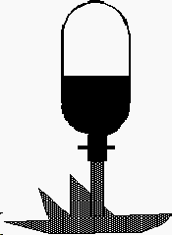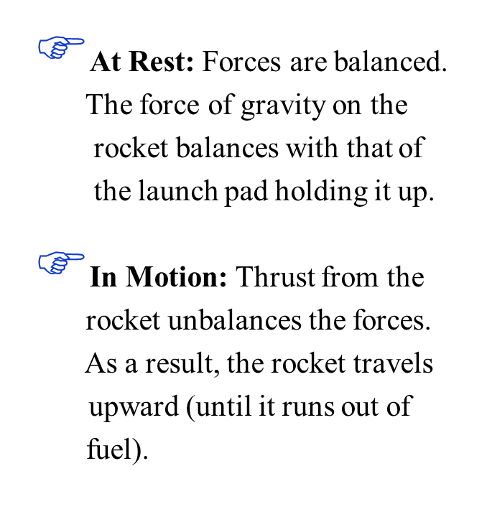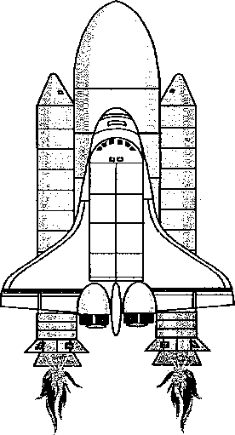When we pressurize the water inside the rocket and it releases from the launch pad the forces become unbalanced. The small opening in the bottom of the rocket allows fluid to escape in one direction and in doing so provides thrust (force) in the opposite direction allowing the rocket to propel skyward. This force continues until the pressure forces the last of the water out of

Thrust unbalanced Force

rocket.
Air Pressure

Water

Force of
GRAVITY

Note:
Thrust from the rocket’s engines acts downward producing an upward reaction on the rocket

REACTION
from Thrust

Newton’s Second Law – The acceleration of an object is directly (or depends) on the mass of the object and the amount of force applied.
For example: If you use the same amount of force, you can throw a baseball faster that a basketball because the baseball has less mass. So acceleration depends on Mass and Force.
Acceleration Depends on Mass
The smaller the mass the smaller force needed to accelerate it.
So to help your rocket go faster and higher:

- Minimize the rockets mass or weight
- Be careful when minimizing the rocket’s weight. If it is too light it will lose stability as soon as the water is expelled and turn end over end.

Note: The acceleration of an object decreases as its mass increases and its acceleration increases as its mass decreases
Acceleration Depends on Force
An object’s acceleration increases as the force on the
object increases.
So to help your rocket go faster and higher:

- The faster the fluid can be expelled from the rocket, the greater the thrust (force) of the rocket.
- Increasing the pressure inside the bottle rocket produces greater thrust. This is because a greater mass of air inside the bottle escapes with a higher acceleration.

Note: An object’s acceleration decreases as the force
on the object decreases

Newton’s Second Law can be expressed mathematically:

The relationship of acceleration (a) to mass (m) and force (F) can be expressed mathematically with the following equation: or
Mass
F
o r c e
Thrust Force Is produced as water
rapidly exits & accelerates rocket
Acceleration

 Force equals mass times acceleration. The pressure created inside the rocket acts across the area of the bottle’s neck and produces force (thrust). Mass represents the total mass of the rocket, including its fuel.

 The mass of the rocket changes during flight. As water is rapidly expelled, the rocket weighs less and accelerates.

 Thrust continues until the water is gone.

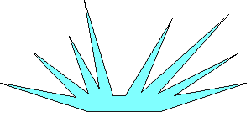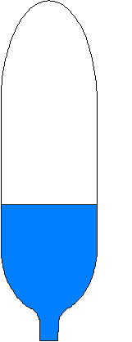
 A rocket takes off only when it expels water. Action: The rocket pushes the water out of the engine.
 Reaction: The water pushes up on the rocket.

 The Action (Thrust) has to be greater than the weight of the rocket for the reaction (lift-off) to happen.

UP

DOWN
(Bottle & Water Mass) X
(Bottle Velocity) EQUALS
(Ejected Water Mass) X
(Ejected Water Velocity)

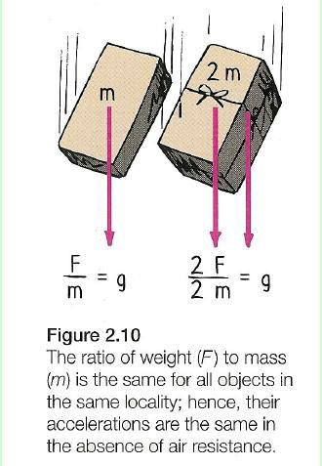
Newton’s Second Law explains why objects fall to Earth with the same acceleration
An objects acceleration of free fall is independent of an object’s mass.
A boulder 100 times more massive than a pebble falls at the same acceleration as the pebble because, although the force on the boulder (its weight) is 100 time greater than the weight of the pebble, its resistance to a change in motion (mass ) is 100 times that of the pebble. The greater force offsets the equally greater mass.

Newton’s Third Law – Whenever one object exerts a force on a second object, the second object exerts an equal and opposite force on the first.

This law can be simply stated as: All forces act in pairs. If a force is exerted, another force occurs (somewhere) that is equal in size and opposite directions.
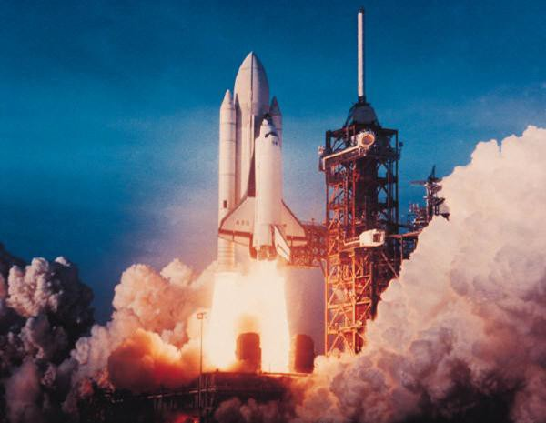
For every action there is an equal & opposite reaction.

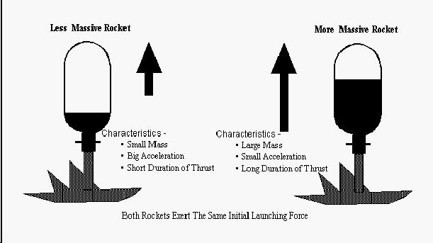
How this relates to our water rocket is like a balloon full of air, the bottle rocket is pressurized. When the locking clamp is released, fluid escapes the bottle providing an action force that is accompanied by an equal and opposite reaction force which results in the movement of the rocket in the opposite direction.
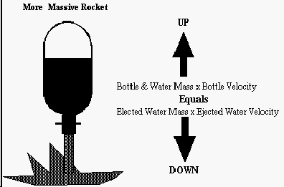
Essentially, the faster the water is ejected, and the more mass that is ejected, the greater the reaction force on the rocket.

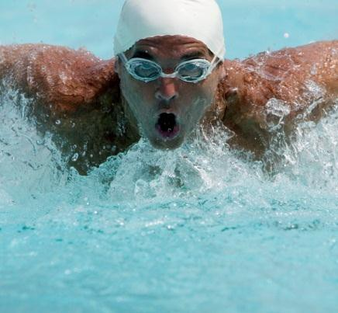
- Newton’s 3 law states that whenever an object exerts a force on a second object, the second object exerts an equal and opposite force on the first object.
- The law states that forces act in pairs, but do not act on the same object.
- There are action and reaction forces (acting in pairs).
- Example: A swimmer’s arms act on the water. The water reacts by pushin on the arms, hand, and feet which moves the swimmer forward.
- Effects of a Reaction force can be difficult to see.
– When a ball falls to Earth, gravity pulls the ball (action force). The reaction force is gravity pulling Earth towards the ball (reaction force). The Earth is so massive; its acceleration is much smaller
than the ball, so it’s impossible to see.
rd

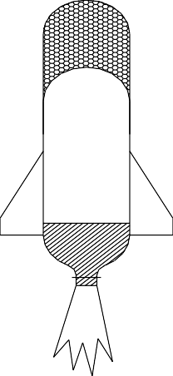
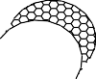Inertia – The tendency of an object to resist any change in motion. It is associated with the mass of an object.
A bottle rocket that is
HEAVIER has MORE
Inertia, because it has MORE mass. MORE Inertia will offer GREATER resistance to a change in direction. Therefore the wind will have LESS effect on a bottle with MORE INERTIA.

Wind Direction
Desired Path of Motion
A LIGHTER bottle rocket has LESS inertia, because it has LESS mass. LESS inertia means the rocket will have LESS resistance to change in direction.
Consequently, the wind has a GREATER effect on the rocket’s path of motion.
(Trajectory)

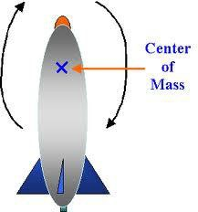
Stability - Center of Mass and Center of Pressure:
When you launch a water rocket it quickly loses stability and tumbles end over end as soon as the water is expelled. In order for your rocket to reach heights of 500 feet or more, the rocket must be aerodynamically stable during flight. To increase the stability of the rocket there are two principles you need to understand:

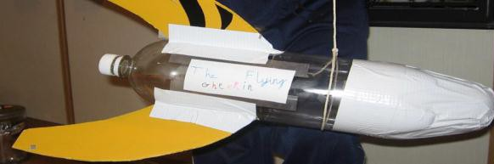
Center of Mass (CM) - The point at which the rocket balances. If you were to tie a string around the rocket at its CM, it would balance from the string horizontally. All matter, regardless of size, mass or shape has a center of gravity.

Center of Pressure (CP). The CP exists only when air is flowing past the moving rocket. The CP is defined as the point along the rocket where, if you were to attach a pivot and then hold the rocket crossways into the wind by that pivot, the wind forces on either side of the CP are equal.
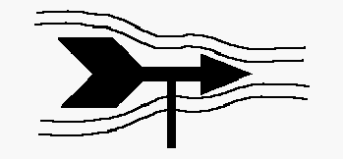
This principle is similar to that of a weather vane. When wind blows on a weathervane the arrow points into the wind because the tail of the weathervane has a surface area much
greater than the point. The flowing air imparts a greater pressure on the tail and therefore the tail is pushed away.

On a rocket the purpose of the fins is to add surface area to the rear of the rocket (which increases the CP) which helps keep
the nose of the rocket pointed into the wind. If the fins on a rocket were placed at the front of the rocket, the nose of the rocket would swap positions with the tail a few feet into the flight which would be disastrous!

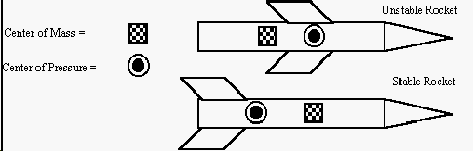
Relationship of CM to CP
In order for a rocket to fly in a stable fashion the center of mass (CM) of the rocket must be forward of the center of pressure (CP)

Note: It is important that the CP is located toward the tail of the rocket and the CM is located toward the nose some things that will help adjust your CP and CM are:
- Adding fins to a rocket increases the surface area of the tail section. The wind forces will thus increase in the tail section which in turn will move the CP toward the fins. In fact, that is the main function of fins. The larger the fins, the further back the CP will be.
- Adding weight to the nose cone section will help move the CM toward the nose of the rocket. Experiment with your rocket by adding amounts of modeling clay to the nosecone section of the rocket and then launching it to check stability and height. Be careful not to add too much weight as this will slow down the rocket.
- Typically, the longer the rocket, the more stable the rocket’s flight will be. However, the longer the rocket, the heavier
the rocket will be. This means that you need to increase the thrust to balance for the extra weight.
- Essentially, you need to minimize the rockets weight without affecting stability.

Fill Ratio of Water in Rocket
When water is added to the rockets, the effect of mass is demonstrated. Before air can leave the water rocket, the water has to be first be expelled?

Because water has a much greater mass than air, it contributes to a much greater thrust (Newton’s 2nd Law).
A rocket filled with water will fly much farther than a rocket filled only with air. By varying the amount of water and air in the rocket and graphing how high the rockets travel, you can see that the thrust of the rocket is dependent on the mass being expelled and the speed of expulsion.
The best way to determine the fill ratio is to launch 3-4 test flights using differing amounts of fluid and graph the height of rocket flight for each.

Pressure of Fluid:
By using an air pump to pressurize the air inside the rocket, we can increase the launch pressure of the water in the rocket which will then increase the thrust available to the rocket for lift off. The rocket launchers we will use for this project will be regulated to a maximum launch pressure of between 100 psi to 120 psi. Typically, you will want to use a pressure close to 100 psi. However, you need to remember that at high pressures there may be a tradeoff in rocket stability related to center of mass and center of pressure might need to be adjusted.

Air Drag:
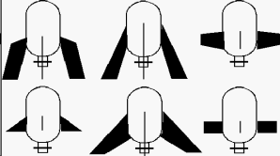
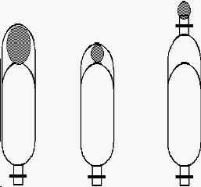
As a rocket moves through the air, friction between the rocket surface and the air (air drag) will slow it down. At the high velocities these rockets achieve, air drag becomes a very significant force. To reduce air drag, the rocket should be designed so that air passing over the surfaces of the rocket flows in smooth lines (streamlining) thus reducing drag to a minimum.

Some general rules of design to decrease air drag include:
- The fins should be thin and tapered.
- 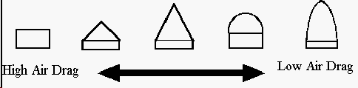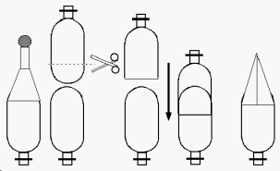Swept back fins create less drag than straight fins and rounded corners create less drag than sharp corners
- Every surface on the rocket should be as smooth as possible.
- The nose cone should be a reasonable shape.

Fins:
Without fins, your rocket will not fly straight. Typically, water bottle rockets have three or four fins attached at the neck of the bottle. Remember the larger the fins and the further back they are placed on the rocket, the further back the center of pressure (CP) will be thus increasing the stability of rocket flight.

Nose Cone:
The nose cone serves several purposes for the water bottle rocket. These include:
- The nose cone helps reduce air drag by streamlining the air as it flows past the surface of the rocket.
- Adding weight to the nose cone helps move the center of mass (CM) toward the nose of the rocket increasing the stability of the rocket.
- The nose cone is often used to hold a payload such as a parachute, camera or instruments.

Calculating the Height of a Water Rocket:
We will use the average angle method since the average angle method is the easiest and most commonly used.
This method makes an approximation of rocket height rather than an exact calculation. However, considering human error and the basic measuring instruments we will use, this method is fairly accurate in calculating rocket height.

Step #1
Measure two locations 150 feet on either side of and in a direct line with the launch pad. Place a person at each of these locations with a protractor that will let them determine the angle a rocket reaches from their vantage point.

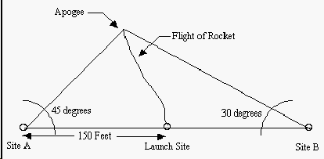
Step #2
Assume that your team has launched a rocket and Person A measures 45° and Person B measures 30°
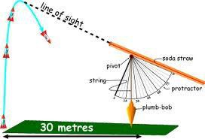
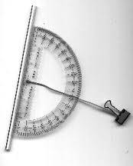

Step #3
Use the average angle formula to calculate the height of the rocket. Average Angle formula: a = b(tan A) a= height of rocket flight b= distance from the launch pad (150 feet) A = the average of the
two angles (Given Angle 1 = 45°, and Angle 2 = 30°, A= 37.5°) 45° + 30° = 75° ÷ 2 = 37.5°
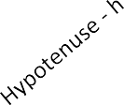Let’s make it simple and round down to 37°
Next, using the formula a = 150' x (tan 37°), the height of this rocket flight would be 113 feet. (Opposite side O = 113 ft).
150' x (tan of 37° is .7535) = 150' x .7535 = 113'
Opposite Side - 0

DON’T PANIC - A tangent (also called TAN) is a trigonometry function, so if you understand the idea of ratios, one variable divided by another variable, you should be able to understand TAN.
Let us begin with some definitions and terminology which you
already know. A right triangle is a three sided figure with b

one angle equal to 90 degrees. (A 90 degree angle is called a
right angle.) We define the side of the triangle
Angle = B

ADJACENT Side – a
Right Angle = 90°

opposite from the right angle to be the hypotenuse, "h". It is the
this side is 150 feet

longest side of the three sides of the right triangle. The word "hypotenuse" comes from two Greek words meaning "to stretch", since this is the longest side.

We pick one of the other two angles and label it b. We don't have to worry about the other angle because the sum of the angles of a triangle is equal to 180 degrees. If we know one angle is 90 degrees, and when we find the value of the b angle (using our protractor to see how high the rocket goes), we then know that the value of the other angle is 90 - b.
There is a side opposite the angle "b" which we designate o for "opposite". The remaining side we label a for "adjacent", since there are two sides of the triangle which form the angle "b". One is "h" the hypotenuse, and the other is "a" the adjacent. So the three sides of our triangle are "o", "a" and "h", with "a" and "h" forming the angle "b".

We are interested in the relations between the sides and the angles of our right triangle. While the length of any one side of a right triangle is completely arbitrary, the ratios of the sides of a right triangle depend only on the value of the angle "b". So the ratio of the opposite side to the adjacent side is called the tangent of the angle "b" is given the symbol tan(b). TAN(b) = o / a

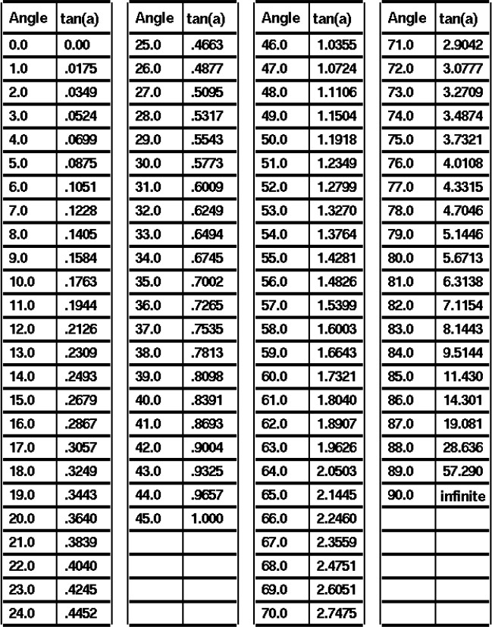
Table of TAN (angle)

