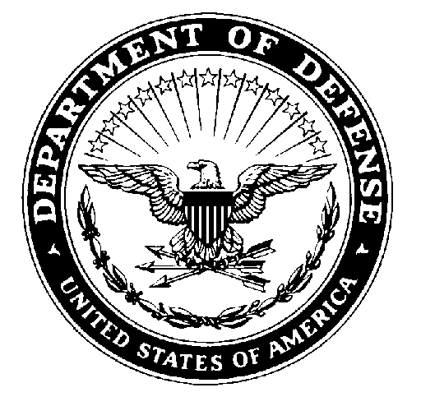 | REPLY TO  ATTENTION OF | Department of the Army  U.S. Army Cadet Command  Brigham Young Univ., Cougar Battalion  320 Wells ROTC Building  Provo, UT 84602-1048
ATCC-EUT-BY (145) 1 May 2009

MEMORANDUM FOR ALL CONTRACTED CADETS

SUBJECT: Professional Military Education (PME) Requirements

1. References:

a. Cadet Command Regulation 145-3 (para 2.5)

b. TRADOC Regulation 350-13 (para 3-3)

c. Cougar Battalion Annual Training Guidance

2. Purpose: To notify cadets of the Cougar Battalion of the Professional Military Education (PME) requirements.

3. Cadets complete the following PME requirements prior to receiving a commission:

a. Receipt of a baccalaureate degree from an accredited institution.

b. Completion of the ROTC Advanced Course.

c. Completion of the Leader Development and Assessment Course (LDAC).

d. Completion of an approved course in American Military History.

e. Cadets will participate in a staff ride or battlefield tour prior to commissioning.

4. A list of approved courses that satisfy the American Military History requirement is enclosed as TAB A of this document. Prior to contracting, cadets may request that the PMS consider other history courses as a substitute (the staff ride or battlefield tour is not an authorized substitute).

5. Instructors will address PME satisfaction with each cadet during end-of-term counseling, to ensure compliance.

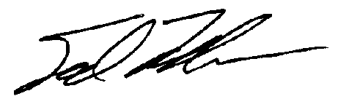
Encl TED M. LEBLOW
as LTC, AV
Professor of Military Science

TAB A: History Courses Satisfying PME “American Military History” Requirement

BYU History Courses (3 credit hours each, unless indicated otherwise)

HIST 220: The United States Through 1877
HIST 221: The United States Since 1877
HIST 371: Revolutionary America
HIST 372: U.S. History from 1815 to 1848
HIST 373: Civil War Era, 1848-1877
HIST 374: U.S. History from 1890 to 1945
HIST 376: U.S. History from 1945 to 2000
HIST 398R: Special Topics in Military History (Note: This class may not be offered
every semester)

REL C 393R: LDS in Wartime (2 credit hours) – Not pre-approved, can be used only as
a substitute class with PMS approval

DSC History Courses (3 credit hours each, unless indicated otherwise)

HIST 3670: Slavery and the Am Republic
HIST 3730: The Am Civil War/Reconstruction
HIST 3740: The Emergence of Modern America
HIST 3930: U.S. Military History (taught by Army ROTC)

SUU History Courses (3 credit hours each)

HIST 2700: United States 1607 – 1877
HIST 2710: United States 1877 – Present
HIST 4480: Europe in the 20th Century
HIST 4490: Hitler and Nazi Germany
HIST 4510: World Military History
HIST 4730 United States 1845 – 1898
HIST 4740: United States 1898 – 1945
HIST 4750: United States Since 1945

UVU History Courses (3 credit hours each, unless indicated otherwise)

HIST 2700: U.S. History to 1877 AS
HIST 270H: U.S. History to 1877 AS
HIST 2710: U.S. History since 1877 AS
HIST 271H: U.S. History since 1877 AS
HIST 290H: Independent Study course in military history (1 credit hour)
HIST 290R: Independent Study course in military history (1 to 4 credit hours)
HIST 3190: Twentieth Century Europe
HIST 3430: Middle East History, 1914 to Present
HIST 3450: The History of World War II
HIST 3460: U.S. Military History
HIST 3520: The United States and Vietnam, 1945 to Present
HIST 3530: History of Vietnam
HIST 3710: Reform and Crisis in Antebellum America

