Credit Scores
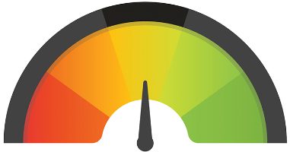
What Banks are looking for:
- Debt to equity ratio - 20%
- Collateral – discount assets to get
- Credit History on company and person
- Management of company
- Ability to repay the loan – Pro forma cash flow statement

Credit Score;
- On time payment history (35%)
- Total personal debt (30%)
- Length of credit – history to pay off debt (15%)
- New credit (10%). Keep inquires under 4 per year
- Types of credit (10%)

What FICO Score means:
300-500 Very poor
500-620 Poor
620-700 Average
700-740 Good
740-850 Excellent

To Find Credit Score:
www.annualcreditreport.com

3 Credit Bureau Websites:
www.transunion.com
www.experian.com
www.equifax.com

