Utah Fire and Rescue Academy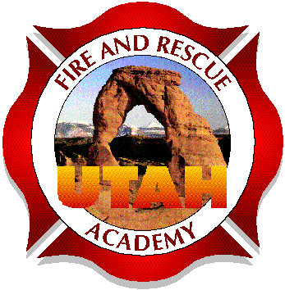
Fire Officer I
Lesson Outline Template

Basic Lesson Outline:

Audience, Support, and Materials
Identify the Audience
Facilities, Equipment, or Tools needed
Audio/Visual needs
Additional or specialized personnel required?
_______________________________________________________________________

Administrative Details
Expected duration of the training (times)
Exists, Restrooms, Breaks
Sign the Roster

Introduction
Instructor
Topic

Motivation of Students
Why is this information important to the student?

Lesson Goal
What are the expectations of the student once training is completed?

Learning Objectives
Describe, Demonstrate, List, Observe, Diagram, Complete, etc...
The steps necessary to fulfill the Lesson Goal

Lecture or Demonstration
Deliver the knowledge and/or skills to the student based on objectives
Must meet the objectives

Evaluation
Written exam, quiz, survey, or skills demonstration based on criteria
Method to determine if learning occurred

