The ART of READING SMOKE

for Rapid Decision Making

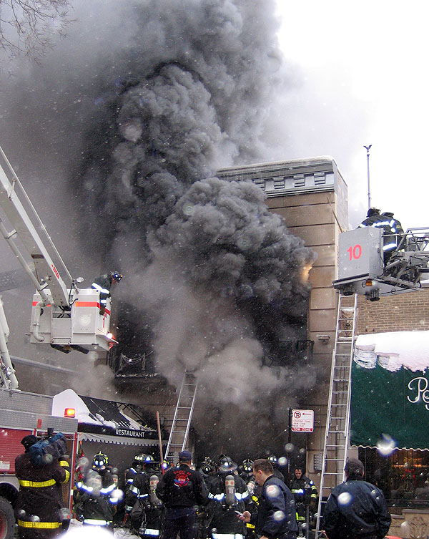

Developed By:

Dave Dodson
Former Battalion Chief & Duty Safety Officer
Lead Instructor – Response Solutions, LLC


The Art of Reading Smoke for Rapid Decision Making

Fighting fires in the year 2006 and beyond will be unlike the fires we fought in the 1900’s. Composites, lightweight construction, engineered structures, and unusual fuels will cause hostile fires to burn hotter, faster, and less predictable.

As a Fire OFFICER – or Firefighter - you MUST be able to predict fire behavior and hostile fire events. If you don’t or can’t, firefighters will die or be critically injured. The key to predicting fire behavior is directly related to your ability to READ SMOKE as you arrive and begin firefighting operations.

This class will help you rediscover the ART of READING SMOKE!

- First, you must know the Advanced Basics:

Concept #1: “Smoke” is FUEL!
Firefighters use the term “smoke” when addressing the solids, aerosols, and gases being produced by a hostile fire. Carbon, soot, dust, and fibers make up the solids. Aerosols are suspended liquids such as water and hydrocarbons (oil). Gases are numerous in smoke – mass quantities of Carbon Monoxide lead the list. Other notable gases that impact fire behavior include the “hydrogens,” benzene, and acrolein.

Concept #2: The Fuels have changed:
The contents and structural elements being heated or burned are of LOWER MASS than previous decades. These materials are also more synthetic than ever.

Concept #3: The Fuels have trigger points:
There are “Triggers” for Hostile Fire Events: These triggers are simply “right temperature” and “right mixture.” Flash Point can trigger a smoke explosion. Fire Point triggers rapid fire spread, ignition temperature triggers auto ignition, backdraft, and flashover.

Flash Point: The lowest temperature a fuel will off-gas an ignitable mixture that will simply flash – but not SUSTAIN, given an ignition source.

Fire Point: The lowest temperature a fuel will off-gas an ignitable mixture that will ignite and continue to burn given an ignition source.

Ignition Temperature: The lowest temperature a fuel will off-gas an ignitable mixture that can self-ignite.

Burnable gases must be in their right percentage with air to ignite. In hostile fires, a gas may be hot enough to self-ignite – but is too rich to burn. Firefighters’ efforts can cause this ignition.

Now, you must be able to:

- Tell what “stage’ the fire is in (from outside the building: This is simple – is the fire in early, growth, or late stages?)

- Tell if the “box” is absorbing heat or not: Turbulent vs. Laminar smoke flow

- Tell if the “box” is in thermal balance

IS the smoke rising and leaving the building with natural flow?

Hostile fire events (know the warning signs):

Flashover:
The classic American Version of a Flashover is the simultaneous ignition of fuels within a compartment due to reflective radiant heat – the “box” is heat saturated and can’t absorb any more. Signs: Turbulent smoke, rollover, and auto-ignition outside the box.

Backdraft:
A “true” backdraft occurs when oxygen is introduced into an O2 deficient “closed-box” environment that is charged with gases (pressurized) at or above their ignition temperature. Warning signs include yellow smoke from seams (sulfur compounds that have been carbon filtered), bowed windows, no visible flame. Backdrafts are rare in large scale – but probably happen often in small, confined areas. Think of backdraft as a “closed box event.”

Smoke Explosion:
The over-simplification of texts has led to some miss-understanding here. A smoke explosion is the brief “flash” of a pocket of gas that is above its flash point. This causes a rapid surge (expansion) of the remaining gases. It can be forceful enough to throw firefighters. Signs include trapped gases that mix with air and continue to be heated – they just need a spark or flame to ignite (flashpoint). The set-up for a smoke explosion is the accumulation of gases distal to the actual fire.

Rapid Fire Spread:
Hot smoke flowing quickly through hallways and stairways rapidly spreads the fire. Smoke ignition is causing this rapid fire spread. Watch for smoke moving faster than people can (heat pushed vs. volume pushed smoke).

SOME “OVERHEAD” RULES FOR “READING SMOKE”:

1. Observations are best made from the outside

2. Nothing is Absolute about Fires – fires are dynamic and there are too many variables

3. Don’t get sucked into “Reading Flames” - What you see is usually what you get with the orange stuff!

The 4-STEP process to READING SMOKE:

STEP 1: INVENTORY the KEY ATTRIBUTES of smoke:

- Volume = Amount of fuel off-gassing, fullness of box, sets an impression for everything else.

- Velocity (How fast is the smoke leaving?) = Indicates pressure build-up. Only volume and heat can cause pressure. Volume-caused pressure will immediately slow down, heat-caused pressure slows gradually. Turbulent smoke is heat-caused. Comparing velocities help you figure WHERE the actual fire is.

- Density = Quality of Burning, Potential for event - PERHAPS THE MOST IMPORTANT FACTOR – the thicker the smoke, the more dangerous it is.

- Color = usually indicates the stage of heating and distance to fire. As a starting place, White is cooler, black is hotter. Carbon and hydrocarbons can be FILTERED – taking away blackness as smoke travels over distance or through cracks. White smoke should not be discarded! White smoke with velocity means a hot fire – but the smoke you see has traveled some distance. Thin, black smoke means “Flame Pushed.” Brown Smoke means ufinished wood is being heated.

REMEMBER THE TERM: “BLACK FIRE”
Black fire is high-volume, turbulent velocity, super dense black smoke. It is a sure sign of an impending (delayed) flashover!

STEP 2: WHAT is INFLUENCING THE KEY ATTRIBUTES?

- Container – can change the meaning of volume, velocity, density, and color

- Weather – hot/humid gives a narrow, defined column; hot/dry gives a cone shaped column; cold/humid causes the smoke to crash and hangout near; cold/dry causes the smoke to crash but disperse easily. Below freezing air temperatures can make black smoke look white within a few feet of the outside vent opening (moisture content of smoke condensing).

- Firefighting Efforts – all four attributes should change: Volume increases; velocity surges then slows down; density immediately decreases; color goes white. If this isn’t happening, the fire attack is inadequate. PPV fans can alter all the smoke attributes.

STEP 3: Determine the Rate of Change

Getting Better or Getting Worse? (not the flames – the smoke conditions!)

How fast is it changing?

Finally, PREDICT THE FIRE EVENT !!!

Remember to communicate key observations

Trust your instincts – if something doesn’t look right – it probably isn’t!

You should now know:

The exact location of the fire
The size of the fire
The potential for a hostile fire event and the rate of change

Some other little Tricks:

- When you open a door, watch what the smoke does

Finds balance = fire on same level
Smoke rises and door becomes a fresh air intake = Fire above
Smoke thins but still fills door = fire below

- If visibility is bad, stop and shine a light – what is the smoke doing?

Use a light beam to establish direction of smoke flow
IF no movement, you are in a dead-end or below the fire

Some Quick short-cuts (remember, short cuts are just that):
- Turbulent smoke = flashover or ignition imminent
- Brown Smoke = unfinished wood - Structural elements mid-stage heating?
- “Black Fire” = too rich to burn but acting just like flames – EXPLOSIVE!
- Smoke leaving multiple openings is same color and velocity = deep seated fire (open bldg=distance, partitioned bldg=fire in walls)
- Whitish smoke that has it’s own energy (speed) = hot fire but smoke has traveled some distance
- Very thin, active, black smoke = flame driven – flaming is nearby

GROUP ACTIVITY: What Does the Smoke Say?

When you read smoke – you are basically trying to ascertain:

- The EXACT location of the fire
- The SIZE of the fire
- The PATH/SPEED of fire spread
- The likelihood of a HOSTILE FIRE EVENT

For the scenarios, try to answer these questions in your group:

Specifically where is the fire?

How big is the fire?

What’s Next? (where is the fire going and how fast - be specific)

Best Tactic:

Remember:

- With Less Fires, the Art of Reading Smoke could be lost….at the expense of our lives

- If we do what we’ve always done, we’ll get what we’ve always got!

- Practice doesn’t make perfect, PERFECT practice makes perfect!

- Don’t be ARBITRARILY AGGRESSIVE – Be INTELLECTUALLY AGGRESSIVE!

- PASS ON THIS INFORMATION!!!!!!!!!!!!!!!!!!!!!!!!!!!!!!!!!!!

Call me if you want more info or have questions: Dave Dodson (303) 912-1201
Dave@ReadingSmoke.com

Special THANKS to:
David Ross, Chief of Safety, Toronto Fire Services (class development, mentoring)
Peter McBride, Safety Battalion Chief, Ottawa (technical expertise)
Mike Scott, Battalion Chief, Kent, WA (PowerPoint)
Billy Goldfeder, Battalion Chief, Loveland/Symmes, OH (mentoring, commitment)
Jeff, John, & “Juice”, Everett, WA (encouragement)

The “Reading Smoke” PowerPoint is available as a free download at: www.firefighterclosecalls.com

Study fire behavior! Start with Paul Grimwood’s collection of information at www.firetactics.com

Some VIDEOS used in this class are available through www.FDSOA.org. I use:
“Buffalo’s Bravest” and “Early Fire Ground Ops.” You can find more videos at www.firevideo.com or www.firelinevideo.com or www.firestormvideos.com

Don’t just Be SAFE – Go out and Make it SAFE !

