Scenario #2
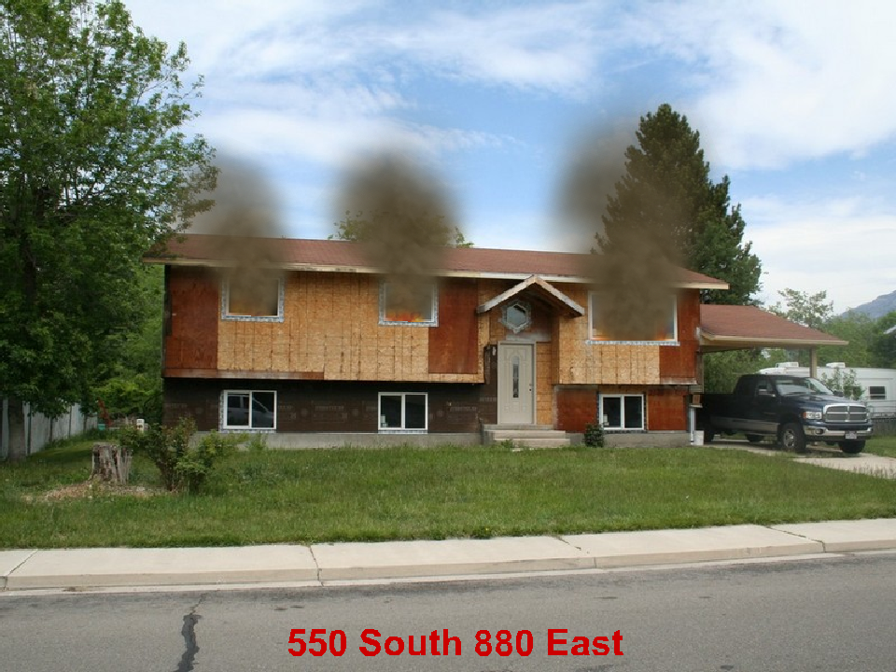

2 Story Residential 50’ x 30’ 50% involved(50 % of the total structure, 100% second floor). Exposure 40’ away on the “B” side.
July 8 2:00 pm Wednesday.

What are your Incident Priorities?
_______________________________________
_______________________________________
_______________________________________

Initial Report with Strategy
______________________________________________________________________
______________________________________________________________________
______________________________________________________________________
______________________________________________________________________
______________________________________________________________________
______________________________________________________________________
Fire Flow Required
______________________________________________________________________

Initial assignments for your engine, 2 additional engines, 1 truck, 1 ambulance
_____________________________________________________________________
_____________________________________________________________________
_____________________________________________________________________
_____________________________________________________________________
_____________________________________________________________________
____________________________________________________________________

