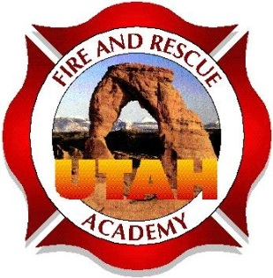

Utah Fire and Rescue Academy
Re: Student Participation
Dear Student,
Thank you for scheduling a UFRA training course for your department. It is the goal of UFRA to provide a training course that will help the students and department obtain the needed information for them to be safe and successful in the fire service. In order to provide the best learning environment and opportunity for success for all students, the following guidelines are provided to you for your review.

Student expectations:
- Students are expected to arrive on time and not leave until the end of each class.
- Breaks should not go past the allotted time allowed by the instructor.
- Reading assignments and work assignments which will be covered during the scheduled class periods will be completed prior to attending the class. Any assignments or projects not completed or turned in on the designated date in the syllabus will not be accepted. Failure to complete assignments places undue difficulty on the instructors and impacts the other students when others are not prepared for the material being presented.
- Proper language will be used at all times by everyone in the class. Crude, demeaning or comments that by be construed as offensive shall not be used or referred at any time.
- While professional debate and interaction is welcome, no arguing or confrontational actions will be allowed. Students who do so will be asked to leave the class. The instructor will then notify the Program Manager to notify the students Training Officer or Chief.
- Students will be respectful of beliefs, national origin, gender differences and religious beliefs.
- Respect will be shown for differing views or opinions.
- Class attendance to 80% of the classes is required to attend and participate in the certification testing process.
- Students will be respectful of the facility and all equipment at all times. The classroom is to remain clean and free of trash or debris.
- The classroom, drill ground and all equipment will be returned to its proper location and condition before the class is dismissed.
- Cellphone and pagers should not be used, unless required by the department for contact for emergencies. If these items are required, they should be placed on vibrate, silent mode or the lowest possible volume so as to not disrupt the other students.
- Students will report all and document all injuries that occur during training period. All required paperwork and notifications will be made to the instructor. The instructor will then notify the Program Manager, who then makes all other required notifications as per UFRA policy.

By signing you acknowledge and understand the Student Expectations

___________________________________________________ __________________
Signature Date

Thank you,
Utah Fire and Rescue Academy.

