Online Application Process for NFA-Sponsored Non-Resident Classes

The National Fire Academy has transitioned to an online admissions application process and the online application can be found at (you may need to press Ctrl with your cursor over the link):

https://training.fema.gov/generaladmissionsapplication/staticforms/startapplication.aspx

If you have an issue or a question regarding the online admissions application, please contact:

NETC Admissions Department
(301) 447-1035
NETCAdmissions@fema.dhs.gov

The online application will open the day before the class and be open fourteen days after the class concludes. Failure to turn in an application will result in not receiving credit for the course.

Tutorial:

NOTE: Information is required for each of the starred fields.

Step 1: After reading the Legal Notice, click continue.

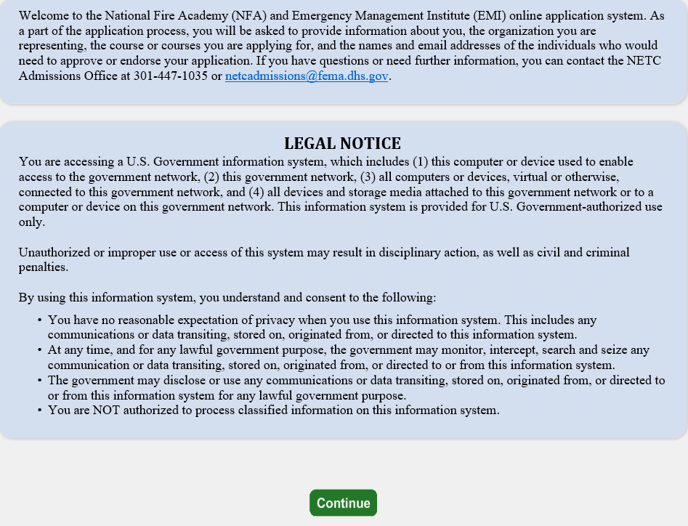
Step 2: Read the statements below and click continue if you have a FEMA Student Identification (SID) Number. If not, follow the instruction for obtaining one.

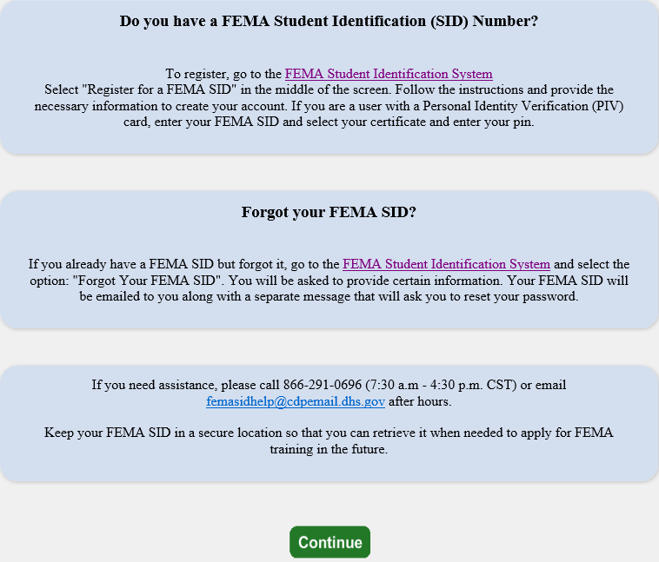

Step 3: Read the statements below, check the box at the bottom, and click continue.

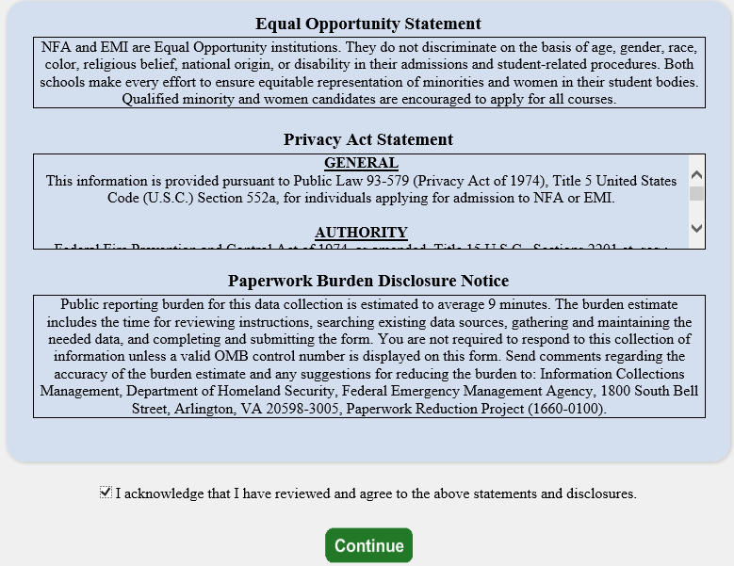

Step 4: You must input your FEMA Student Identification (SID) Number and first/last name. After entering your FEMA SID and first and last names, click Verify. The system will return your middle name, suffix, and date of birth from the SID system.

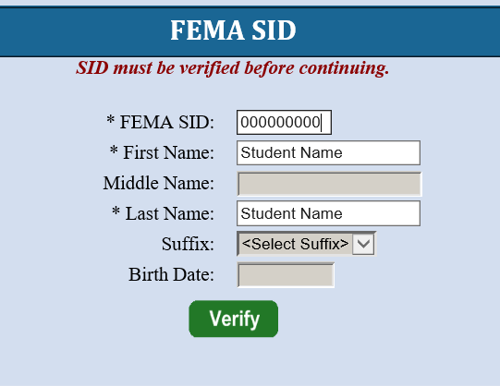

Step 5: Once you see “Verified!”, select next to continue.

Step 6: Complete the fields on the Demographic Information screen. Select next to continue.

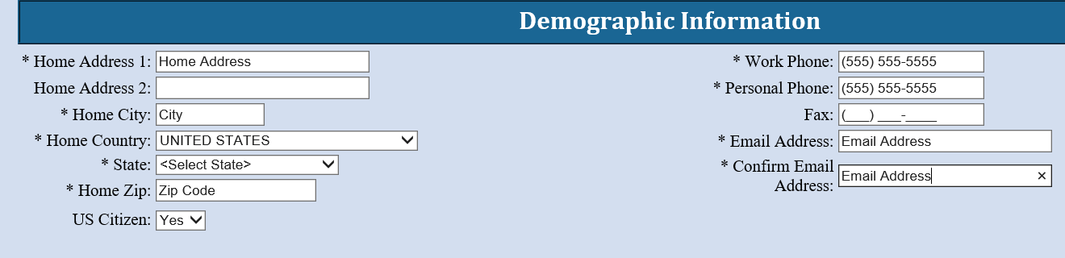

Step 7: The Course/Offer Information screen requires you to select a course. To do this, use the drop-down arrow and scroll to the applicable course. After selecting the course, click apply which takes you to the next screen.

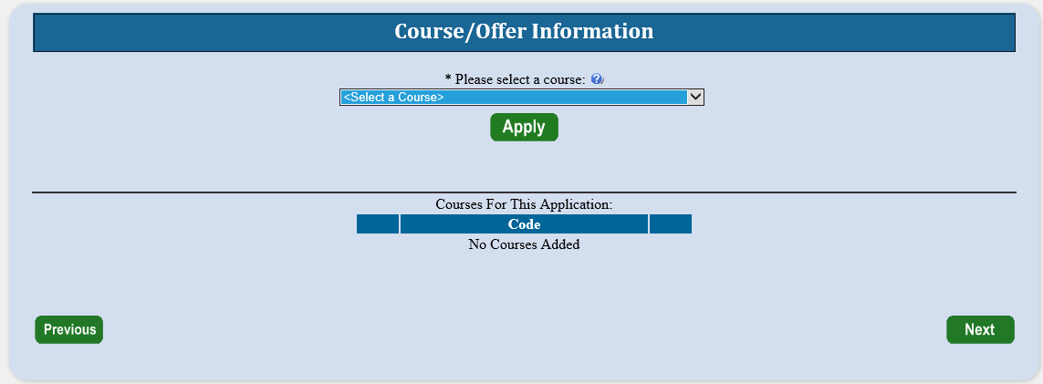

Step 8: The second Course/Offer Information screen allows you to select the Offer Start Date and Offer Location from the drop-down. There is no need to select an Offer Title. In the “Briefly describe…” box, enter “not required”. Disregard the disabilities drop-down. Once completed, select save. A second screen will appear where you can apply for a second course using the same application. Ignore it and select next.

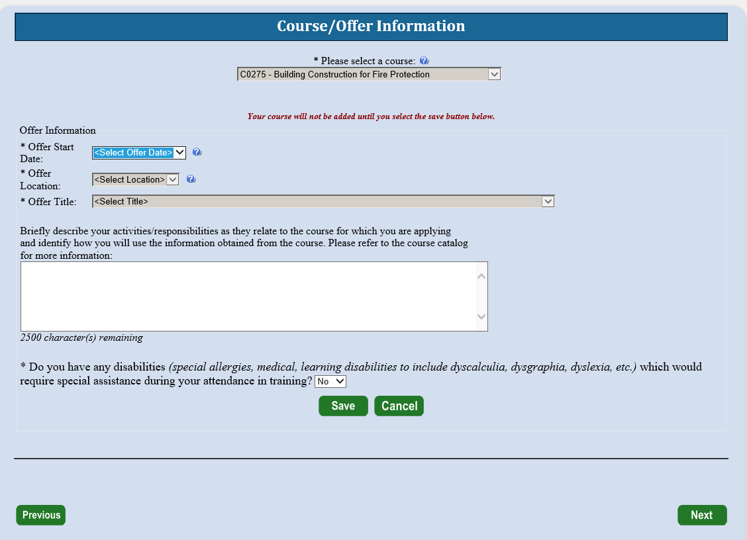

Step 9: On the Organizational Information section, you must fill in all information requested. You must also check a box in each category that best applies. Once completed, you should select next.

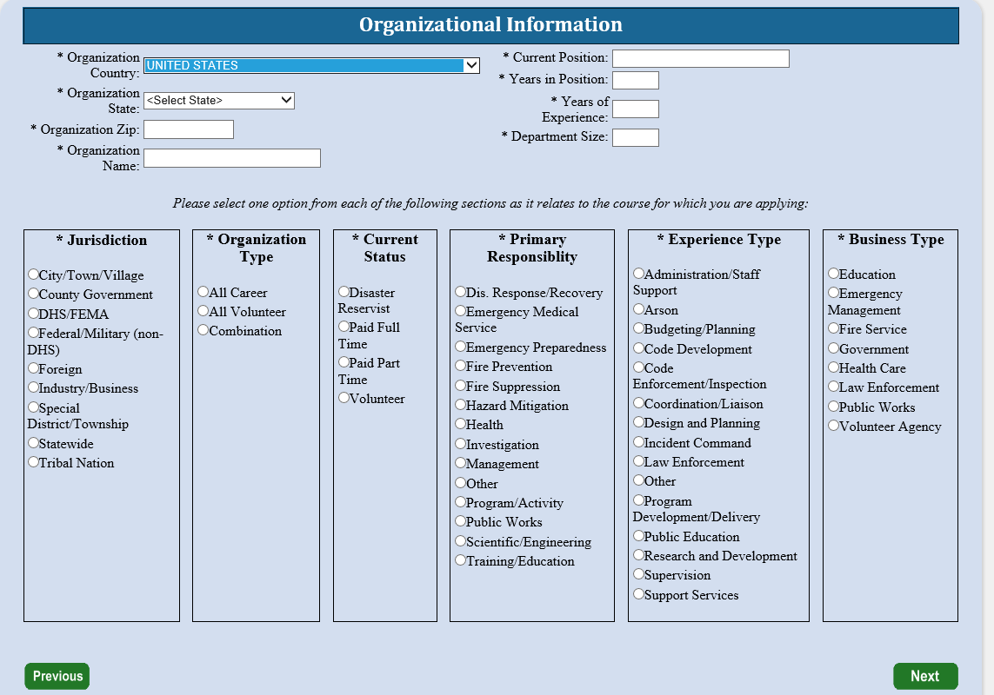

Step 10: The next screen is labeled Other Information. This section is optional. These fields are used for statistical purposes only. Once completed select next.

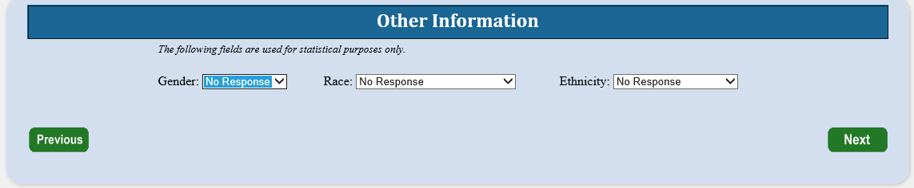

Step 11: Since there are no Attachments, select continue.

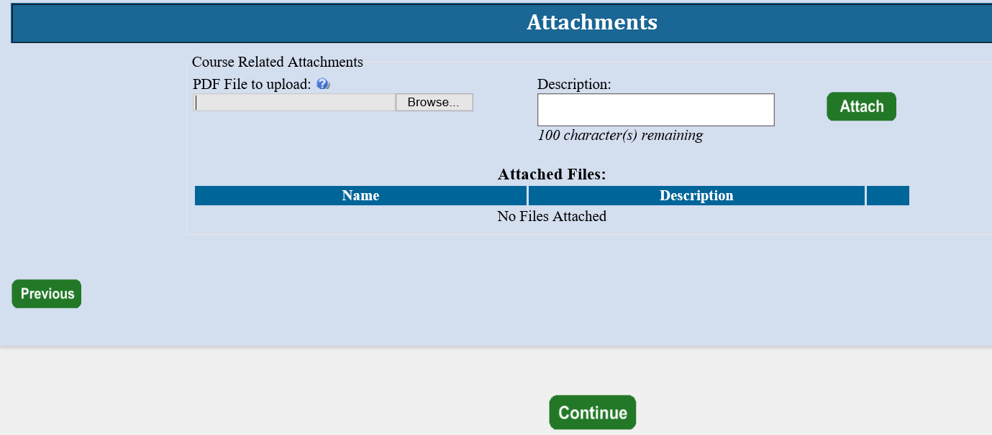

Step 12: On the Application Submittal screen, you will be asked if you have completed all the information. You should select Yes. If there is any required information that is missing, you will need to go back and correct that before the application is forwarded.

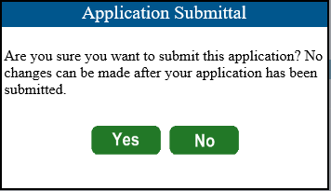

Step 13: On the Student Acknowledgement screen, you will be asked to acknowledge the four items shown by checking the box at the bottom of the screen which is also your electronic signature for the application. Once you have checked the box, click continue.

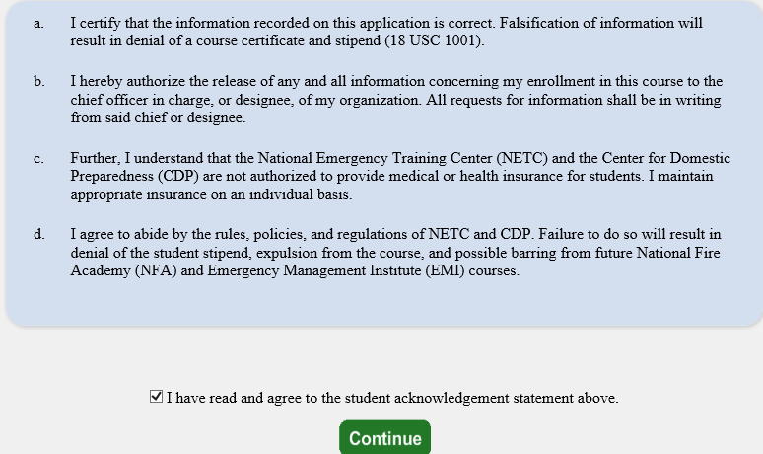

Step 14: The Head of Organizational Information is where you enter the name and email address of the person who has been designated to endorse the application. Once you click submit, the Head of the Sponsoring Organization has 14 days to respond to the request or it will be automatically rejected.

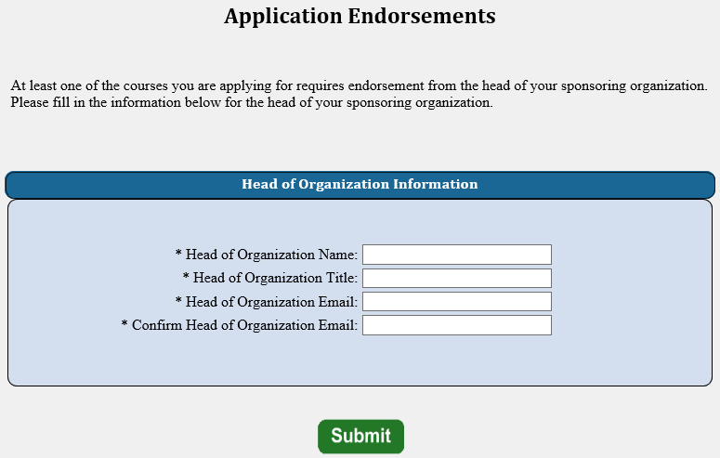

Step 15: This is the final screen showing that you successfully applied for their selected course.

