Learning Activity 4-1
Distinguishing the Characteristics
of an Explosion and Preserving Evidence

Name Date

References
Fire Investigator, 2nd Edition, pp. 101-112
NFPA® 1033, 4.2.9

Directions
Analyze each photograph. On a separate sheet of paper, write the characteristics of the explosions viewed and compare the damage views with the normal characteristics of a structure fire. Identify proper and improper methods that were followed regarding:
a. Type of damage portrayed in the photograph.
b. Compare the damage views with the normal damage that is views at a structure fire.
c. Analyze whether the internal air/vapor ratios were in the upper, lower, or near the stoichiometric condition at the time of ignition.
d. Identify the vapor density of the fuel involved in this fire/explosion incident.
e. Recognize the evidence depicted at this fire/explosion scene.
f. Analyze the evidence that may be found at the fire/explosion scene that may not be provided in the exposure.
g. Consider the type of building construction involved in the fire/explosion scene.

Photo 1

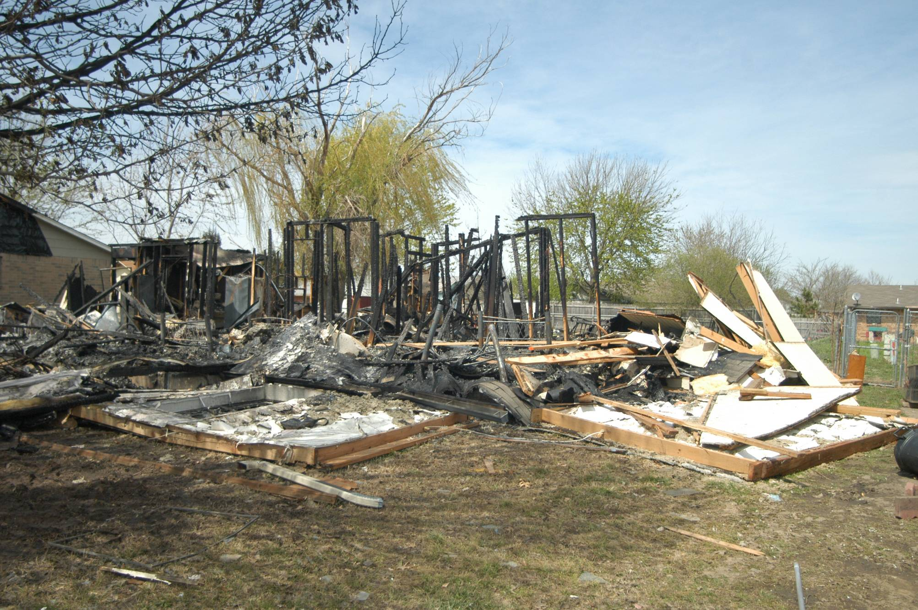

Photo 2
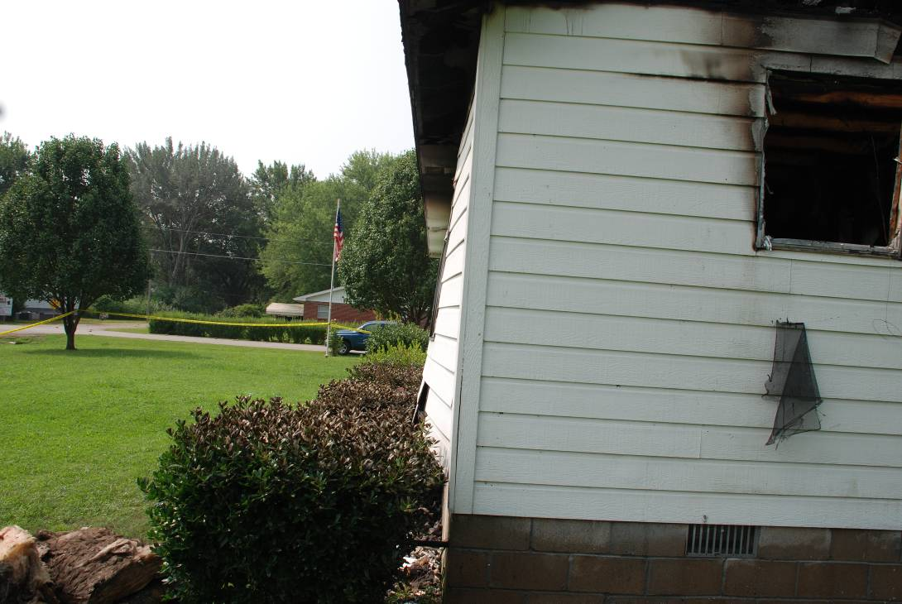

Photo 3
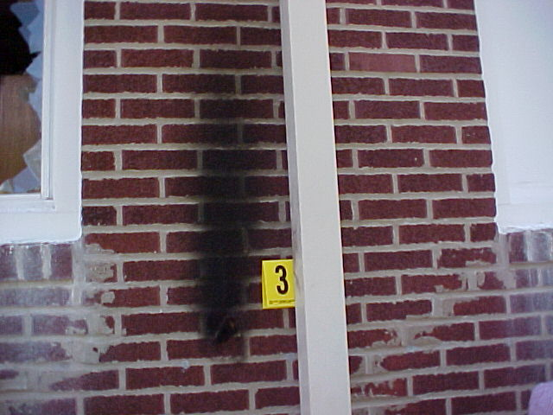

Photo 4
