Learning Activity 1-1
Manage a Fatality Fire Scene

Name Date

References
Fire Investigator, 2nd Edition, pp. xxx
NFPA® 1033, 4.4.1

Directions
Analyze each photograph. On a separate sheet of paper, write the proper and improper methods that were followed regarding:
a. Managing victims
b. Managing fatalities
c. Evidence preservation

In addition, list protocols for investigators to follow to accommodate the proper methods for managing and preserving the fire scene, victims, fatalities and evidence. When you are finished, turn in to the instructor the sheet of paper with your responses.

Photo 1 Photo 2

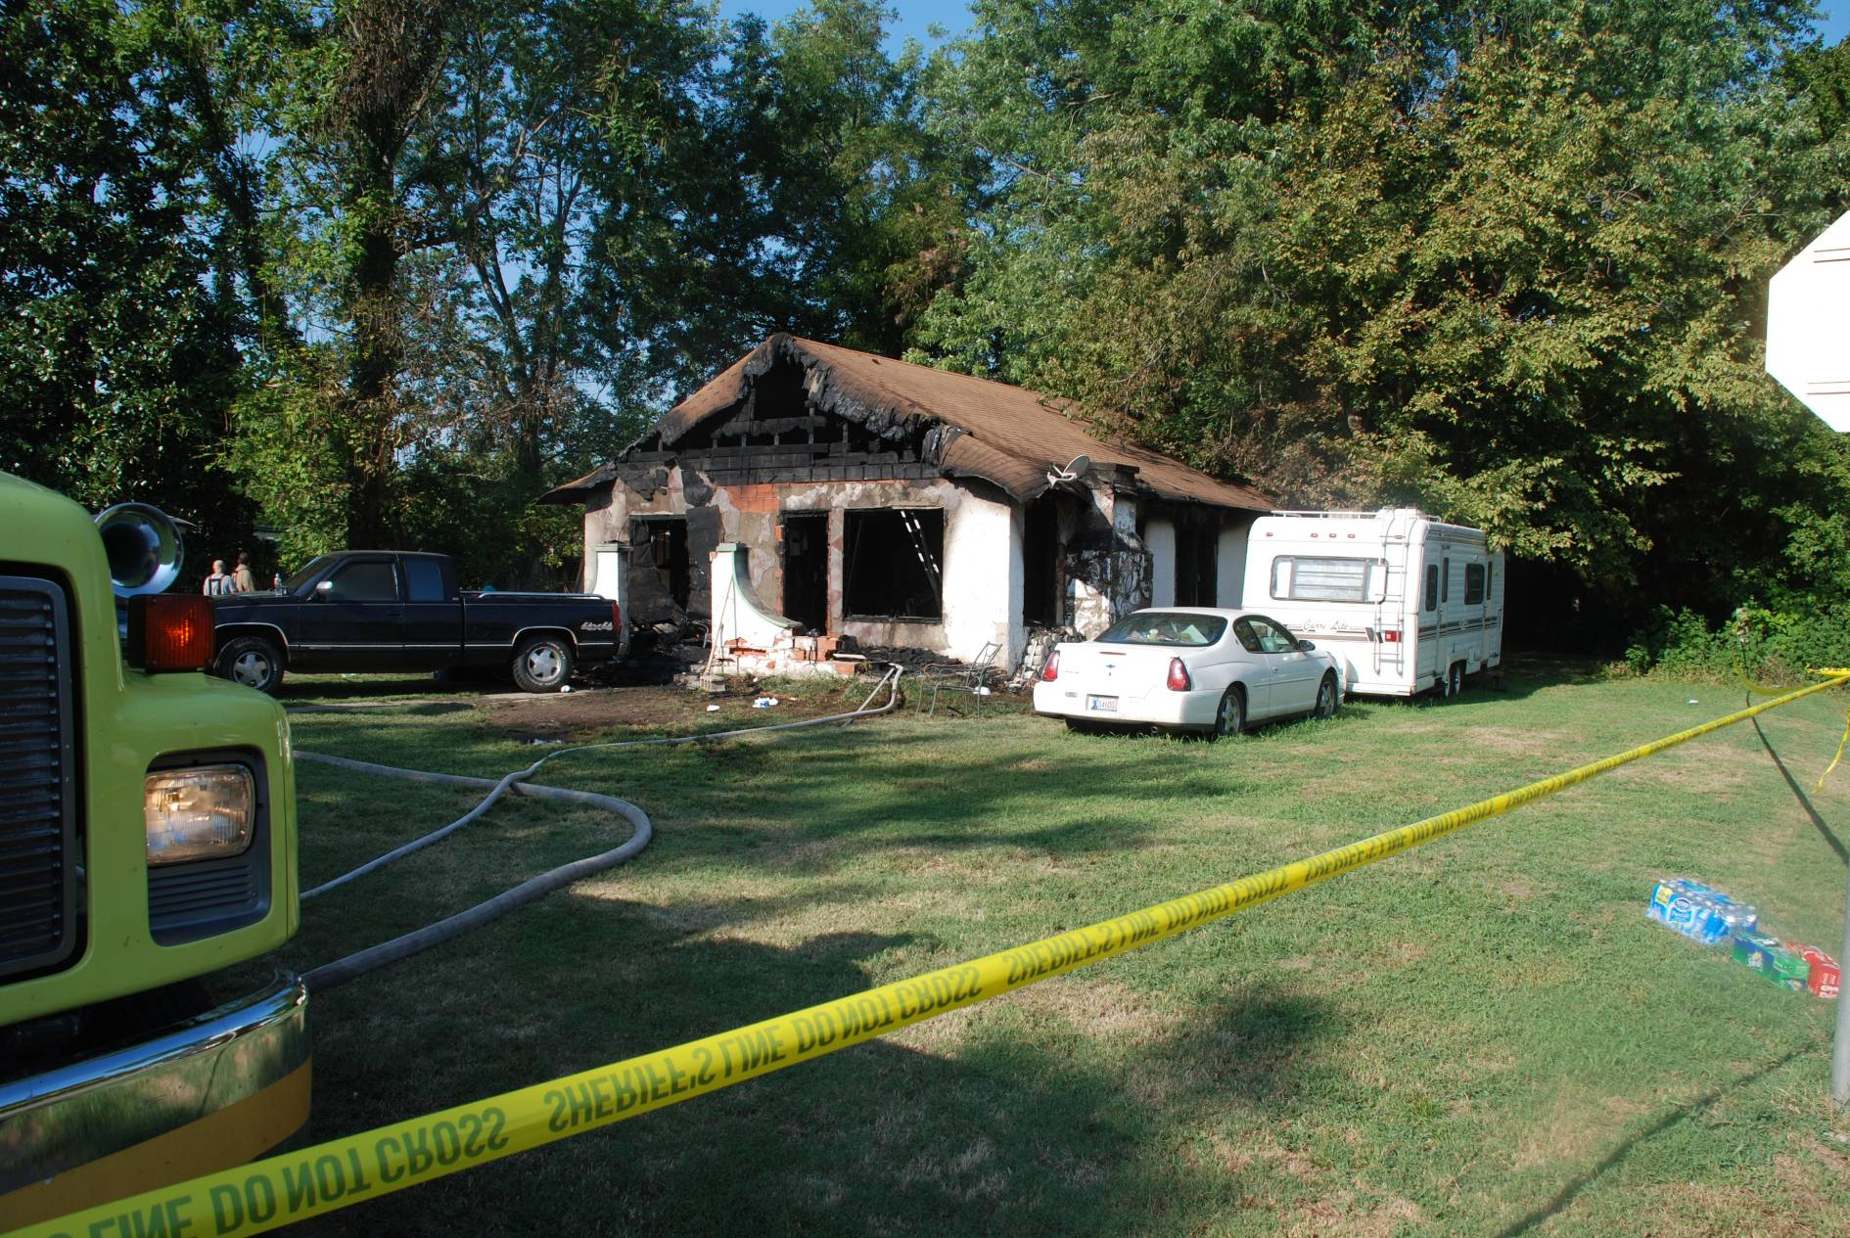

Photo 3
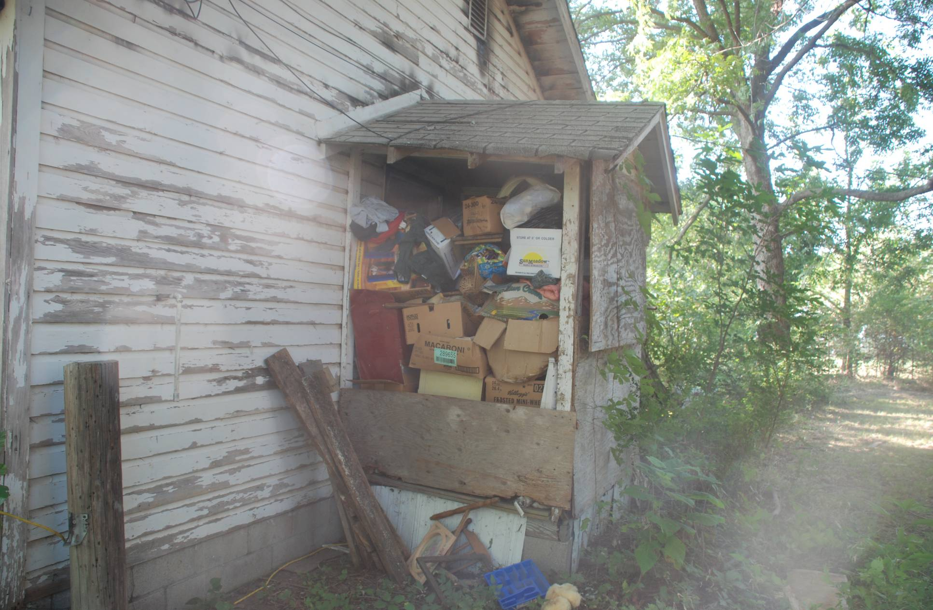
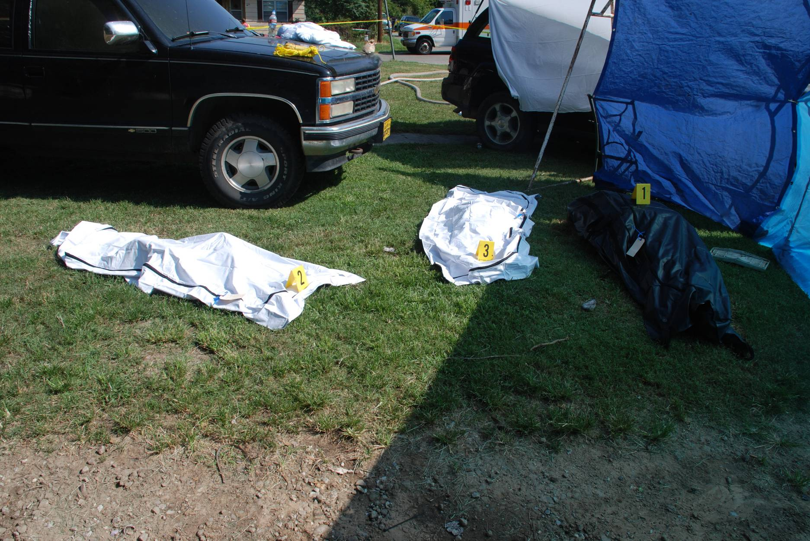

Photo 4
