Learning Activity 7-1
Utilizing Ohm’s Law Formula as Related to the Ignition Scenario

Name Date

References
Fire Investigator, 2nd Edition, pp. 184 - 187
NFPA® 1033, 4.2.8

Directions
Analyze each photo and answer the questions that follow. Be sure to utilize Ohm’s Law formulas for each question.

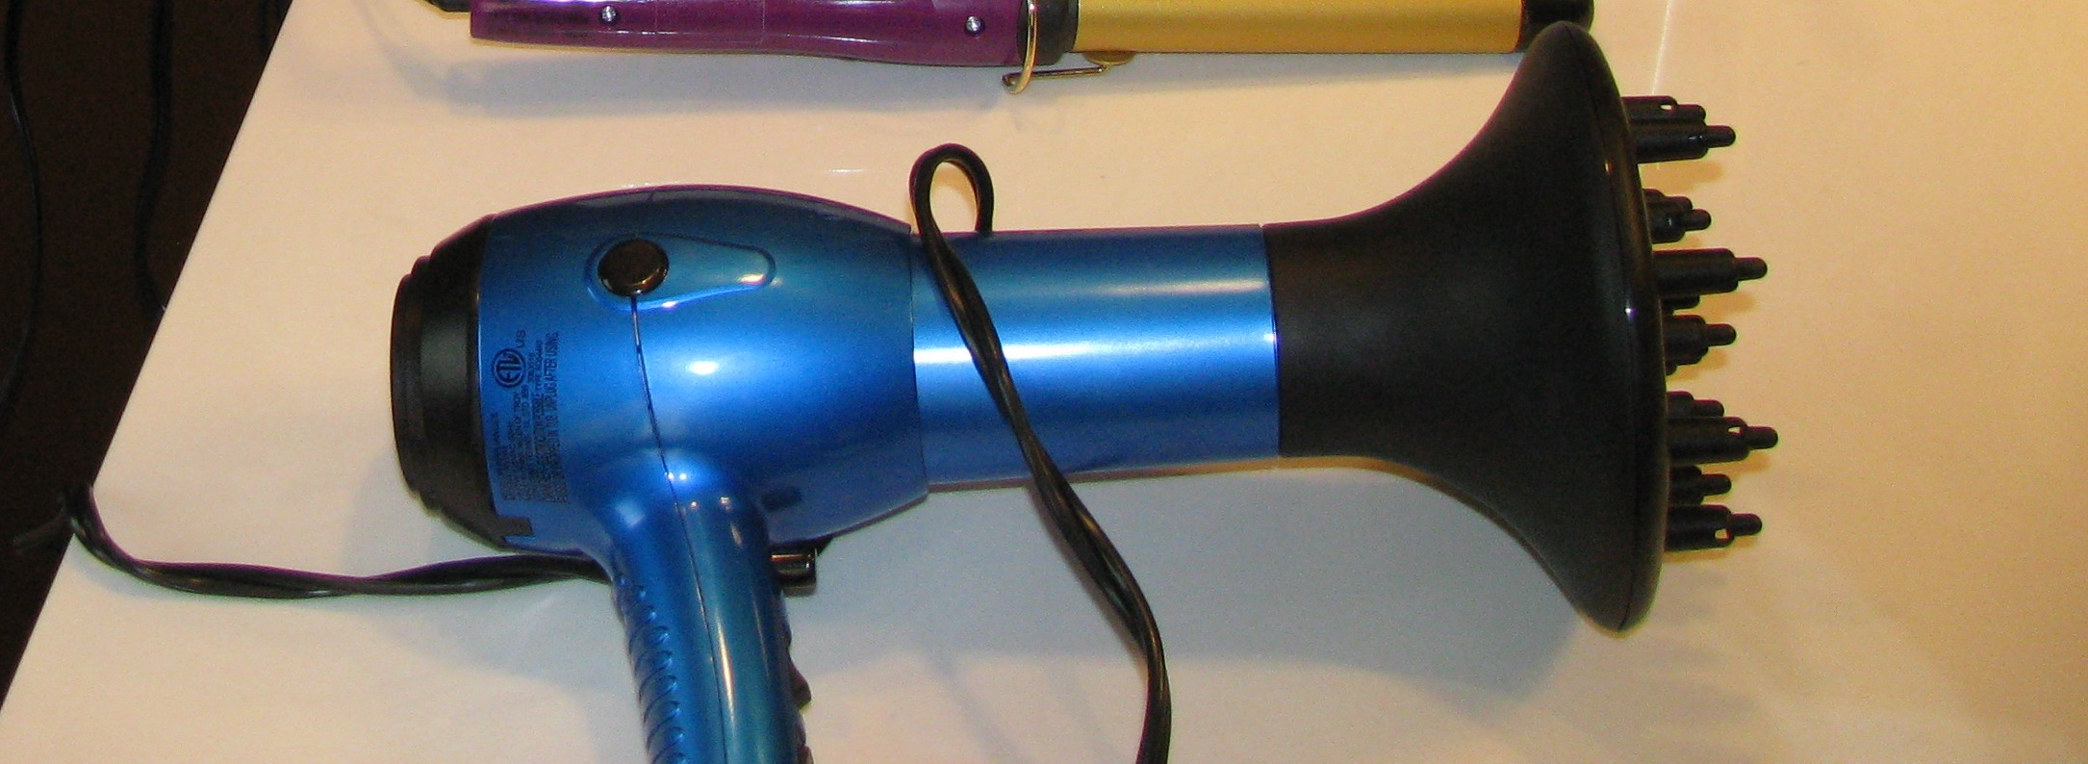

1. For a 1200 watt appliance operating on 120 volts, determine the current (amperes).

2. For the appliance above, determine the resistance (ohms).

3. From your determination of current and resistance in the previous questions, determine the power (watts).

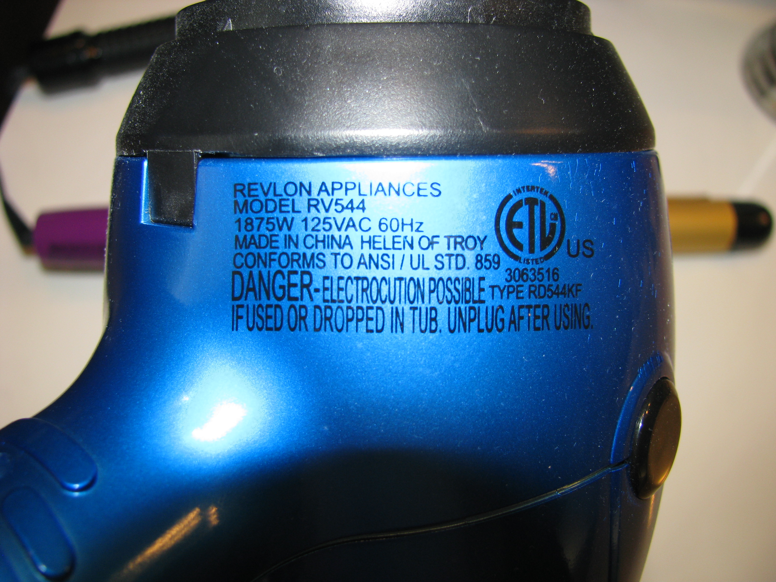
4. Determine the watts and voltage for this appliance.

5. Determine the current (amperes) for this appliance.

6. Determine the resistance for this appliance.

