Learning Activity 2-1
Safety Analysis and Mitigation

Name Date

References
Fire Investigator, 2nd Edition, pp. 25-45
NFPA® 1033, 4.2.2

Directions
Analyze each photograph. On a separate sheet of paper, write the proper and improper methods that were followed regarding:
a. Securing the fire scene
b. Identify potential hazards
c. Provide mitigating actions to provide the scene safer for the investigator
d. Identify safety concerns for the egress and ingress
e. Provide mitigating actions to provide for the safe egress and ingress, if possible

In addition, list protocols for investigators to follow to recognize, analyze, and mitigate potential hazards and to provide a safer fire scene that may prevent injuries.

Photo 1

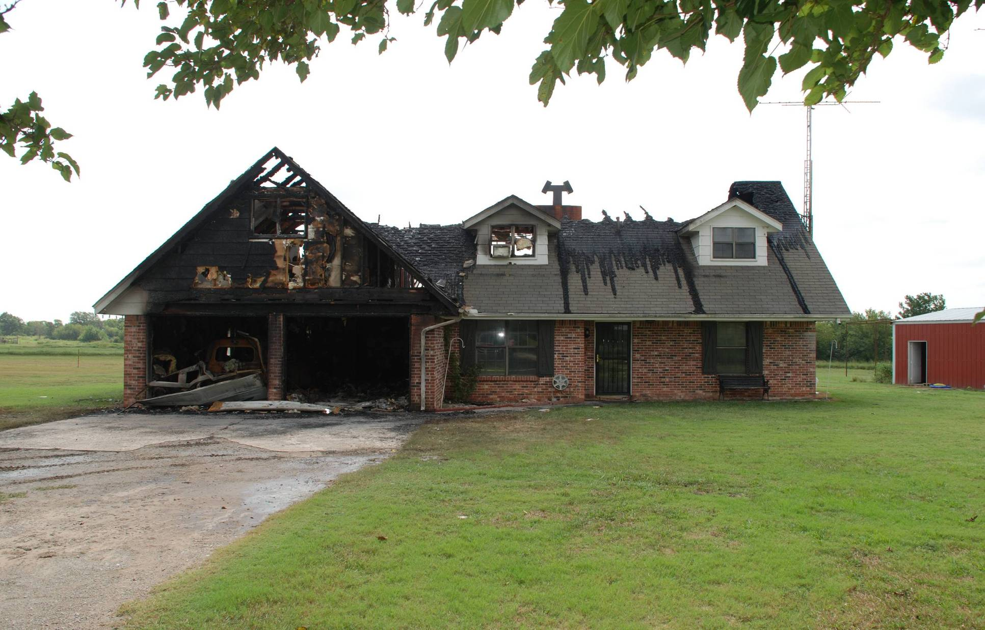

Photo 2

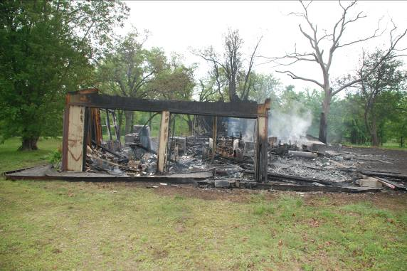

Photo 3

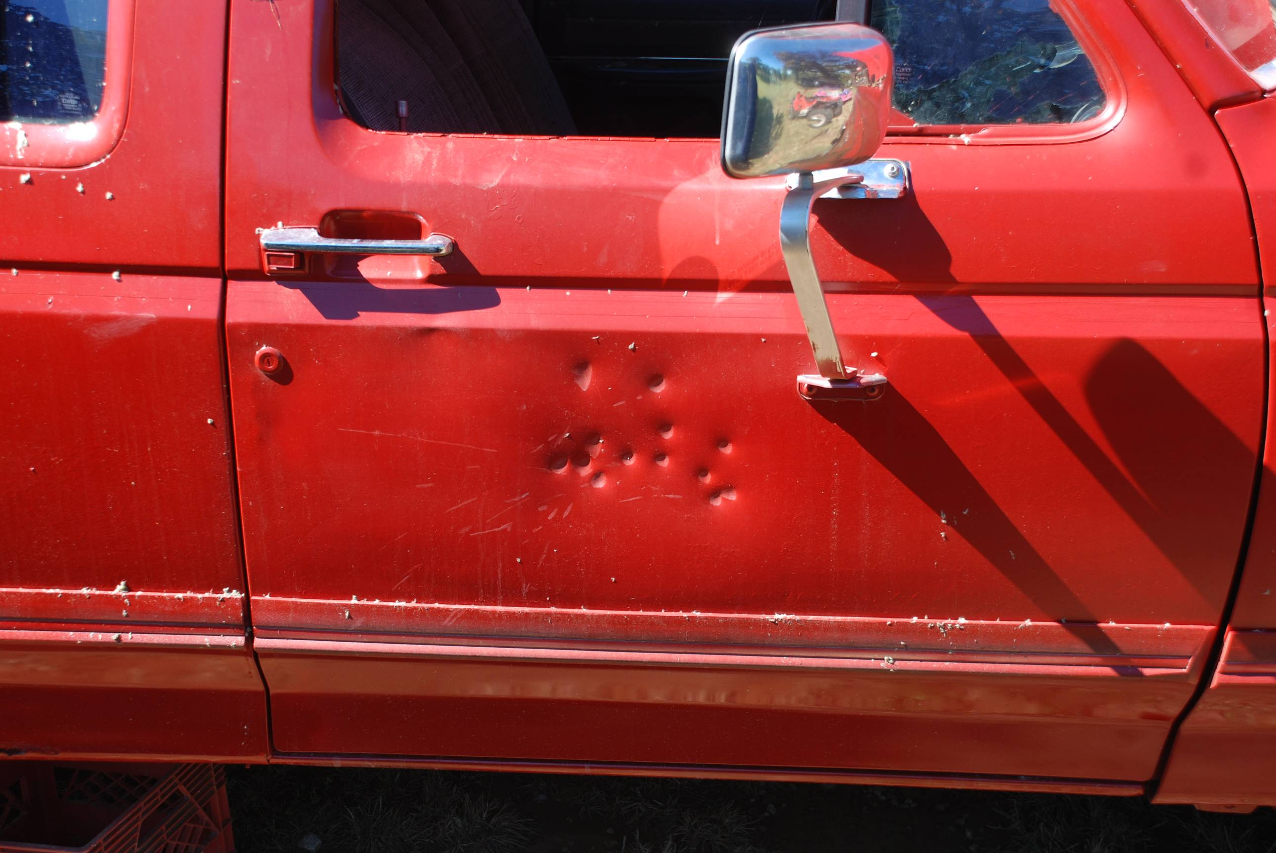

Photo 4

