Fire Investigator 1 - Assignment #4
Utah Fire and Rescue Academy

Directions:

You are assigned to investigate 4 scenes with potential explosive damage. Analyze each photograph as if you were the investigator on scene.

Assignment:

1. What concerns do you have as you begin this investigation?
2. What is the first step of your investigation?
3. Type of damage portrayed in the photograph.
4. Compare the damage views with the normal damage that is viewed at a structure fire.
5. Does the picture represent low-order or high-order damage
6. Identify the vapor density of the fuel involved in this fire/explosion incident.
7. Recognize the evidence depicted at this fire/explosion scene.
8. Analyze the evidence that may be found at the fire/explosion scene that may not be provided in the exposure.
9. Consider the type of building construction involved in the fire/explosion scene.

Requirements:

1. Answer each question for each photograph. Use a word processing or other data management software program to type your answers. Double space blocks of typed text.
2. Each answer should be complete. Each answer should be grammatically correct with no spelling errors.
3. Technical terms should be explained for clarification.

State skill # 1, 2, 3, 4, 5, 6, 7, 8, 9

Photo 1

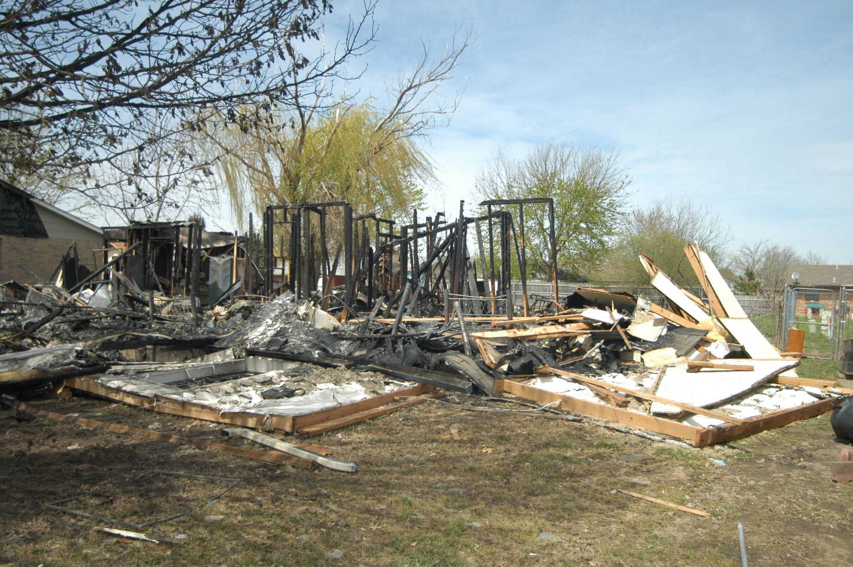

Photo 2

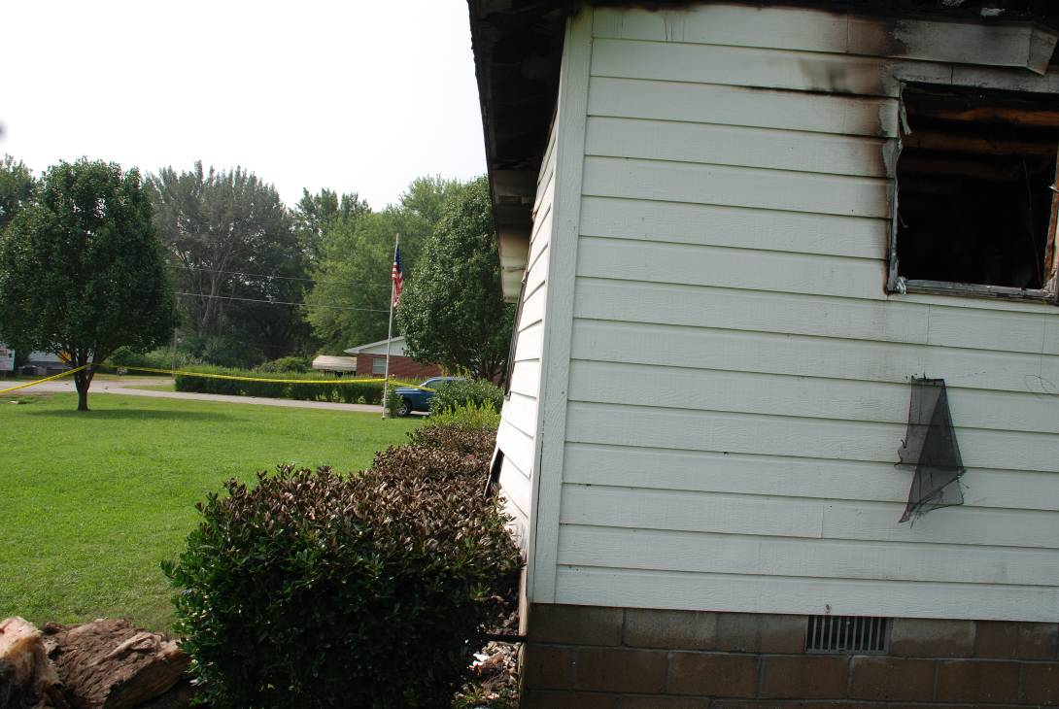
Photo 3

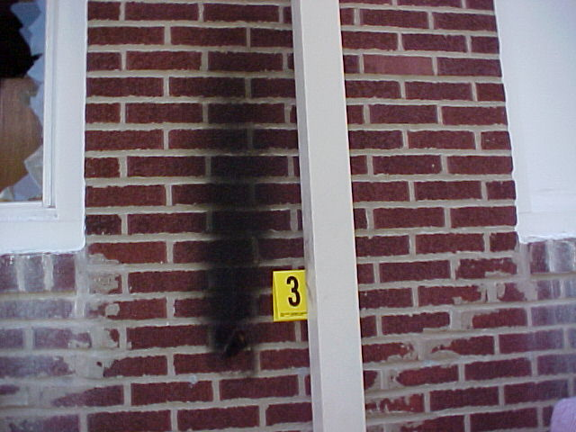

Photo 4

